­­

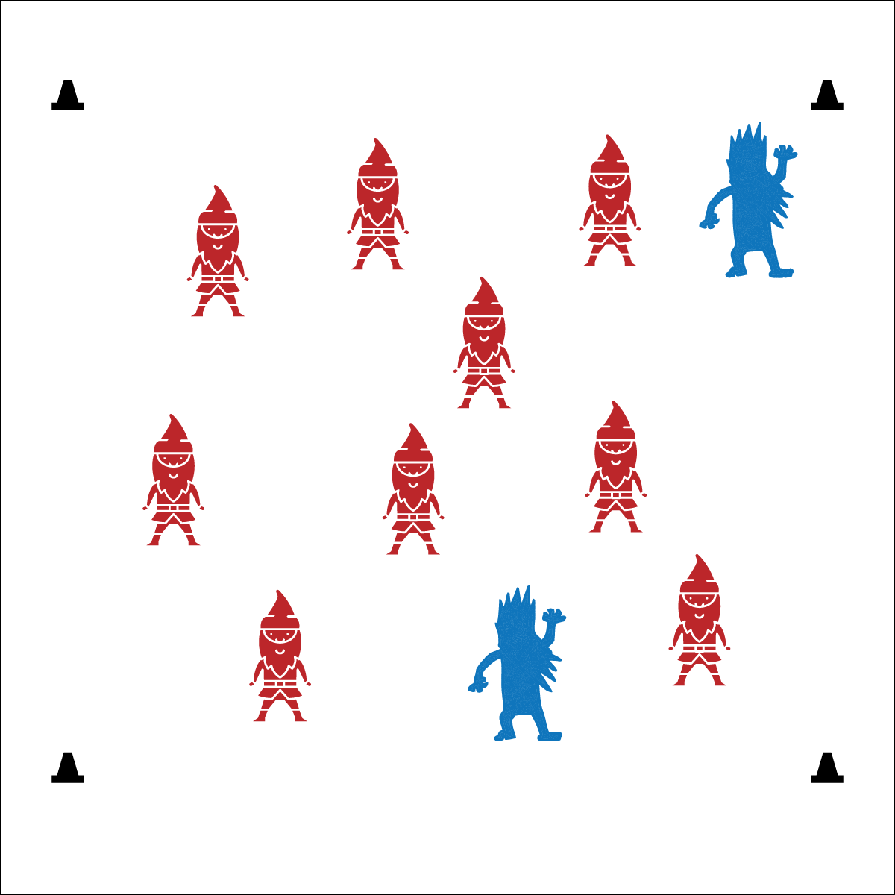



**Values Physical Activity: Social Interaction** (K) Discusses the enjoyment of playing with family and friends. (1) Discusses the reasons for participating in physical activity with friends. (2) Discusses ways to encourage others to be physically active with friends. (3) Describes the positive social interactions that come when engaged with others in physical activity. (4) Describes and compares positive social interactions when engaged in partner, small-group, and large-group physical activities. (5) Describes the social benefits gained from participating in physical activity. (6) Demonstrates respect for self and others in activities and games by following the rules, encouraging others, and playing within the spirit of the game or activity. (7) Demonstrates the importance of social interaction by helping and encouraging others, avoiding trash talk, and providing support to classmates. (8) Demonstrates respect for self by asking for help and helping others in various physical activities.

**Activity Procedures:**

1. Let’s warm up our bodies for physical education class by playing Frostbite Tag. Frostbite occurs when our skin isn’t covered in cold winter weather. Frostbite can cause damage to your skin. That’s why it’s important to dress appropriately in cold weather.
2. When I say “GO!” we’ll begin at a speed-walking pace. Taggers will do 10 jumping jacks to give you time to move away. The taggers are “frostbite” looking for students with exposed skin on a cold winter day.
3. If you’re tagged, stop moving and act like you’re freezing cold. You are frozen until a classmate comes up to you and wraps an imaginary blanket around you and then gives you a double high five to increase blood flow to your frozen hands.
4. Activity will continue until you hear the stop signal. We will then change taggers and begin again.

**Modifications:**

* Prompt students to use a variety of locomotor skills.



**DOK 1:** What is a consequence?

**DOK 2:** How does decision making affect consequences?

**DOK 3:** On a cold winter day, what decisions can you make about what you wear in order to avoid negative consequences?

**Equipment:**

* 4 cones to create boundaries
* 2-3 noodles to identify the taggers

**Set-Up:**

1. Create a large playing area using the 4 cones.
2. Scatter students in the activity area.
3. Identify 2-3 taggers by giving them noodles.

* Control Your Speed
* Be Aware of Space and Others
* Move and Tag Safely
* **Fitness:** I will increase my heart rate to improve my fitness.
* **Personal & Social Responsibility:** I will work safely by controlling my movements and my behavior.