­­

**Menorah Relay**

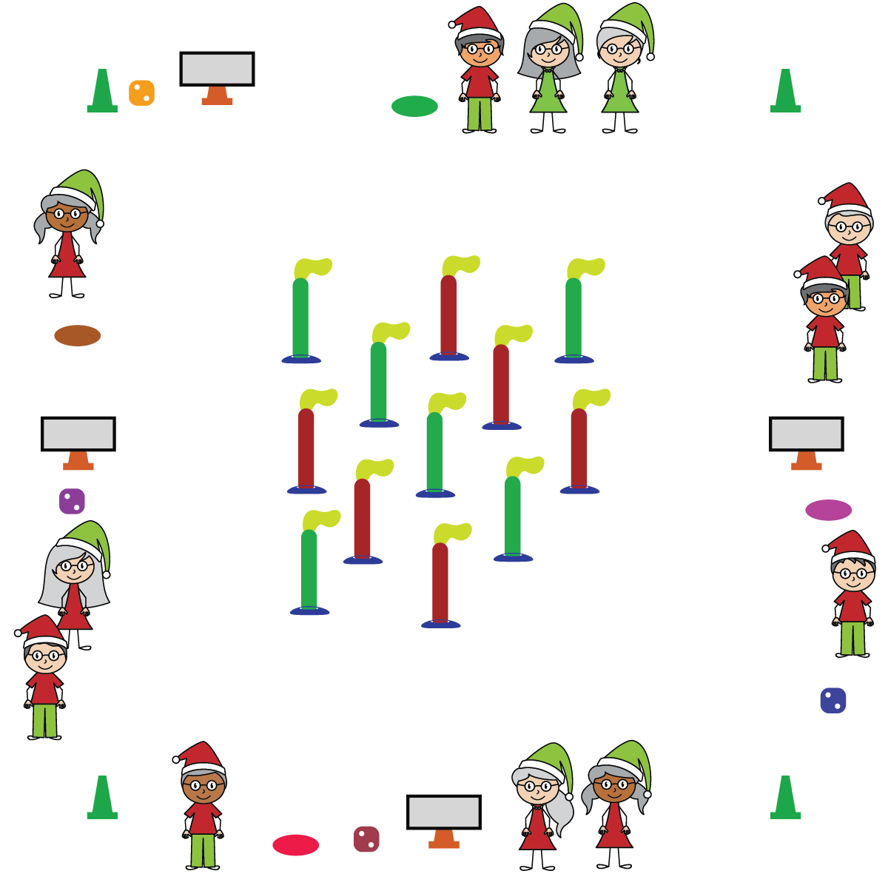

**Activity Procedures:**

1. It’s time to light the Menorah! On the music, begin collecting candles to create and light your Menorah.
2. You’ll do that by rolling the die and completing the corresponding exercise on the activity card. That earns you one candle to add to your Menorah.
3. One team member goes to the center of the activity area and brings back 1 candle (noodle). The first candle should be at the center of the Menorah (on the spot marker), and the remaining 8 candles placed with 4 on each side (a total of 9). Once you’ve collected a candle from the center of the activity area, have the next team member roll the die. Continue this process until Menorah is completely “lit” or until music stops. Rotate who gets to roll dice and who gets to collect the next candle.

**SEL Integration & Academic Language:** Engage, Kindness, Support

**Discussion Starters:**

* The lighting of the Menorah occurs during the 8 nights of Hanukkah, with the center candle being used to light the 8 candles. Does anyone know why a Menorah is typically placed in a window?

**Priority Learning Outcomes:**

* **Values Physical Activity: Social Interaction** (K) Discusses the enjoyment of playing with family and friends. (1) Discusses the reasons for participating in physical activity with friends. (2) Discusses ways to encourage others to be physically activity with friends. (3) Describes the positive social interactions that come when engaged with others in physical activity. (4) Describes and compares positive social interactions when engaged in partner, small-group, and large-group physical activities. (5) Describes the social benefits gained from participating in physical activity. (6) Demonstrates respect for self and others in activities and games by following the rules, encouraging others, and playing within the spirit of the game or activity. (7) Demonstrates the importance of social interaction by helping and encouraging others, avoiding trash talk, and providing support to classmates. (8) Demonstrates respect for self by asking for help and helping others in various physical activities.

**Equipment:**

* Cones for boundaries
* 1 spot marker, task tent, activity card & die per team
* 9 half noodles (for candles) & 9 scarves (for the flames) per team; low profile cones for noodle base

**Set-Up:**

* Place a spot marker (as base of Menorah), task tent with activity card and die for each team around the perimeter of the activity space.
* Place half noodles (with scarves tucked in the top and low profile cone on bottom) in the center of the teaching area.
* Create equal teams of 3-4 students. Each team starts at a spot marker.
* **Skill:** I will safely move demonstrating relationships with people and objects.
* **SEL:** I will use communication skills to help establish a positive learning environment for myself and others.
* Move Safely
* Work Cooperatively