­­

**ELF ON THE SHELF TAG**

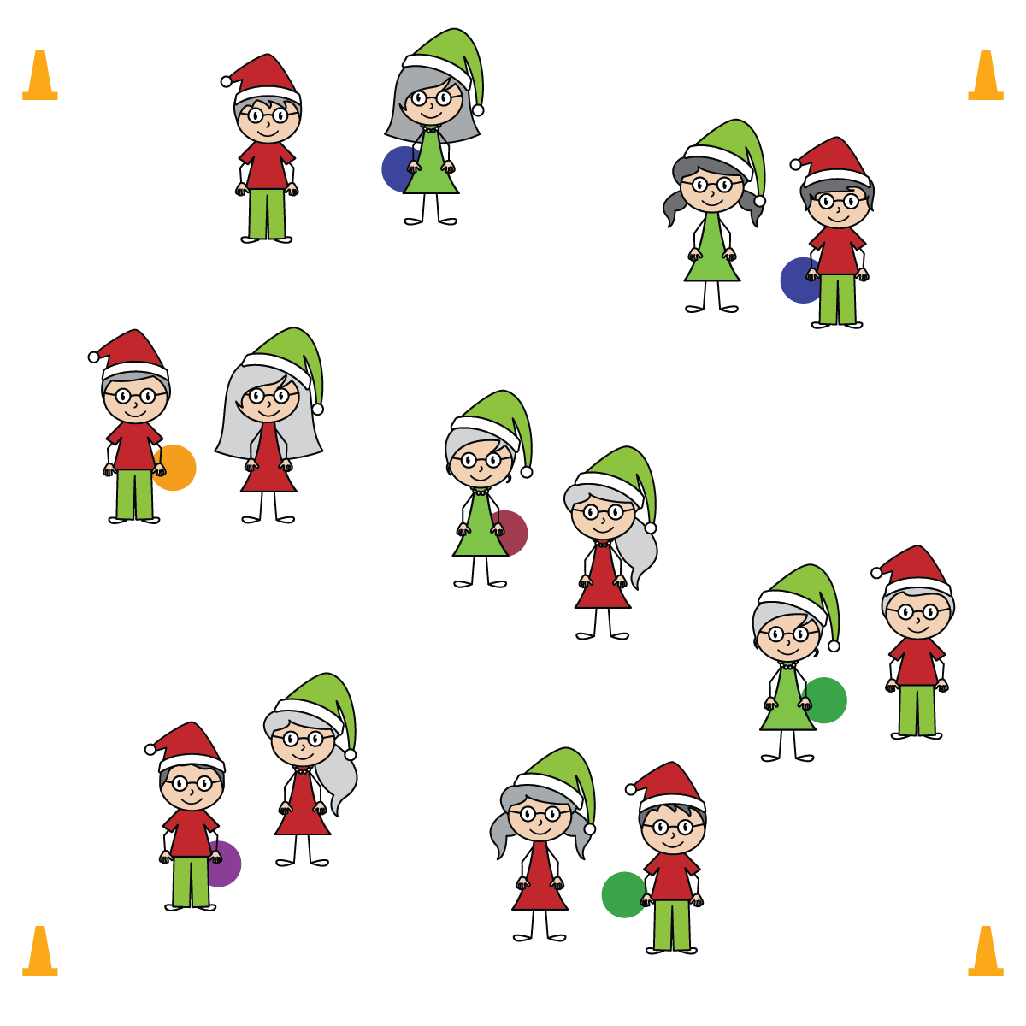

**Activity Procedures:**

1. In some homes during the holidays, families play a fun game called Elf on the Shelf. Every night when people are sleeping, the elf moves all around the house and tries not to get caught.
2. On the start signal, toss the ball back and forth with your partner. When you hear the music begin, the partner with the ball becomes the elf. They will move at a speed-walking pace through the activity area, trying not to get tagged by their partner without the ball. If tagged, hand the ball off and switch roles. The new tagger will do 3 snowman jacks before trying to tag the new elf.
3. When the music stops, find a new partner to play catch with. This will be your new tag partner when the music starts again.

**SEL Integration:**

* **KEYWORD:** CONSIDERATION. It’s important that students adhere to safety rules and routines. As they progress and mature, the goal is that they not only follow safety rules, but also behave with consideration of their classmates. This includes both physical and emotional safety.

**Grade-Level Outcomes:**

* **Demonstrates Responsible Behaviors ­– Working with Others** (K) Shares equipment and space with others. (1) Works independently with others in a variety of class environments. (2) Accepts responsibility for class protocols with personal and cooperative behavior as well as performance actions. (3) Works cooperatively with others. (4) Accepts “players” of all skill levels into the physical activity. (5) Accepts, recognizes, and actively involves others with both higher and lower skill abilities into physical activities and group projects. (6) Accepts differences among classmates in physical development, maturation, and varying skill levels by providing encouragement and positive feedback. (7) Demonstrates cooperation skills by establishing rules and guidelines for resolving conflicts. (8) Responds appropriately to participants’ ethical and unethical behavior during physical activity by using rules and guidelines for resolving conflicts.

**Equipment:**

* 4 large cones to create boundaries
* 1 foam ball per pair of students
* Music and music player

**Set-Up:**

1. Use 4 cones to mark boundaries of a large activity area.
2. Pair students. Scatter pairs in the activity area, each pair with a foam ball.

* Safely Control Your Body
* Look Where You’re Going
* Consider the Safety of your Classmates
* **Skill:** I will move safely, with consideration for my classmates.
* **Personal & Social Responsibility:** I will write a sentence describing why it’s important to be considerate of others’ physical and emotional safety.