­­

**GIFT NINJAS**

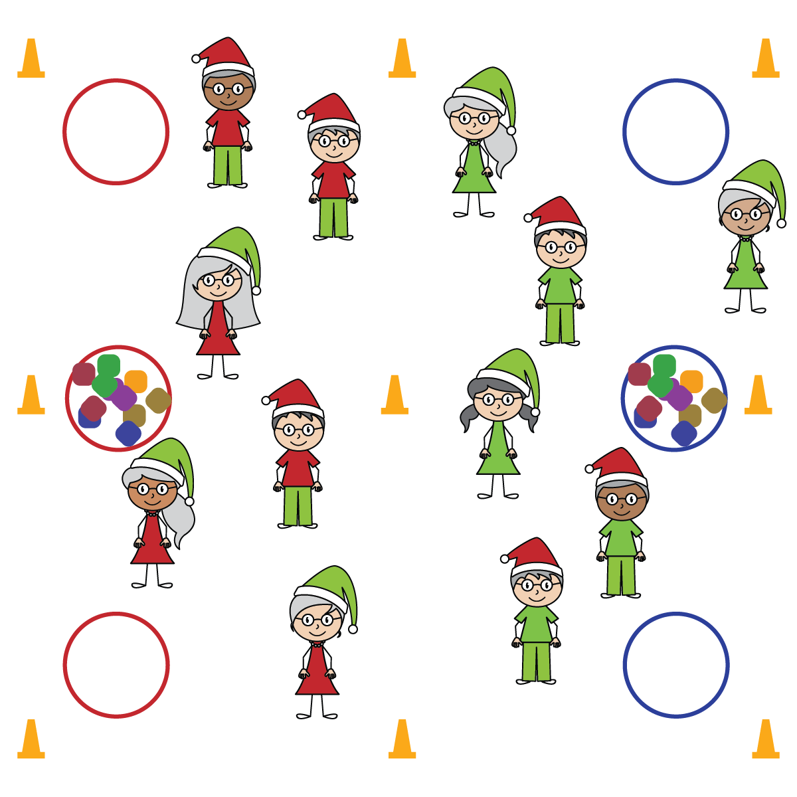

**Equipment:**

* 9 large cones to create boundaries
* 6 hula hoops
* 8–12 beanbags or foam balls as gifts
* 2 mesh equipment bags

**Set-Up:**

1. Use cones to create 2 activity areas side by side, with 3 cones forming a center line and 3 on each end line.
2. Space 3 hoops evenly across the back of each activity area. In 1 hoop on each side, place an equipment bag and 4–6 “gifts.” Leave the other 2 hoops empty.
3. Divide students into 2 equal teams, each team on 1 side of activity area.

**Activity Procedures:**

1. Some people love giving gifts without getting caught. Some people are *Gift Ninjas*!
2. This game is the opposite of capture the flag. Instead of capturing a flag from the other side without getting tagged, you’ll be delivering “gifts” to the other side without being tagged.
3. On the start signal, take a “gift” from the hoop with the mesh bag and deliver it to one of the other team’s “chimneys” (empty hoops) without getting tagged.
4. If you’re tagged, gallop around the perimeter of the activity area and return to the game through your team’s end line. Play continues until 1 team has delivered all of their gifts.

**SEL Integration:**

* **KEYWORD:** ENJOYMENT. Our emotions can directly and immediately impact personal behaviors. The life-hack we want students to learn is how to use the power of emotions to empower positive behaviors and NOT self-destructive and dangerous ones. Enjoyment is a great way to teach and develop this skill. Look for moments when student enjoyment contributes positively to the class, and also for times when it negatively impacts the learning environment. Treat both events as learning opportunities and provide students with positive feedback on how to harness enjoyment for good.

**Grade-Level Outcomes:**

* **Values Physical Activity –** **Personal Enjoyment** (K) Identifies physical activities that are enjoyable.   
  (1) Describes positive feelings that result from physical activity participation. (2) Discusses personal reasons for enjoying selected physical activities. (3) Reflects on the reasons for enjoying selected physical activities. (4) Ranks the enjoyment of participating in different physical activities. (5) Analyzes different activity choices for enjoyment and identifies reasons for positive or negative responses.   
  (6) Describes how moving competently creates enjoyment and self-expression. (7) Explains the relationship between self-expression and lifelong enjoyment of physical activity. (8) Discusses ways to increase enjoyment in self-selected physical activities.
* **Skill:** I will demonstrate safe behaviors and movements.
* **Personal & Social Responsibility:** I will express enjoyment of play appropriately and with consideration of others.
* Enjoy Safe Play
* Enjoy Friendly Competition
* Enjoy Challenging Movement