­­

**GIFT WRAPPERS**

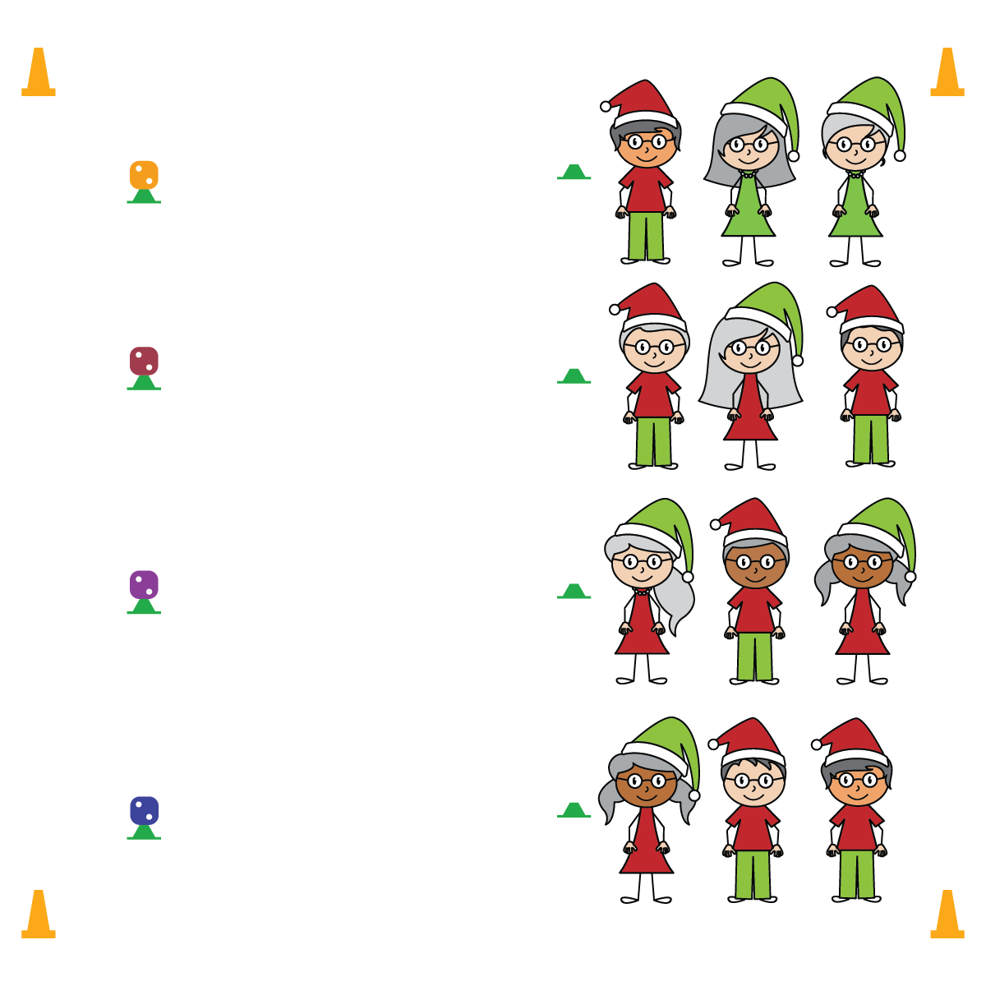

**Activity Procedures:**

1. Optimism is the greatest gift that you can give the world! Let’s practice expressing optimism as we play Gift Wrappers. The object is to “wrap your gift” by taking turns rolling the dice and adding each roll’s value until you reach the sum of exactly 20. However, if your team rolls a 6, you must “unwrap” your gift and start back at 0.
2. On the music, 1 player on each team will run to their die and roll it. Remember its value, place the die back on the cone, and run back to your team. Give a high-5 and the next person in line will go.
3. Continue rolling and adding until 1 team reaches exactly 20. If you roll a 5 and you already have 18, just return to your line and keep playing until someone on your team rolls a 2.
4. We’ll play 4 rounds. After each round, the winning team will choose the exercise that the entire class will perform for 20 repetitions.

**SEL Integration:**

* **KEYWORD:** OPTIMISM. Most students have some desire and drive to win. However, everyone suffers defeat and setbacks. Optimism is like any other skill. Becoming proficient requires purposeful practice, performance adjustments, and then repetitive success. During the game of Gift Wrappers, most teams and most students are going to lose. Use each loss as an opportunity to reinforce optimism and growth mindset.

**Grade-Level Outcomes:**

* **Demonstrates Responsible Behaviors ­– Working with Others** (K) Shares equipment and space with others. (1) Works independently with others in a variety of class environments. (2) Accepts responsibility for class protocols with personal and cooperative behavior as well as performance actions. (3) Works cooperatively with others. (4) Accepts “players” of all skill levels into the physical activity. (5) Accepts, recognizes, and actively involves others with both higher and lower skill abilities into physical activities and group projects. (6) Accepts differences among classmates in physical development, maturation, and varying skill levels by providing encouragement and positive feedback. (7) Demonstrates cooperation skills by establishing rules and guidelines for resolving conflicts. (8) Responds appropriately to participants’ ethical and unethical behavior during physical activity by using rules and guidelines for resolving conflicts.

**Equipment:**

* Large foam dice — 1 per team of 3 students
* Low-profile cones — 2 per team of 3 students
* Music and music player

**Set-Up:**

1. Use low-profile cones to create 2 parallel lines on opposite ends of a large activity area.
2. Place the foam dice on top of the cones on one side of the area.
3. Create teams of 3 and line them up relay-race style behind the low-profile cones opposite the dice.

* **Skill:** I will use positive language to express optimism.
* **Personal & Social Responsibility:** I will encourage my classmates to express their optimism.
* Think Positive
* Look for the Good in Every Situation