­­

**Christmas Tree Relay**

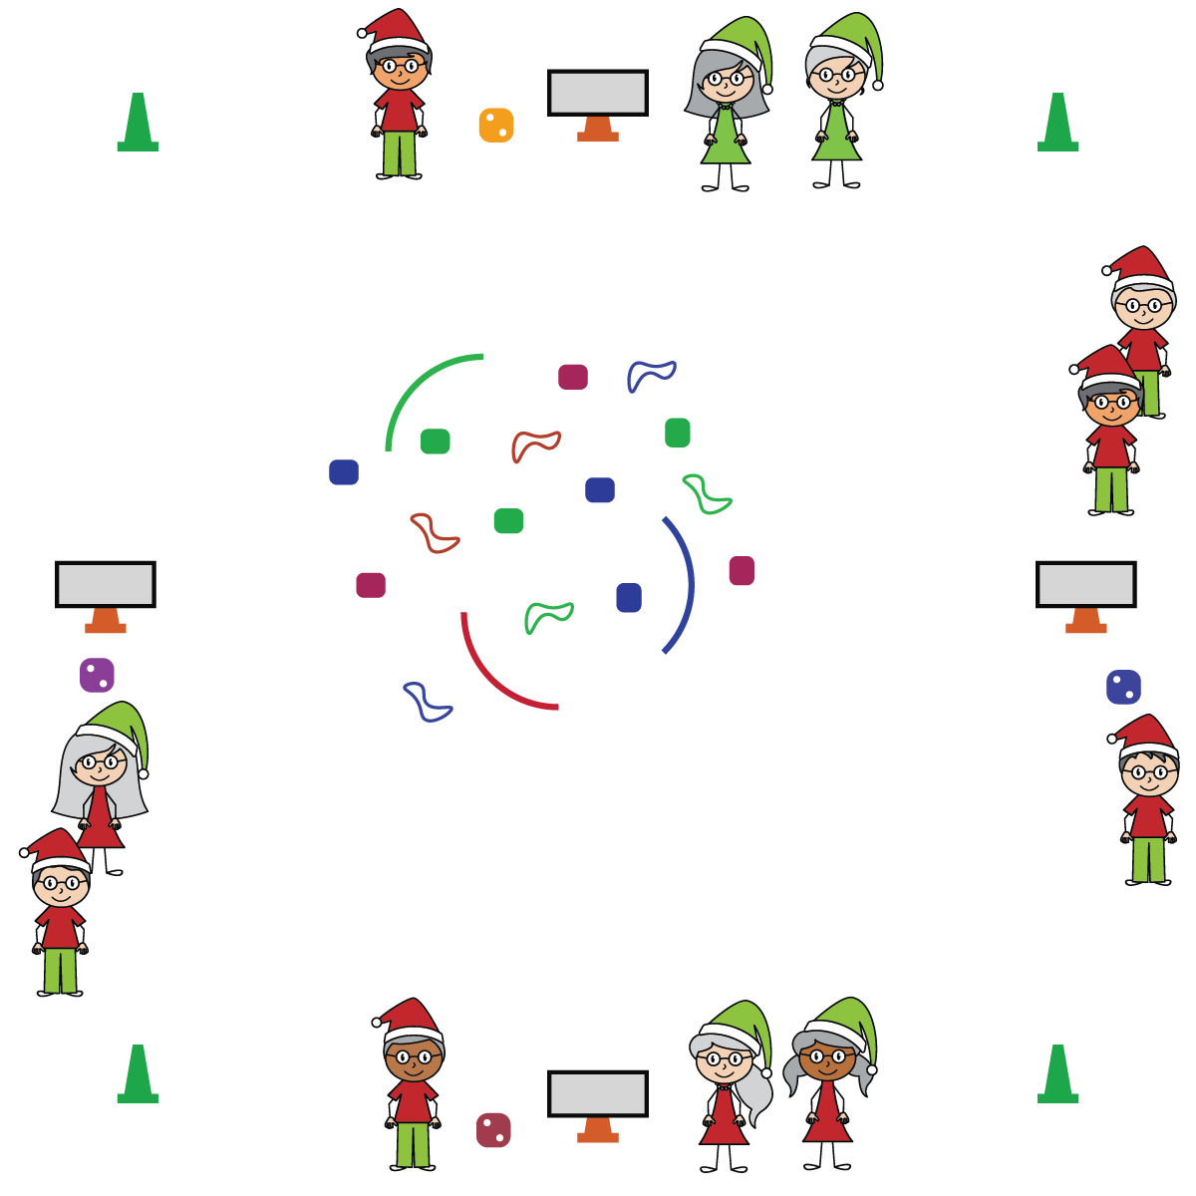

**Equipment:**

* Cones for boundaries
* 1 cone & die per team
* 1 task tent & activity card per team
* Equipment to create/decorate trees (e.g., jump ropes, bean bags, fluff balls, scarves, noodles)

**Set-Up:**

* Place a cone, task tent with activity card, and die for each team around the perimeter.
* Place a variety of equipment in the center of the teaching area for teams to choose the items they want to use to create and decorate their tree.
* Create equal teams of 3-4 students. Each team at a cone.

**Activity Procedures:**

1. It’s time for teams to create a unique Christmas Tree!
2. When the music starts, begin collecting items to create and decorate your tree. Do that by rolling the die and completing the corresponding exercise on the activity card. Each roll earns 1 decoration.
3. One teammate will move to the center of the area to collect a decoration item. Once you’ve collected and placed your item, the next team member will roll the die. Continue until trees are complete or for a specified amount of time.
4. Remember, collect 1 decoration at a time. Roll the die and complete the activity to “earn” the next item.
5. Rotate who gets to roll the die and who gets to choose (and place) the item added to the tree.

**SEL Integration:**

* **Academic Language:** Engage, Cooperation, Leadership

**Discussion Starters:**

* The holidays are a time for giving. What is something kind or thoughtful you could do for a friend or family member during the holidays?

**Grade-Level Outcomes:**

* **Demonstrates Responsible Behaviors ­– Working with Others** (K) Shares equipment and space with others. (1) Works independently with others in a variety of class environments. (2) Accepts responsibility for class protocols with personal and cooperative behavior as well as performance actions. (3) Works cooperatively with others. (4) Accepts “players” of all skill levels into the physical activity. (5) Accepts, recognizes, and actively involves others with both higher and lower skill abilities into physical activities and group projects. (6) Accepts differences among classmates in physical development, maturation, and varying skill levels by providing encouragement and positive feedback. (7) Demonstrates cooperation skills by establishing rules and guidelines for resolving conflicts. (8) Responds appropriately to participants’ ethical and unethical behavior during physical activity by using rules and guidelines for resolving conflicts.
* **Cognitive:** I will identify the rules and etiquette for creating the Christmas Tree during this activity.
* **Personal & Social Responsibility:** I will demonstrate personal responsibility through teamwork and cooperation.
* Move Safely
* Work Cooperatively