­­

**ORNAMENTS IN THE ATTIC**

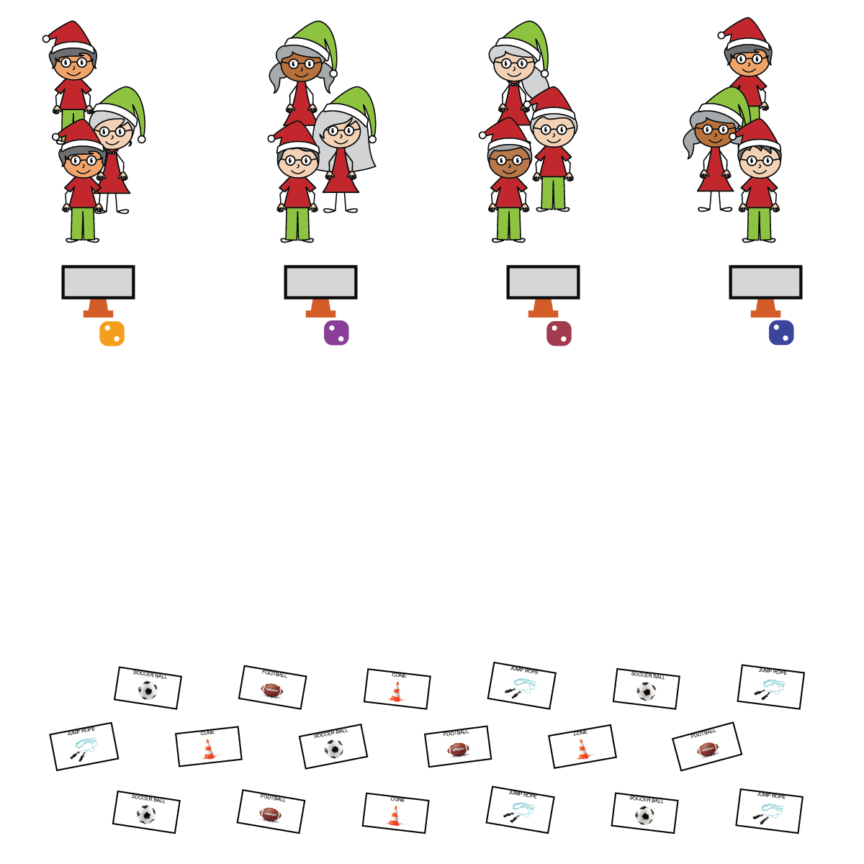

**Activity Procedures:**

1. We are going to decorate a physical education themed Christmas tree today!
2. The object of the game is to use the foam noodles to build your tree, and then to collect all 8 different ornaments from the attic to decorate the tree.
3. On the start signal, your team will use the 5 noodles by your cone to make a tree. Next, one person from each team will roll the die to see what activity your team needs to complete to be eligible to go and collect one ornament. Once your entire team has completed the activity, one teammate will run to the other side of the activity area and collect one ornament.
4. Teams place the ornament on your tree, until you have collected all 8 different ornaments. If you choose an ornament you already have, then return it and select another one.

**SEL Integration:**

* **SELF-CONTROL**: Students will be tempted to collect more than one ornament at a time, or flip over multiple ornaments during one turn to find a specific one they are missing. These situations are perfect examples of SEL teachable moments and should be used to teach students about self-control and etiquette.

**Grade-Level Outcomes:**

* **Demonstrates Responsible Behaviors ­– Working with Others** (K) Shares equipment and space with others. (1) Works independently with others in a variety of class environments. (2) Accepts responsibility for class protocols with personal and cooperative behavior as well as performance actions. (3) Works cooperatively with others. (4) Accepts “players” of all skill levels into the physical activity. (5) Accepts, recognizes, and actively involves others with both higher and lower skill abilities into physical activities and group projects. (6) Accepts differences among classmates in physical development, maturation, and varying skill levels by providing encouragement and positive feedback. (7) Demonstrates cooperation skills by establishing rules and guidelines for resolving conflicts. (8) Responds appropriately to participants’ ethical and unethical behavior during physical activity by using rules and guidelines for resolving conflicts.

**Equipment:**

* 1 starting cone, task tent, Relay Activity Card, and die per team
* 5 foam noodles per team (cut or full)
* 1 set of cut-out ornaments per team

**Set-Up:**

1. Create a starting line of cones with a team of 3-4 students at each cone. Place 5 foam noodles, one die, and a task tent with the activity card at each cone.
2. Scatter the cut-out ornaments face down on the opposite side of the activity space.

* Move Safely
* Follow All Rules
* Demonstrate Self-Control
* **Skill:** I will demonstrate proper form when completing the exercises and movements.
* **Personal & Social Responsibility:** I will demonstrate self-control when working with teammates to place ornaments on the tree.