­­

**NO GRINCHES ALLOWED**

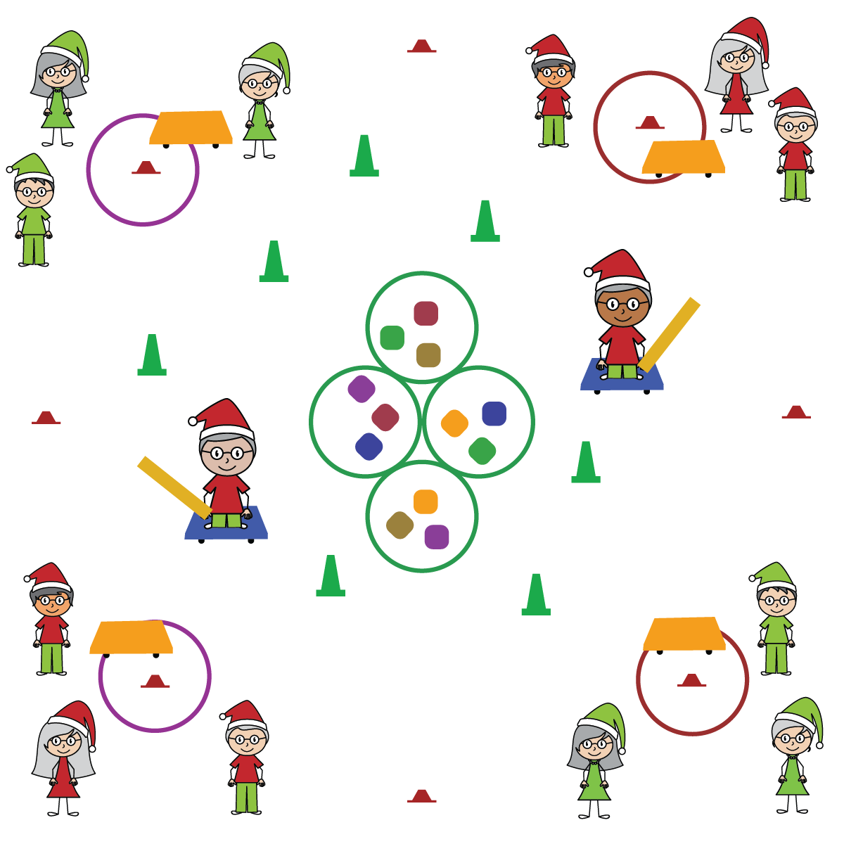

**Activity Procedures:**

1. We are going to try and return all of the presents that were stolen by the grinch! The object of the game is to go to the center of the activity area and steal the presents back without being tagged.
2. On the start signal, one teammate from each team will use the scooter to try and steal back one present. But be careful, don’t get tagged by the grinches or run into the trees (cones)!
3. If you make it back to your starting cone without being tagged, place the item in the hoop by your cone and let the next teammate have a turn. If you’re tagged, return to your team without a present. Continue to rotate trying to steal the presents relay race style until you hear the stop signal.

**SEL Integration:**

* **KEYWORD:** PERSONAL BEHAVIOR. Tag games are vigorous opportunities for students to practice safe and considerate personal behaviors. In order for that opportunity to promote social and emotional learning, focused conversations must take place before and after the activity with an emphasis on the SEL skills you’re working to develop.

**Grade-Level Outcomes:**

* **Demonstrates Responsible Behaviors ­– Working with Others** (K) Shares equipment and space with others. (1) Works independently with others in a variety of class environments. (2) Accepts responsibility for class protocols with personal and cooperative behavior as well as performance actions. (3) Works cooperatively with others. (4) Accepts “players” of all skill levels into the physical activity. (5) Accepts, recognizes, and actively involves others with both higher and lower skill abilities into physical activities and group projects. (6) Accepts differences among classmates in physical development, maturation, and varying skill levels by providing encouragement and positive feedback. (7) Demonstrates cooperation skills by establishing rules and guidelines for resolving conflicts. (8) Responds appropriately to participants’ ethical and unethical behavior during physical activity by using rules and guidelines for resolving conflicts.

**Equipment:**

* 1 starting cone, hoop, and scooter per team
* 1 scooter and foam noodle per tagger
* 20-30 Cones (or dome cones)
* Tossables to use as presents (beanbags, yarn balls, foam balls, etc.)

**Set-Up:**

1. Create a large activity circle with cones.
2. Place a scooter and a hoop by each cone and have teams of 3-4 students begin at a cone.
3. Place the tossables (presents) in several hoops in the center of the activity space, and evenly spread out the cones (trees) inside of activity space.
4. Have 2 taggers begin in center of activity space on a scooter, holding a foam noodle to tag with.

* Move Safely
* Follow All Rules
* Demonstrate Self-Control
* **Skill:** I will move safely through the activity space demonstrating respect for my classmates.
* **Personal & Social Responsibility:** I will cooperate with my teammates and use positive language for communication.