­­

**SNOWMOBILE TAG**

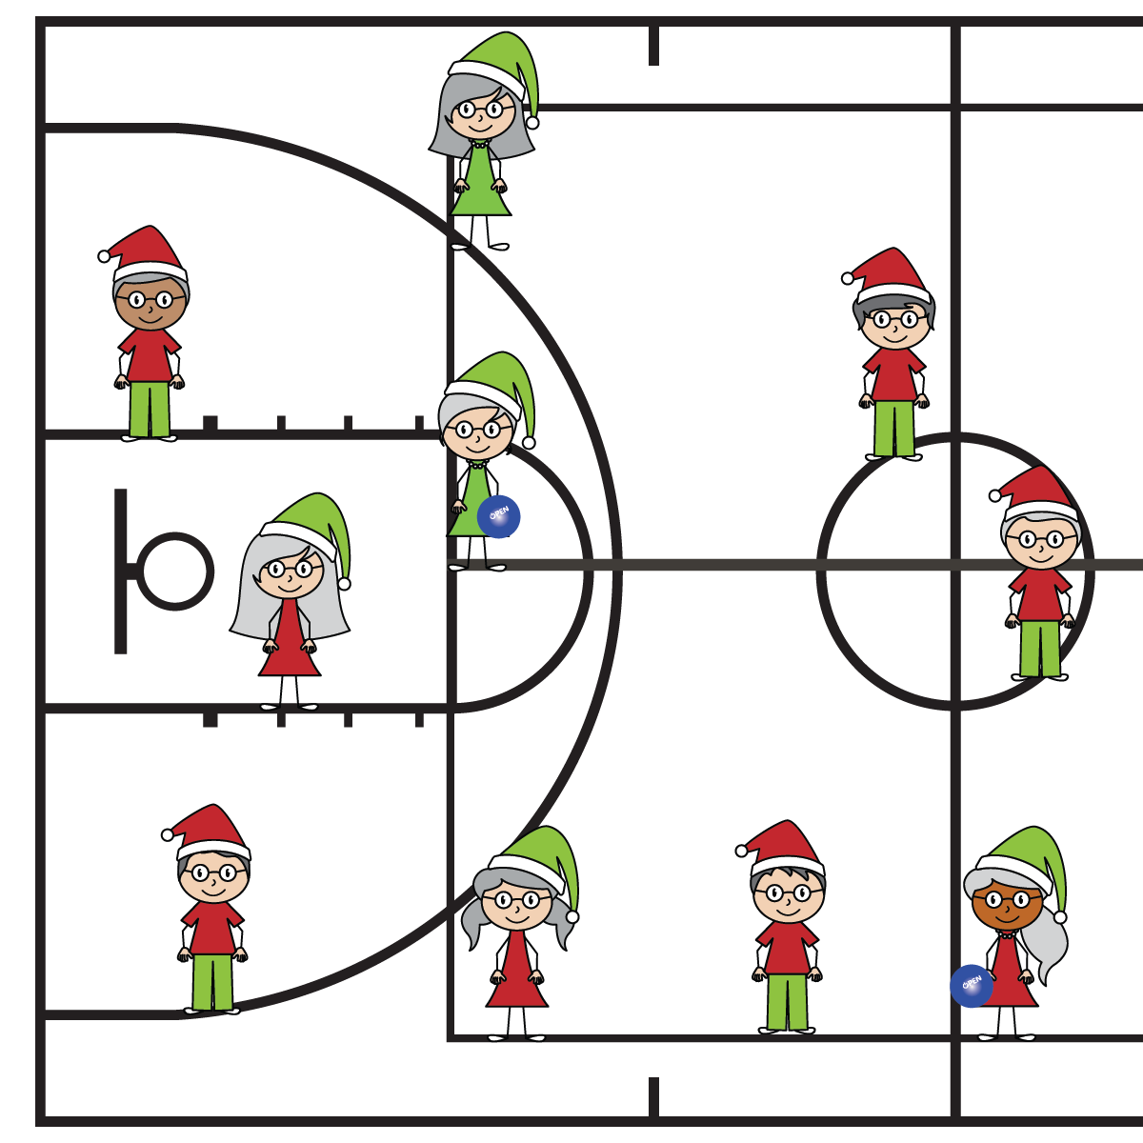

* **Skill:** I will demonstrate self-control by following the rules and etiquette of Snowmobile Tag.
* **Personal & Social Responsibility:** I will write a sentence describing how I demonstrated self-control during this lesson.

**Equipment:**

* 1 large gym floor (or other area) with various floor lines
* 2–4 foam balls to identify taggers

**Set-Up:**

1. Scatter students throughout the area, each standing balanced with both feet on the same floor line.
2. Select 2–4 taggers. Give each tagger a foam ball.

**Activity Procedures:**

1. In very snowy climates, snowmobiles travel on a network of trails with packed snow and safe passageways. Today we’re going to use the lines on our gym floor as snowmobile trails.
2. The object of the game is to stay on the trails (lines) while avoiding taggers. If you’re tagged, step off the trail, complete 5 snowman-jacks, and then get back on the line and restart.
3. You can turn around on a line, but you can’t step off. If you do, you tag yourself and you have to do 5 snowman-jacks to get back on the trail.
4. Taggers may jump from trail to trail (line to line). However, everyone must play at a walking pace.

**SEL Integration:**

* **KEYWORD:** SELF-CONTROL. Students will be extremely tempted to run and/or jump from line to line when it’s not appropriate. These situations are perfect examples of SEL teachable moments and should be used to teach students about self-control, safety, and etiquette.

**Grade-Level Outcomes:**

* **Demonstrates Responsible Behaviors ­– Working with Others** (K) Shares equipment and space with others. (1) Works independently with others in a variety of class environments. (2) Accepts responsibility for class protocols with personal and cooperative behavior as well as performance actions. (3) Works cooperatively with others. (4) Accepts “players” of all skill levels into the physical activity. (5) Accepts, recognizes, and actively involves others with both higher and lower skill abilities into physical activities and group projects. (6) Accepts differences among classmates in physical development, maturation, and varying skill levels by providing encouragement and positive feedback. (7) Demonstrates cooperation skills by establishing rules and guidelines for resolving conflicts. (8) Responds appropriately to participants’ ethical and unethical behavior during physical activity by using rules and guidelines for resolving conflicts.
* Move Safely
* Follow All Rules
* Demonstrate Self-Control