TEAM LEADERS (Grades 5-12)

STUDENT TARGETS
- Skill: I will demonstrate nonverbal communication as I search for my leadership teammate.
- Cognitive: I will discuss leadership cards with my teammates in a thoughtful way.
- Fitness: I will stay actively engaged throughout this activity.
- Social/Emotional: I will demonstrate positive communication skills while discussing leadership cards with teammates.

EQUIPMENT & SET-UP | 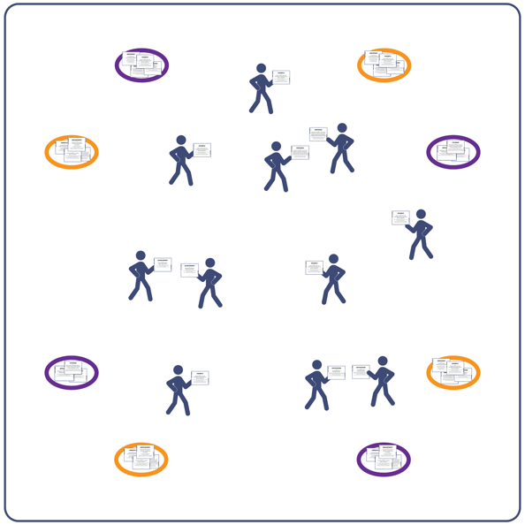
Equipment:
- 4-8 hoops
- 2 sets of Lead By Example cards printed and cut
- Music as a start/stop signal (optional)
Set-Up:
- Place hoops around the perimeter of the area.
- Based on class size, choose the correct number of leadership card matches. For example, for 20 students, choose 10 leadership vocabulary words, 2 copies of each word, 20 cards total. Keep a set of 3 for use with odd numbers.
- Shuffle and scatter cards in each hoop.
- Scatter students in open space throughout the activity area.
ACTIVITY PROCEDURES
- This activity is called Team Leaders. The object of the activity is for everyone to use only nonverbal communication to find their leadership teammate.
- On the start signal, move to a hoop and select 1 leadership card. Look at the card to see what leadership vocabulary word you’ve been assigned. There is 1 other student with that same card (in classes with odd numbers there will be 1 set of 3 mixed in).
- As soon as you have your card, move around the activity area and look for your leadership teammate. There are 2 important rules. You cannot use any verbal communication and you cannot show anyone else your card. You must only use nonverbal communication to find your match.
- Once you’ve found your match, read the discussion questions on the card. Quietly discuss these questions with your teammate until you hear the stop signal.
- Reset the game by having students place their cards in the nearest hoop. On the restart signal, they must choose a card from a different hoop. Play 3 or 4 rounds and then discuss what the students learned from talking about their leadership cards.
PRIORITY OUTCOMES
Responsible Behaviors: Working With Others
- (6) Accepts differences among classmates in physical development, maturation, and varying skill levels by providing encouragement and positive feedback.
- (HS) Uses communication skills and strategies that promote positive team/group dynamics.
DEBRIEF QUESTIONS
- DOK 1: Can you remember one of the words and definitions from your leadership cards?
- DOK 2: How could you apply what you learned from that card in your daily life?
- DOK 3: How is personal leadership related to goal setting and achievement?

