RIDE OUT

STUDENT TARGETS
- Skill: I will demonstrate the movements with the correct rhythm and in the correct sequence.
- Cognitive: I will perform the order and sequence of the routine by memory.
- Fitness: I will actively engage for the duration of the routine.
- Social/Emotional: I will demonstrate patience with myself and others as we learn this routine.

EQUIPMENT & SET-UP | 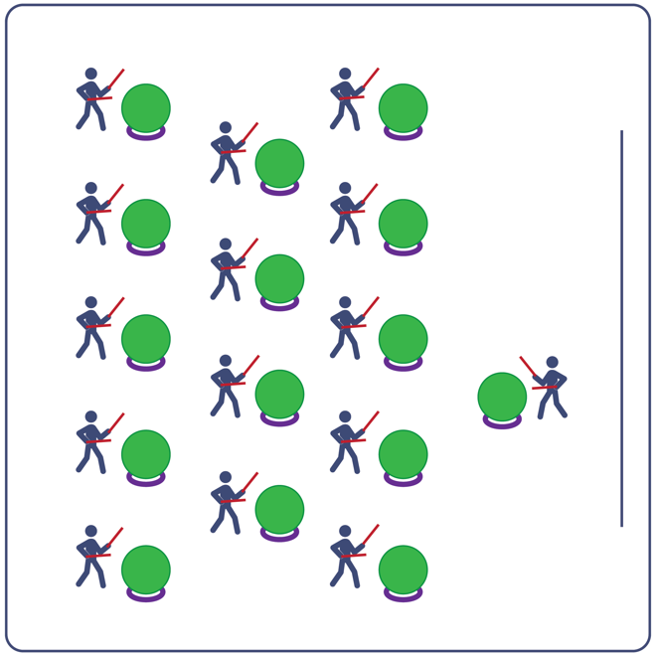
Equipment:
- Computer or tablet to play video
- Projector and screen (or wall to project on)
- Exercise ball for each student
- Large deck rings (for each exercise ball to sit on)
- Drumsticks, Lummi sticks, or pool noodles for each student
- Ride Out Routine Card
- Video: Ride Out Rhythm Fit Routine (YouTube)

Set-Up:
- Arrange exercise balls (on large deck rings) in rows, with enough space for all students to move in a full circle around their exercise ball.
- Have technology set up to project the video for students (with sound).

ACTIVITY PROCEDURES
- This activity is a Rhythm Fit routine called Ride Out.
- The object of this routine is to focus on having empathy for your classmates if they are struggling with the routine and have optimism for yourselves and others that you will be successful.
- When the video begins, you will follow along working to perform movements with the beat and tempo of the music.
- Teachers: you can teach the movement sequences using the routine card prior to playing the video.

GRADE LEVEL PROGRESSION
- Grades K-2: Try this activity with students sitting on the floor, using pool noodles (instead of drumsticks/Lummi sticks) and spot markers on the floor in front of them (instead of an exercise ball).
- Grades 3-5: Perform the activity as described above.
- Grades 6-8: Choose a few students to be in the front of the class to help demonstrate the routine and call out the sequences/counts from the routine card.

TEACHING CUES
- Cue 1: Listen and count with the beat of the music.
- Cue 2: Use equipment safely.
- Cue 3: If you get lost, jump back in on the next movement.

Ride Out (continued…)

UNIVERSAL DESIGN ADAPTATIONS
- UDL 1: Provide modified movements or equipment to make sure the activity is inclusive for all.
- UDL 2: Provide noise canceling headphones to reduce the volume of noise the equipment will make.
- UDL 3: Display the routine sequence card.

ACADEMIC LANGUAGE
Empathy, Optimism, Movement, Actively Engage

PRIORITY OUTCOMES
Personal Challenge:
- Participates in physical activities that bring confidence and challenge.
Personal Enjoyment:
- Describes positive feelings that result from physical activity participation.
Personal Responsibility & Safety:
- Follows directions for safe participation and proper use of equipment without reminders.

DEBRIEF QUESTIONS
Cognitive Question Set:
- DOK 1: Can you remember some of the movements used for this routine?
- DOK 2: How did the music affect how you moved during this routine?
- DOK 3: What did you notice about how the beat and tempo impacted the movement choices used in this routine?

Social & Emotional Question Set:
- DOK 1: What is one thing that you feel optimistic about?
- DOK 2: What can you do to help someone who has lost their optimism?
- DOK 3: What might you say to help someone regain their optimism?

