KEEP CLIMBIN’

STUDENT TARGETS
- Skill: I will perform movements with the beat and tempo of the music.
- Cognitive: I will perform the correct movements and sequences on cue.
- Fitness: I will increase and sustain my heart rate for the duration of the routine.
- Social/Emotional: I will demonstrate respect for the special and unique qualities of others.

EQUIPMENT & SET-UP | 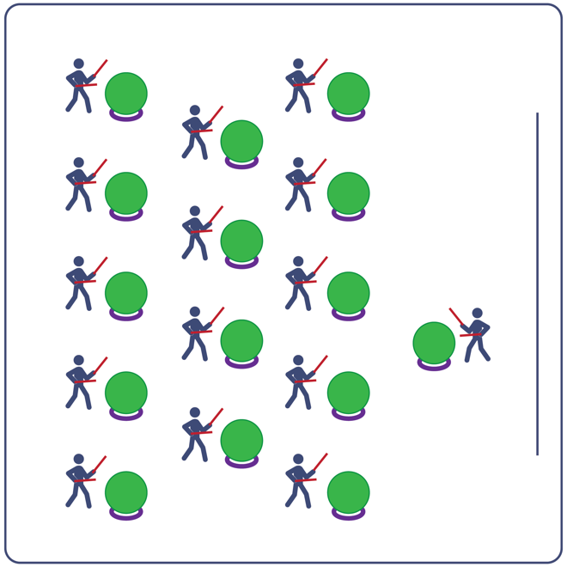
Equipment:
- Computer or tablet to play video
- Projector and screen (or wall to project on)
- Exercise ball for each student
- Large deck rings (for each exercise ball to sit on)
- Drumsticks, Lummi sticks, or pool noodles for each student
- Keep Climbin’ Routine Card
- Video: Keep Climbin’ Rhythm Fit Routine (YouTube)

Set-Up:
- Arrange exercise balls (on large deck rings) in rows, with enough space for all students to move in a full circle around their exercise ball.
- Have technology set up to project the video for students (with sound).

ACTIVITY PROCEDURES
- This activity is a Rhythm Fit routine called Keep Climbin’.
- The object of this routine is to focus on remaining engaged while learning and performing the routine and valuing the special and unique qualities you all have.
- When the video begins, you will follow along working to perform movements with the beat and tempo of the music.
- Teachers: you can teach the movement sequences using the routine card prior to playing the video.

GRADE LEVEL PROGRESSION
- Grades K-2: Try this activity with students sitting on the floor, using pool noodles (instead of drumsticks/Lummi sticks) and spot markers on the floor in front of them (instead of an exercise ball).
- Grades 3-5: Perform the activity as described above.
- Grades 6-8: Choose a few students to be in the front of the class to help demonstrate the routine and call out the sequences/counts from the routine card.

TEACHING CUES
- Cue 1: Listen and count with the beat of the music.
- Cue 2: Use equipment safely.
- Cue 3: If you get lost, jump back in on the next movement.

Keep Climbin’ (continued…)

UNIVERSAL DESIGN ADAPTATIONS
- UDL 1: Provide modified movements or equipment to make sure the activity is inclusive for all.
- UDL 2: Provide noise canceling headphones to reduce the volume of noise the equipment will make.
- UDL 3: Display the routine sequence card.

ACADEMIC LANGUAGE
Engage, Unique, Combination, Enjoyment

PRIORITY OUTCOMES
Social Interaction:
- Describes the social benefits gained from participating in physical activity.
Personal Enjoyment:
- Explains the relationship between self-expression and lifelong enjoyment of physical activity.
Personal Responsibility & Safety:
- Follows directions for safe participation and proper use of equipment without reminders.

DEBRIEF QUESTIONS
Cognitive Question Set:
- DOK 1: Can you remember some of the movements and sequences from this routine?
- DOK 2: What did you notice about the sequence of choreography for this routine?
- DOK 3: If we changed the music used for this routine, would the movements need to be performed differently? If yes, how?

Social & Emotional Question Set:
- DOK 1: Name one activity that you want to engage in.
- DOK 2: Why is that activity so engaging for you?
- DOK 3: How does your participation in that activity enhance your life and the lives of the people you care about?

