BOUNCE

STUDENT TARGETS
- Skill: I will demonstrate the movements with the correct rhythm and in the correct sequence.
- Cognitive: I will perform the order and sequence of the routine by memory.
- Fitness: I will stay actively engaged in this activity in order to increase my heart rate. Social/Emotional: I will demonstrate perseverance and have a growth mindset when learning this routine.

EQUIPMENT & SET-UP | 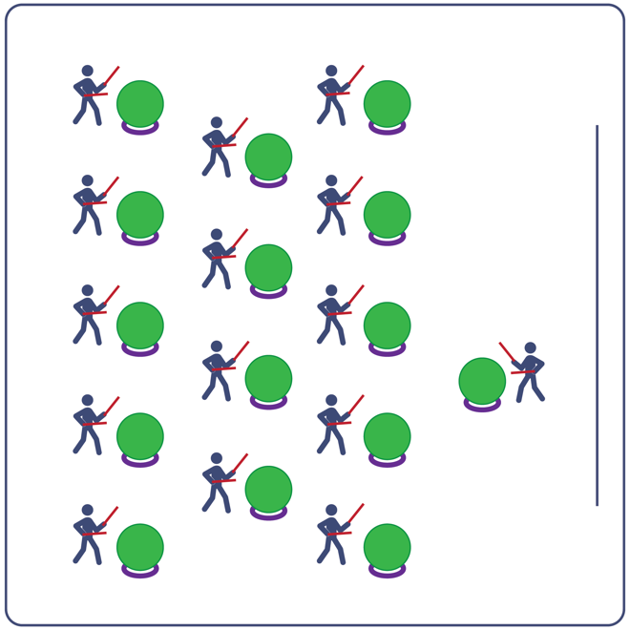
Equipment:
- Computer or tablet to play video
- Projector and screen (or wall to project on)
- Exercise ball for each student
- Large deck rings (for each exercise ball to sit on)
- Drumsticks, Lummi sticks, or pool noodles for each student
- Bounce Routine Card
- Video: Bounce Rhythm Fit Routine (YouTube)

Set-Up:
- Arrange exercise balls (on large deck rings) in rows, with enough space for all students to move in a full circle around their exercise ball.
- Have technology set up to project the video for students (with sound).

ACTIVITY PROCEDURES
- This activity is a Rhythm Fit routine called Bounce.
- The object of this routine is to focus on having a growth mindset while practicing the sequence and utilizing grit and perseverance to learn and perform this routine successfully.
- When the video begins, you will follow along working to perform movements with the beat and tempo of the music.
- Teachers: you can teach the movement sequences using the routine card prior to playing the video.

GRADE LEVEL PROGRESSION
- Grades K-2: Try this activity with students sitting on the floor, using pool noodles (instead of drumsticks/Lummi sticks) and spot markers on the floor in front of them (instead of an exercise ball).
- Grades 3-5: Perform the activity as described above.
- Grades 6-8: Choose a few students to be in the front of the class to help demonstrate the routine and call out the sequences/counts from the routine card.

TEACHING CUES
- Cue 1: Listen and count with the beat of the music.
- Cue 2: Use equipment safely.
- Cue 3: If you get lost, jump back in on the next movement.

Bounce (continued…)

UNIVERSAL DESIGN ADAPTATIONS
- UDL 1: Provide modified movements or equipment to make sure the activity is inclusive for all.
- UDL 2: Provide noise canceling headphones to reduce the volume of noise the equipment will make.
- UDL 3: Display the routine sequence card.

ACADEMIC LANGUAGE
Grit, Growth Mindset, Pattern, Practice

PRIORITY OUTCOMES
Personal Challenge:
- Recognizes that challenges can lead to success.
- Discusses the challenge that comes from learning new physical activities.
Personal Responsibility & Safety:
- Follows directions for safe participation and proper use of equipment without reminders.

DEBRIEF QUESTIONS
Cognitive Question Set:
- DOK 1: Can you remember some of the movements used in this routine?
- DOK 2: Can you describe how the music made you feel when it started to play?
- DOK 3: How were the movements related to the beat and tempo of the music?

Social & Emotional Question Set:
- DOK 1: What does it mean to have a growth mindset?
- DOK 2: What skill(s) have you developed that required you to maintain a growth mindset?
- DOK 3: What skill(s) do you want to develop in the future that will require you to maintain a growth mindset?

