Shout Out
beginner

STUDENT TARGETS
- Skill: I will move in my personal space to the rhythm of the music.
- Cognitive: I will discuss how the rhythm of the song changed how we moved.
- Fitness: I will actively participate by moving to the rhythm of the music.
- Social/Emotional: I will demonstrate safe movement patterns and self-control in my actions.

EQUIPMENT & SET-UP | 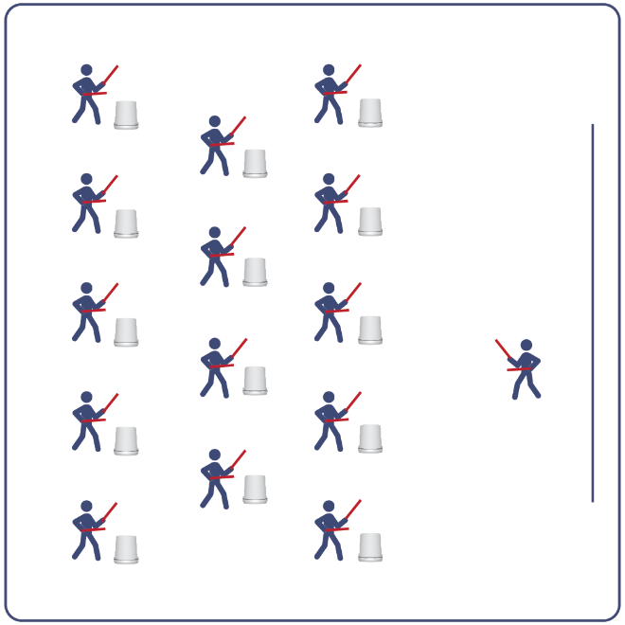
Equipment:
- Computer or tablet to play video
- Projector and screen (or wall to project on)
- Bucket for each student
- Lummi Sticks or drumsticks for each student
- Shout Out Routine Card
- Video: Shout Out Rhythm Fit Routine (YouTube)

Set-Up:
- Arrange buckets in rows, with enough space for all students to move side to side.
- Have technology set up to project the video for students (with sound).

ACTIVITY PROCEDURES
- This activity is a beginner Rhythm Fit routine called Shout Out.
- The object of this routine is to lead and motivate your classmates by demonstrating patience as a virtue while learning this bucket routine.
- When the video begins, you will follow along working to perform movements with the beat and tempo of the music.
- Teachers: you can teach the movement sequences using the routine card prior to playing the video.

GRADE LEVEL PROGRESSION
- Grades K-2: Try this activity with students sitting on the floor, using pool noodles (instead of Lummi sticks or drumsticks) and spot markers on the floor in front of them (instead of a bucket).
- Grades 3-5: Perform the activity as described above.
- Grades 6-8: Choose a few students to be in the front of the class to help demonstrate the routine and call out the sequences/counts from the routine card.

TEACHING CUES
- Cue 1: Listen and count with the beat of the music.
- Cue 2: Use equipment safely.
- Cue 3: If you get lost, jump back in on the next movement.

Shout Out (continued…)

UNIVERSAL DESIGN ADAPTATIONS
- UDL 1: Provide modified movements or equipment to make sure the activity is inclusive for all.
- UDL 2: Provide noise canceling headphones to reduce the volume of noise the equipment will make.
- UDL 3: Display the routine sequence card.

ACADEMIC LANGUAGE
Rhythm, Tap, Virtue, Lead

PRIORITY OUTCOMES
Non-Locomotor Skills:
- Refines non-locomotor skills specific to improve performance in dance, fitness, and sport activities.
Personal Enjoyment:
- Describes how moving competently creates enjoyment and self-expression.
Social Interaction:
- Describes the social benefits gained from participating in physical activity.

DEBRIEF QUESTIONS
Cognitive Question Set:
- DOK 1: How did this routine make you feel?
- DOK 2: What was the rhythm we followed during the movements?
- DOK 3: Since the movements follow the same order every time, how could you know when to do the next movement if the teacher did not call it out for you?

Social & Emotional Question Set:
- DOK 1: It has been said that patience is a virtue. What virtues do you expect leaders to demonstrate?
- DOK 2: When have you demonstrated virtues in your behavior?

