Groove and Flow
beginner

STUDENT TARGETS
- Skill: I will perform movements with the beat and tempo of the music.
- Cognitive: I will discuss how the song we moved to is made up of many 8-counts put together.
- Fitness: I will stay actively engaged in this activity in order to increase my heart rate.
- Social/Emotional: I will move safely and respectfully in self-space.

EQUIPMENT & SET-UP | 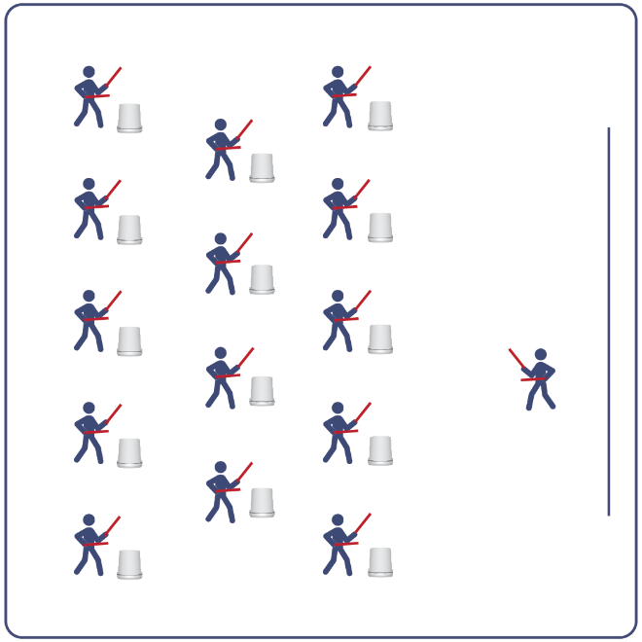
Equipment:
- Computer or tablet to play video
- Projector and screen (or wall to project on)
- Bucket for each student
- Lummi Sticks or drumsticks for each student
- Groove and Flow Routine Card
- Video: Groove and Flow Rhythm Fit Routine (YouTube)

Set-Up:
- Arrange buckets in rows, with enough space for all students to move side to side.
- Have technology set up to project the video for students (with sound).

ACTIVITY PROCEDURES
- This activity is a beginner Rhythm Fit routine called Groove and Flow.
- The object of this routine is to focus on being responsible and setting a good example for your classmates. You can do that by utilizing your power to be a positive influence on your friends.
- When the video begins, you will follow along working to perform movements with the beat and tempo of the music.
- Teachers: you can teach the movement sequences using the routine card prior to playing the video.

GRADE LEVEL PROGRESSION
- Grades K-2: Try this activity with students sitting on the floor, using pool noodles (instead of Lummi sticks or drumsticks) and spot markers on the floor in front of them (instead of a bucket).
- Grades 3-5: Perform the activity as described above.
- Grades 6-8: Choose a few students to be in the front of the class to help demonstrate the routine and call out the sequences/counts from the routine card.

TEACHING CUES
- Cue 1: Listen and count with the beat of the music.
- Cue 2: Use equipment safely.
- Cue 3: If you get lost, jump back in on the next movement.

Groove and Flow (continued…)

UNIVERSAL DESIGN ADAPTATIONS
- UDL 1: Provide modified movements or equipment to make sure the activity is inclusive for all.
- UDL 2: Provide noise canceling headphones to reduce the volume of noise the equipment will make.
- UDL 3: Display the routine sequence card.

ACADEMIC LANGUAGE
Power, Responsible, Tempo, Choreography

PRIORITY OUTCOMES
Personal Challenge:
- Participates in physical activities that bring confidence and challenge.
Personal Enjoyment:
- Describes positive feelings that result from physical activity participation.
Personal Responsibility & Safety:
- Follows directions for safe participation and proper use of equipment without reminders.

DEBRIEF QUESTIONS
Cognitive Question Set:
- DOK 1: Describe the choreography used in this routine.
- DOK 2: What patterns did this routine follow?
- DOK 3: Do you think that the way the music fit together with the movements could help with learning other routines as well? How so?

Social & Emotional Question Set:
- DOK 1: You have the power to influence the attitudes of your friends. What is one action that you take to use that power?
- DOK 2: How can you purposefully use your power to help others?

