Go Off
intermediate

STUDENT TARGETS
- Skill: I will perform the movements of the Go Off routine in the correct pattern.
- Cognitive: I will count and move to the pattern and beat of the routine.
- Fitness: I will actively engage for the duration of the routine.
- Social/Emotional: I will follow directions and stay safely on task.

EQUIPMENT & SET-UP | 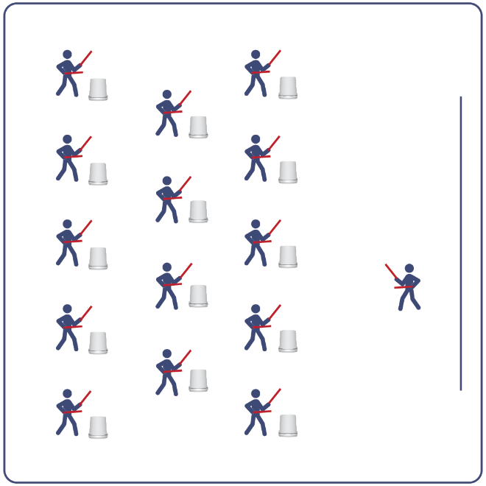
Equipment:
- Computer or tablet to play video
- Projector and screen (or wall to project on)
- Bucket for each student
- Lummi Sticks or drumsticks for each student
- Go Off Routine Card
- Video: Go Off Rhythm Fit Routine (YouTube)

Set-Up:
- Arrange buckets in rows, with enough space for all students to move side to side.
- Have technology set up to project the video for students (with sound).

ACTIVITY PROCEDURES
- This activity is an intermediate Rhythm Fit routine called Go Off.
- The object of this routine is to focus on remaining engaged while learning and performing the routine, and trying to be an example of greatness for your classmates.
- When the video begins, you will follow along working to perform movements with the beat and tempo of the music.
- Teachers: you can teach the movement sequences using the routine card prior to playing the video.

GRADE LEVEL PROGRESSION
- Grades K-2: Try this activity with students sitting on the floor, using pool noodles (instead of Lummi sticks or drumsticks) and spot markers on the floor in front of them (instead of a bucket).
- Grades 3-5: Perform the activity as described above.
- Grades 6-8: Choose a few students to be in the front of the class to help demonstrate the routine and call out the sequences/counts from the routine card.

TEACHING CUES
- Cue 1: Listen and count with the beat of the music.
- Cue 2: Use equipment safely.
- Cue 3: If you get lost, jump back in on the next movement.

Go Off (continued…)

UNIVERSAL DESIGN ADAPTATIONS
- UDL 1: Provide modified movements or equipment to make sure the activity is inclusive for all.
- UDL 2: Provide noise canceling headphones to reduce the volume of noise the equipment will make.
- UDL 3: Display the routine sequence card.

ACADEMIC LANGUAGE
Greatness, Enjoyment, Pattern, Engage

PRIORITY OUTCOMES
Etiquette:
- Identifies the rules and etiquette for physical activities/games and dance activities.
Personal Enjoyment:
- Explains the relationship between self-expression and lifelong enjoyment of physical activity.
Personal Responsibility & Safety:
- Engages in physical activity with responsible interpersonal behavior (e.g., peer to peer, student to teacher).

DEBRIEF QUESTIONS
Cognitive Question Set:
- DOK 1: Can you remember the pattern of movements used for this routine?
- DOK 2: What did you notice about the way the music fit together with the 8-counts of movements?
- DOK 3: Do you think the way the music fit together with the 8-counts can help us learn other routines as well? If so, how?

Social & Emotional Question Set:
- DOK 1: Name one activity that makes you feel alive and invigorated.
- DOK 2: Why is that activity so engaging for you?
- DOK 3: How does your participation in that activity enhance your life and the lives of the people you care about?

