To the Core
intermediate

STUDENT TARGETS
- Skill: I will perform the correct movements with the beat of the music.
- Cognitive: I will remember and perform the correct movements when they are called.
- Fitness: I will increase and sustain my heart rate for the duration of the routine.
- Social/Emotional: I will demonstrate patience with myself and others as we learn this routine.

EQUIPMENT & SET-UP | 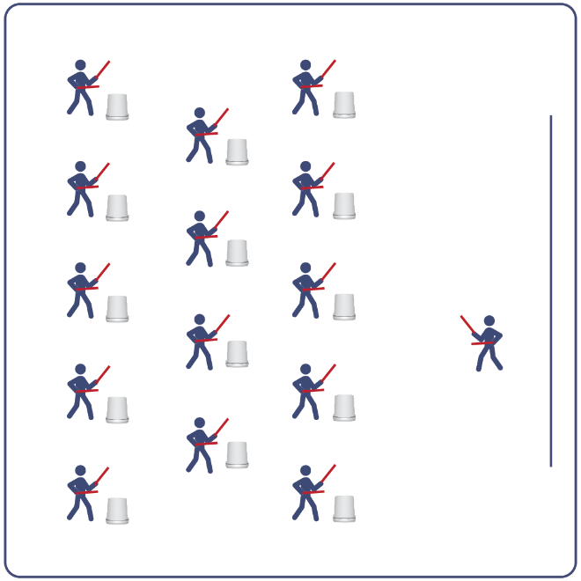
Equipment:
- Computer or tablet to play video
- Projector and screen (or wall to project on)
- Bucket for each student
- Lummi Sticks or drumsticks for each student
- To the Core Routine Card
- Video: To the Core Rhythm Fit Routine (YouTube)

Set-Up:
- Arrange buckets in rows, with enough space for all students to move side to side.
- Have technology set up to project the video for students (with sound).
ACTIVITY PROCEDURES
- This activity is an intermediate Rhythm Fit routine called To the Core.
- The object of this routine is to focus on empowering others while learning and performing the routine and helping yourself and others reach their full potential.
- When the video begins, you will follow along working to perform movements with the beat and tempo of the music.
- Teachers: you can teach the movement sequences using the routine card prior to playing the video.

GRADE LEVEL PROGRESSION
- Grades K-2: Try this activity with students sitting on the floor, using pool noodles (instead of Lummi sticks or drumsticks) and spot markers on the floor in front of them (instead of a bucket).
- Grades 3-5: Perform the activity as described above.
- Grades 6-8: Choose a few students to be in the front of the class to help demonstrate the routine and call out the sequences/counts from the routine card.

TEACHING CUES
- Cue 1: Listen and count with the beat of the music.
- Cue 2: Use equipment safely.
- Cue 3: If you get lost, jump back in on the next movement.

To the Core (continued…)

UNIVERSAL DESIGN ADAPTATIONS
- UDL 1: Provide modified movements or equipment to make sure the activity is inclusive for all.
- UDL 2: Provide noise canceling headphones to reduce the volume of noise the equipment will make.
- UDL 3: Display the routine sequence card.

ACADEMIC LANGUAGE
Empower, Potential, Beat, Sequence

PRIORITY OUTCOMES
Personal Challenge:
- Recognizes that challenges can lead to success.
- Discusses the challenge that comes from learning new physical activities.
Personal Responsibility & Safety:
- Works independently and safely in physical education.

DEBRIEF QUESTIONS
Cognitive Question Set:
- DOK 1: Can you remember some of the movements and sequences from this routine?
- DOK 2: What did you notice about the sequence of choreography for this routine?
- DOK 3: If we changed the music used for this routine, would the movements need to be performed differently? If yes, how?

Social & Emotional Question Set:
- DOK 1: If you had unlimited resources, who would you empower?
- DOK 2: Why did you choose that person or group?
- DOK 3: How would your support empower and/or improve the world?

