Shout Out
beginner

STUDENT TARGETS
- Skill: I will move in my personal space to the rhythm of the music.
- Cognitive: I will discuss how the rhythm of the song changed how we moved.
- Fitness: I will actively participate by moving to the rhythm of the music.
- Social/Emotional: I will demonstrate safe movement patterns and self-control in my actions.

EQUIPMENT & SET-UP | 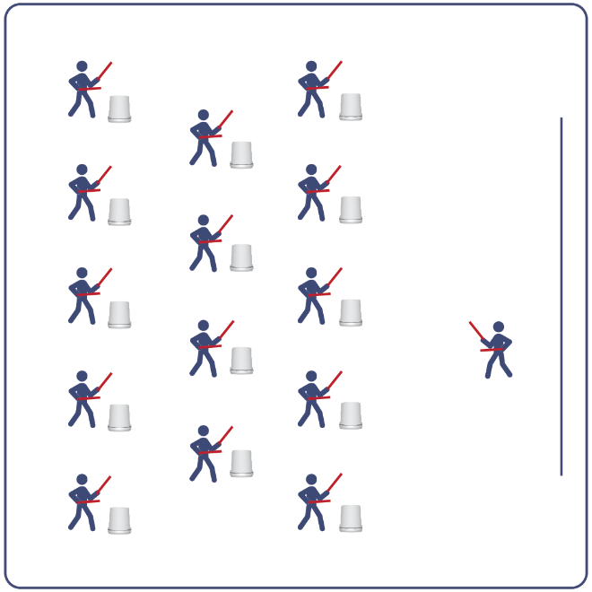
Equipment:
- Computer or tablet to play video
- Projector and screen (or wall to project on)
- Bucket for each student
- Lummi Sticks or drumsticks for each student
- Shout Out Routine Card
- Video: Shout Out Rhythm Fit Routine (YouTube)

Set-Up:
- Arrange buckets in rows, with enough space for all students to move side to side.
- Have technology set up to project the video for students (with sound).

ACTIVITY PROCEDURES
- This activity is a beginner Rhythm Fit routine called Shout Out.
- The object of this routine is to lead and motivate your classmates by demonstrating patience as a virtue while learning this bucket routine.
- When the video begins, you will follow along working to perform movements with the beat and tempo of the music.
- Teachers: you can teach the movement sequences using the routine card prior to playing the video.

GRADE LEVEL PROGRESSION
- Grades K-2: Try this activity with students sitting on the floor, using pool noodles (instead of Lummi sticks or drumsticks) and spot markers on the floor in front of them (instead of a bucket).
- Grades 3-5: Perform the activity as described above.
- Grades 6-8: Choose a few students to be in the front of the class to help demonstrate the routine and call out the sequences/counts from the routine card.

TEACHING CUES
- Cue 1: Listen and count with the beat of the music.
- Cue 2: Use equipment safely.
- Cue 3: If you get lost, jump back in on the next movement.

Shout Out (continued…)

UNIVERSAL DESIGN ADAPTATIONS
- UDL 1: Provide modified movements or equipment to make sure the activity is inclusive for all.
- UDL 2: Provide noise canceling headphones to reduce the volume of noise the equipment will make.
- UDL 3: Display the routine sequence card.

ACADEMIC LANGUAGE
Rhythm, Tap, Virtue, Lead

PRIORITY OUTCOMES
Non-Locomotor Skills:
- Refines non-locomotor skills specific to improve performance in dance, fitness, and sport activities.
Personal Enjoyment:
- Describes how moving competently creates enjoyment and self-expression.
Social Interaction:
- Describes the social benefits gained from participating in physical activity.

DEBRIEF QUESTIONS
Cognitive Question Set:
- DOK 1: How did this routine make you feel?
- DOK 2: What was the rhythm we followed during the movements?
- DOK 3: Since the movements follow the same order every time, how could you know when to do the next movement if the teacher did not call it out for you?

Social & Emotional Question Set:
- DOK 1: It has been said that patience is a virtue. What virtues do you expect leaders to demonstrate?
- DOK 2: When have you demonstrated virtues in your behavior?

Groove and Flow
beginner

STUDENT TARGETS
- Skill: I will perform movements with the beat and tempo of the music.
- Cognitive: I will discuss how the song we moved to is made up of many 8-counts put together.
- Fitness: I will stay actively engaged in this activity in order to increase my heart rate.
- Social/Emotional: I will move safely and respectfully in self-space.

EQUIPMENT & SET-UP
Equipment:
- Computer or tablet to play video
- Projector and screen (or wall to project on)
- Bucket for each student
- Lummi Sticks or drumsticks for each student
- Groove and Flow Routine Card
- Video: Groove and Flow Rhythm Fit Routine (YouTube)

Set-Up:
- Arrange buckets in rows, with enough space for all students to move side to side.
- Have technology set up to project the video for students (with sound).

ACTIVITY PROCEDURES
- This activity is a beginner Rhythm Fit routine called Groove and Flow.
- The object of this routine is to focus on being responsible and setting a good example for your classmates. You can do that by utilizing your power to be a positive influence on your friends.
- When the video begins, you will follow along working to perform movements with the beat and tempo of the music.
- Teachers: you can teach the movement sequences using the routine card prior to playing the video.

GRADE LEVEL PROGRESSION
- Grades K-2: Try this activity with students sitting on the floor, using pool noodles (instead of Lummi sticks or drumsticks) and spot markers on the floor in front of them (instead of a bucket).
- Grades 3-5: Perform the activity as described above.
- Grades 6-8: Choose a few students to be in the front of the class to help demonstrate the routine and call out the sequences/counts from the routine card.

TEACHING CUES
- Cue 1: Listen and count with the beat of the music.
- Cue 2: Use equipment safely.
- Cue 3: If you get lost, jump back in on the next movement.

Groove and Flow (continued…)

UNIVERSAL DESIGN ADAPTATIONS
- UDL 1: Provide modified movements or equipment to make sure the activity is inclusive for all.
- UDL 2: Provide noise canceling headphones to reduce the volume of noise the equipment will make.
- UDL 3: Display the routine sequence card.

ACADEMIC LANGUAGE
Power, Responsible, Tempo, Choreography

PRIORITY OUTCOMES
Personal Challenge:
- Participates in physical activities that bring confidence and challenge.
Personal Enjoyment:
- Describes positive feelings that result from physical activity participation.
Personal Responsibility & Safety:
- Follows directions for safe participation and proper use of equipment without reminders.

DEBRIEF QUESTIONS
Cognitive Question Set:
- DOK 1: Describe the choreography used in this routine.
- DOK 2: What patterns did this routine follow?
- DOK 3: Do you think that the way the music fit together with the movements could help with learning other routines as well? How so?

Social & Emotional Question Set:
- DOK 1: You have the power to influence the attitudes of your friends. What is one action that you take to use that power?
- DOK 2: How can you purposefully use your power to help others?

Go Off
intermediate

STUDENT TARGETS
- Skill: I will perform the movements of the Go Off routine in the correct pattern.
- Cognitive: I will count and move to the pattern and beat of the routine.
- Fitness: I will actively engage for the duration of the routine.
- Social/Emotional: I will follow directions and stay safely on task.

EQUIPMENT & SET-UP
Equipment:
- Computer or tablet to play video
- Projector and screen (or wall to project on)
- Bucket for each student
- Lummi Sticks or drumsticks for each student
- Go Off Routine Card
- Video: Go Off Rhythm Fit Routine (YouTube)

Set-Up:
- Arrange buckets in rows, with enough space for all students to move side to side.
- Have technology set up to project the video for students (with sound).

ACTIVITY PROCEDURES
- This activity is an intermediate Rhythm Fit routine called Go Off.
- The object of this routine is to focus on remaining engaged while learning and performing the routine, and trying to be an example of greatness for your classmates.
- When the video begins, you will follow along working to perform movements with the beat and tempo of the music.
- Teachers: you can teach the movement sequences using the routine card prior to playing the video.

GRADE LEVEL PROGRESSION
- Grades K-2: Try this activity with students sitting on the floor, using pool noodles (instead of Lummi sticks or drumsticks) and spot markers on the floor in front of them (instead of a bucket).
- Grades 3-5: Perform the activity as described above.
- Grades 6-8: Choose a few students to be in the front of the class to help demonstrate the routine and call out the sequences/counts from the routine card.

TEACHING CUES
- Cue 1: Listen and count with the beat of the music.
- Cue 2: Use equipment safely.
- Cue 3: If you get lost, jump back in on the next movement.

Go Off (continued…)

UNIVERSAL DESIGN ADAPTATIONS
- UDL 1: Provide modified movements or equipment to make sure the activity is inclusive for all.
- UDL 2: Provide noise canceling headphones to reduce the volume of noise the equipment will make.
- UDL 3: Display the routine sequence card.

ACADEMIC LANGUAGE
Greatness, Enjoyment, Pattern, Engage

PRIORITY OUTCOMES
Etiquette:
- Identifies the rules and etiquette for physical activities/games and dance activities.
Personal Enjoyment:
- Explains the relationship between self-expression and lifelong enjoyment of physical activity.
Personal Responsibility & Safety:
- Engages in physical activity with responsible interpersonal behavior (e.g., peer to peer, student to teacher).

DEBRIEF QUESTIONS
Cognitive Question Set:
- DOK 1: Can you remember the pattern of movements used for this routine?
- DOK 2: What did you notice about the way the music fit together with the 8-counts of movements?
- DOK 3: Do you think the way the music fit together with the 8-counts can help us learn other routines as well? If so, how?

Social & Emotional Question Set:
- DOK 1: Name one activity that makes you feel alive and invigorated.
- DOK 2: Why is that activity so engaging for you?
- DOK 3: How does your participation in that activity enhance your life and the lives of the people you care about?

To the Core
intermediate

STUDENT TARGETS
- Skill: I will perform the correct movements with the beat of the music.
- Cognitive: I will remember and perform the correct movements when they are called.
- Fitness: I will increase and sustain my heart rate for the duration of the routine.
- Social/Emotional: I will demonstrate patience with myself and others as we learn this routine.

EQUIPMENT & SET-UP
Equipment:
- Computer or tablet to play video
- Projector and screen (or wall to project on)
- Bucket for each student
- Lummi Sticks or drumsticks for each student
- To the Core Routine Card
- Video: To the Core Rhythm Fit Routine (YouTube)

Set-Up:
- Arrange buckets in rows, with enough space for all students to move side to side.
- Have technology set up to project the video for students (with sound).
ACTIVITY PROCEDURES
- This activity is an intermediate Rhythm Fit routine called To the Core.
- The object of this routine is to focus on empowering others while learning and performing the routine and helping yourself and others reach their full potential.
- When the video begins, you will follow along working to perform movements with the beat and tempo of the music.
- Teachers: you can teach the movement sequences using the routine card prior to playing the video.

GRADE LEVEL PROGRESSION
- Grades K-2: Try this activity with students sitting on the floor, using pool noodles (instead of Lummi sticks or drumsticks) and spot markers on the floor in front of them (instead of a bucket).
- Grades 3-5: Perform the activity as described above.
- Grades 6-8: Choose a few students to be in the front of the class to help demonstrate the routine and call out the sequences/counts from the routine card.

TEACHING CUES
- Cue 1: Listen and count with the beat of the music.
- Cue 2: Use equipment safely.
- Cue 3: If you get lost, jump back in on the next movement.

To the Core (continued…)

UNIVERSAL DESIGN ADAPTATIONS
- UDL 1: Provide modified movements or equipment to make sure the activity is inclusive for all.
- UDL 2: Provide noise canceling headphones to reduce the volume of noise the equipment will make.
- UDL 3: Display the routine sequence card.

ACADEMIC LANGUAGE
Empower, Potential, Beat, Sequence

PRIORITY OUTCOMES
Personal Challenge:
- Recognizes that challenges can lead to success.
- Discusses the challenge that comes from learning new physical activities.
Personal Responsibility & Safety:
- Works independently and safely in physical education.

DEBRIEF QUESTIONS
Cognitive Question Set:
- DOK 1: Can you remember some of the movements and sequences from this routine?
- DOK 2: What did you notice about the sequence of choreography for this routine?
- DOK 3: If we changed the music used for this routine, would the movements need to be performed differently? If yes, how?

Social & Emotional Question Set:
- DOK 1: If you had unlimited resources, who would you empower?
- DOK 2: Why did you choose that person or group?
- DOK 3: How would your support empower and/or improve the world?

