Hip Hop Feet
beginner

STUDENT TARGETS
- Skill: I will perform movements with the beat and tempo of the music.
- Cognitive: I will perform the order and sequence of the routine by memory.
- Fitness: I will increase and sustain my heart rate for the duration of the routine.
- Social/Emotional: I will demonstrate safe movement patterns and self-control in my actions.

EQUIPMENT & SET-UP | 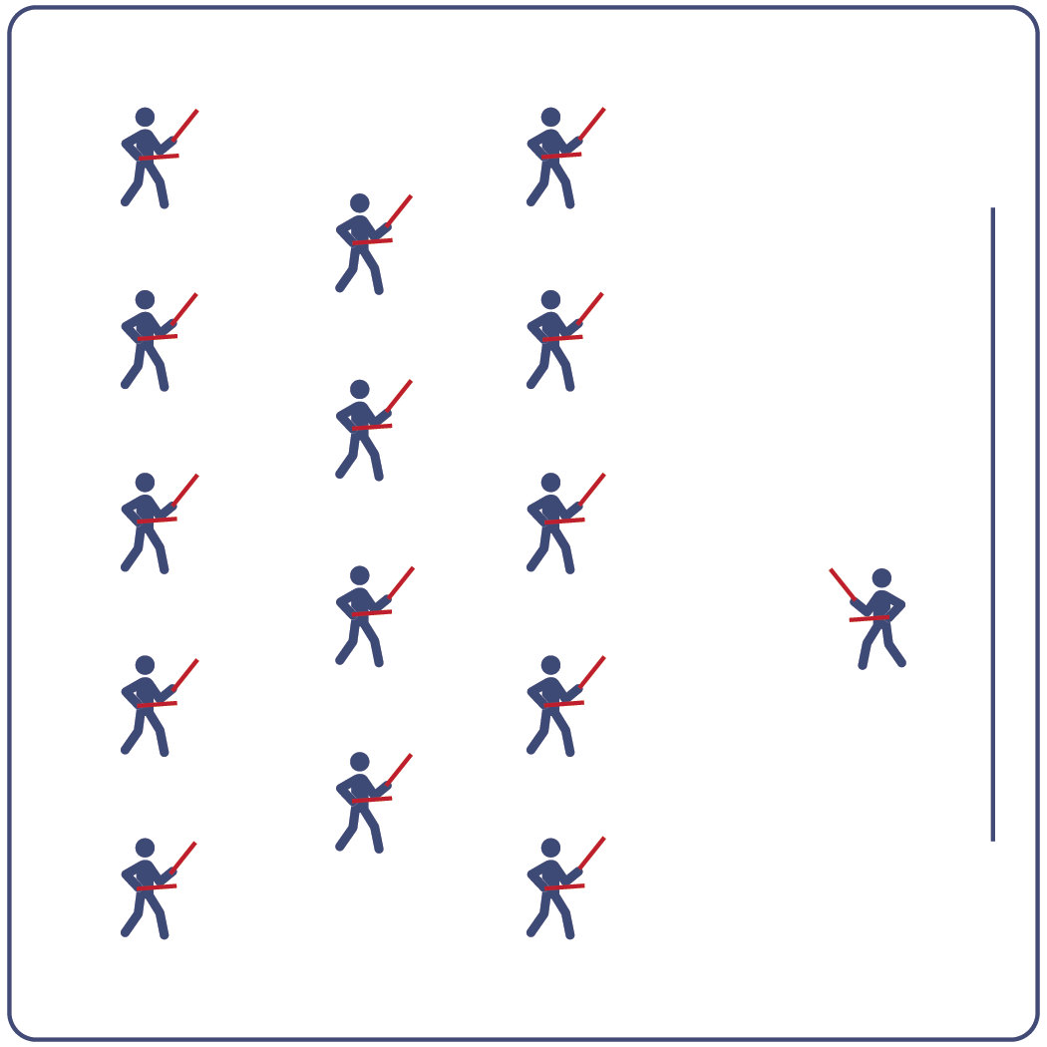
Equipment:
- Computer or tablet to play video
- Projector and screen (or wall to project on)
- Lummi Sticks or pool noodles for each student
- Spot markers for each student
- Hip Hop Feet Routine Card
- Video: Hip Hop Feet Rhythm Fit Routine (YouTube)

Set-Up:
- Arrange spot markers in rows, with enough space for all students to move side to side.
- Have technology set up to project the video for students (with sound).

ACTIVITY PROCEDURES
- This activity is a beginner Rhythm Fit routine called Hip Hop Feet.
- The object of this routine is to identify your motivation to try new things and discuss ways to increase your engagement in this activity.
- When the video begins, you will follow along working to perform movements with the beat and tempo of the music.
- Teachers: you can teach the movement sequences using the routine card prior to playing the video.

GRADE LEVEL PROGRESSION
- Grades K-2: Try this activity with students sitting on the floor and using pool noodles (instead of Lummi sticks).
- Grades 3-5: Perform the activity as described above.
- Grades 6-8: Choose a few students to be in the front of the class to help demonstrate the routine and call out the sequences/counts from the routine card.

TEACHING CUES
- Cue 1: Listen and count with the beat of the music.
- Cue 2: Use equipment safely.
- Cue 3: If you get lost, jump back in on the next movement.

Hip Hop Feet (continued…)

UNIVERSAL DESIGN ADAPTATIONS
- UDL 1: Provide modified movements or equipment to make sure the activity is inclusive for all.
- UDL 2: Provide noise canceling headphones to reduce the volume of noise the equipment will make.
- UDL 3: Display the routine sequence card.

ACADEMIC LANGUAGE
Rhythm, Click, Beat, Engagement, Motivation

PRIORITY OUTCOMES
Non-Locomotor Skills:
- Refines non-locomotor skills specific to improve performance in dance, fitness, and sport activities.
Personal Responsibility & Safety:
- Follows directions for safe participation and proper use of equipment without reminders.
Social Interaction:
- Describes the positive social interactions that come when engaged with others in physical activity.

DEBRIEF QUESTIONS
Cognitive Question Set:
- DOK 1: Can you remember some of the sequences and cues for this routine?
- DOK 2: What did you notice about the sequence of choreography for this routine?
- DOK 3: Since the movements follow the same order every time, how could you know when to do the next movement if the teacher did not call it out for you?

Social & Emotional Question Set:
- DOK 1: Name a person whose engagement improves your school community.
- DOK 2: What skills or qualities does that person contribute?
- DOK 3: What skills or qualities do you have to contribute to your school community?

