Coastin’
beginner

STUDENT TARGETS
- Skill: I will perform the choreography of this routine to the correct beat and tempo.
- Cognitive: I will perform the correct movements and sequences on cue.
- Fitness: I will stay actively engaged in this activity in order to increase my heart rate.
- Social/Emotional: I will recognize and respond appropriately to challenges.

EQUIPMENT & SET-UP | 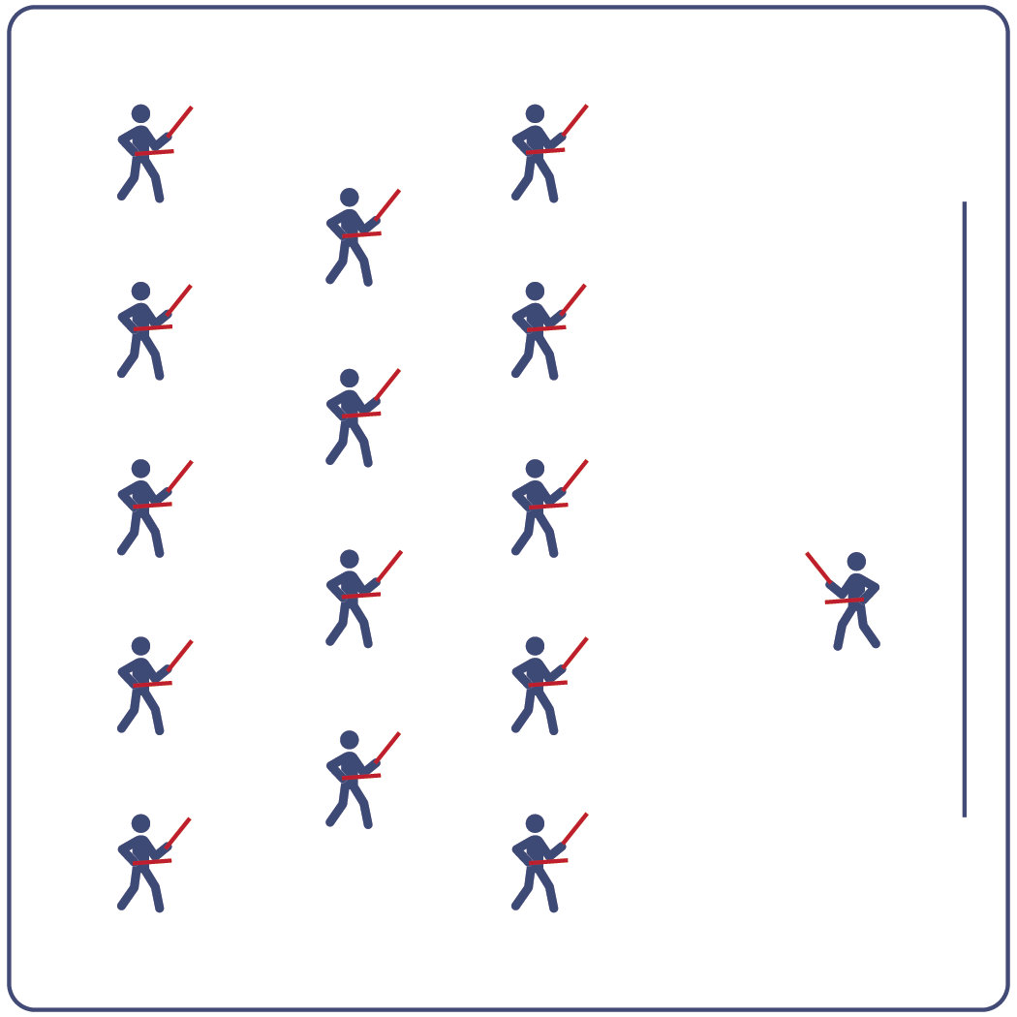
Equipment:
- Computer or tablet to play video
- Projector and screen (or wall to project on)
- Lummi sticks or pool noodles for each student
- Spot Markers for each student
- Coastin’ Routine Card
- Video: Coastin’ Rhythm Fit Routine (YouTube)

Set-Up:
- Arrange spot markers in rows, with enough space for all students to move side to side.
- Have technology set up to project the video for students (with sound).

ACTIVITY PROCEDURES
- This activity is a beginner Rhythm Fit routine called Coastin’.
- The object of this routine is to focus on being responsible and setting a good example for your classmates. You can do that by demonstrating positive characteristics and respect towards them.
- When the video begins, you will follow along working to perform movements with the beat and tempo of the music.
- Teachers: you can teach the movement sequences using the routine card prior to playing the video.

GRADE LEVEL PROGRESSION
- Grades K-2: Try this activity with students sitting on the floor using pool noodles (instead of Lummi sticks).
- Grades 3-5: Perform the activity as described above.
- Grades 6-8: Choose a few students to be in the front of the class to help demonstrate the routine and call out the sequences/counts from the routine card.

TEACHING CUES
- Cue 1: Listen and count with the beat of the music.
- Cue 2: Use equipment safely.
- Cue 3: If you get lost, jump back in on the next movement.

Coastin’ (continued…)

UNIVERSAL DESIGN ADAPTATIONS
- UDL 1: Provide modified movements or equipment to make sure the activity is inclusive for all.
- UDL 2: Provide noise canceling headphones to reduce the volume of noise the equipment will make.
- UDL 3: Display the routine sequence card.

ACADEMIC LANGUAGE
Responsible, Example, Tempo, Choreography

PRIORITY OUTCOMES
Social Interaction:
- Describes the social benefits gained from participating in physical activity.
Personal Enjoyment:
- Describes how moving competently creates enjoyment and self-expression.
Personal Responsibility & Safety:
- Follows directions for safe participation and proper use of equipment without reminders.

DEBRIEF QUESTIONS
Cognitive Question Set:
- DOK 1: Can you describe the pattern of movements we used in this routine?
- DOK 2: What did you notice about the way the music fit together with the choreography for this routine?
- DOK 3: Do you think that the way the beats of the music fit together with the movements could help with learning other routines as well? How so?

Social & Emotional Question Set:
- DOK 1: Name 1 younger person that you know who you would like to set a good example for.
- DOK 2: Ten years into the future, what do you hope that person says when they are asked to describe you?

