Jump-N-Kick
intermediate

STUDENT TARGETS
- Skill: I will demonstrate the movements with the correct rhythm and in the correct sequence.
- Cognitive: I will perform the order and sequence of the routine by memory.
- Fitness: I will actively engage for the duration of the routine.
- Social/Emotional: I will demonstrate patience with myself and others as we learn this routine.

EQUIPMENT & SET-UP | 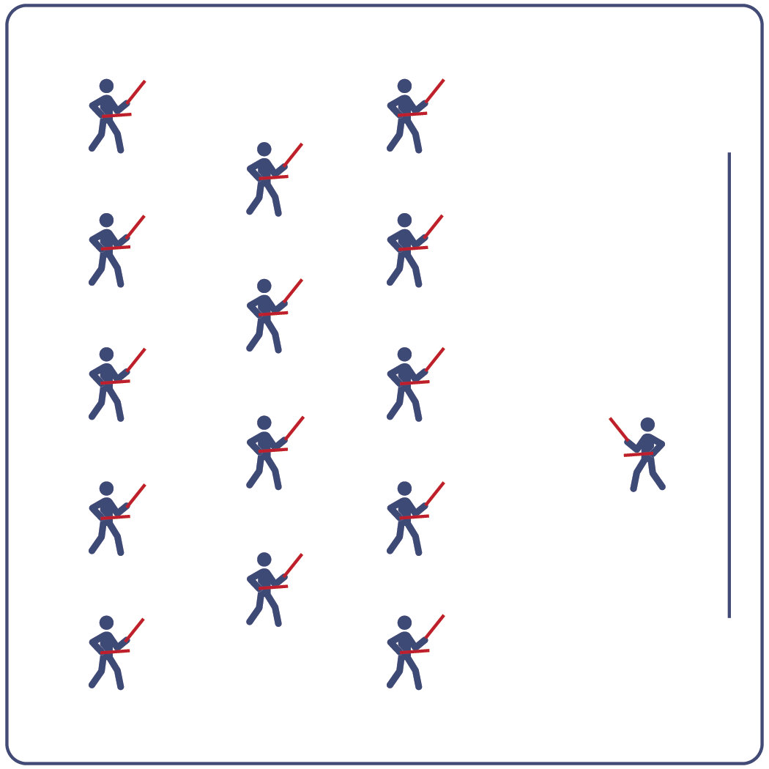
Equipment:
- Computer or tablet to play video
- Projector and screen (or wall to project on)
- Lummi sticks or pool noodles for each student
- Spot markers for each student
- Jump-N-Kick Routine Card
- Video: Jump-N-Kick Rhythm Fit Routine (YouTube)

Set-Up:
- Arrange spot markers in rows, with enough space for all students to move side to side.
- Have technology set up to project the video for students (with sound).

ACTIVITY PROCEDURES
- This activity is an intermediate Rhythm Fit routine called Jump-N-Kick.
- The object of this routine is to be a leader for your classmates if they are struggling with the routine and to try and reach your full potential.
- When the video begins, you will follow along working to perform movements with the beat and tempo of the music.
- Teachers: you can teach the movement sequences using the routine card prior to playing the video.

GRADE LEVEL PROGRESSION
- Grades K-2: Try this activity with students sitting on the floor using pool noodles (instead of Lummi sticks).
- Grades 3-5: Perform the activity as described above.
- Grades 6-8: Choose a few students to be in the front of the class to help demonstrate the routine and call out the sequences/counts from the routine card.

TEACHING CUES
- Cue 1: Listen and count with the beat of the music.
- Cue 2: Use equipment safely.
- Cue 3: If you get lost, jump back in on the next movement.

Jump-N-Kick (continued…)

UNIVERSAL DESIGN ADAPTATIONS
- UDL 1: Provide modified movements or equipment to make sure the activity is inclusive for all.
- UDL 2: Provide noise canceling headphones to reduce the volume of noise the equipment will make.
- UDL 3: Display the routine sequence card.

ACADEMIC LANGUAGE
Leader, Potential, Movement, Actively Engage

PRIORITY OUTCOMES
Etiquette:
- Identifies the rules and etiquette for physical activities/games and dance activities.
Personal Enjoyment:
- Describes positive feelings that result from physical activity participation.
Personal Responsibility & Safety:
- Engages in physical activity with responsible interpersonal behavior (e.g., peer to peer, student to teacher).

DEBRIEF QUESTIONS
Cognitive Question Set:
- DOK 1: Can you remember some of the movements used for this routine?
- DOK 2: How did the music affect how you moved during this routine?
- DOK 3: What did you notice about how the beat and tempo impacted the movement choices used in this routine?

Social & Emotional Question Set:
- DOK 1: Name a time that you used your talents and abilities to reach a goal.
- DOK 2: What does being a leader look like?
- DOK 3: Give an example of a time you thought someone was being a leader. Explain why you thought their actions showed leadership.

