Run It Back
intermediate

STUDENT TARGETS
- Skill: I will perform movements with the beat and tempo of the music.
- Cognitive: I will perform the correct movements and sequences on cue.
- Fitness: I will increase and sustain my heart rate for the duration of the routine.
- Social/Emotional: I will demonstrate respect for the special and unique qualities of others.

EQUIPMENT & SET-UP | 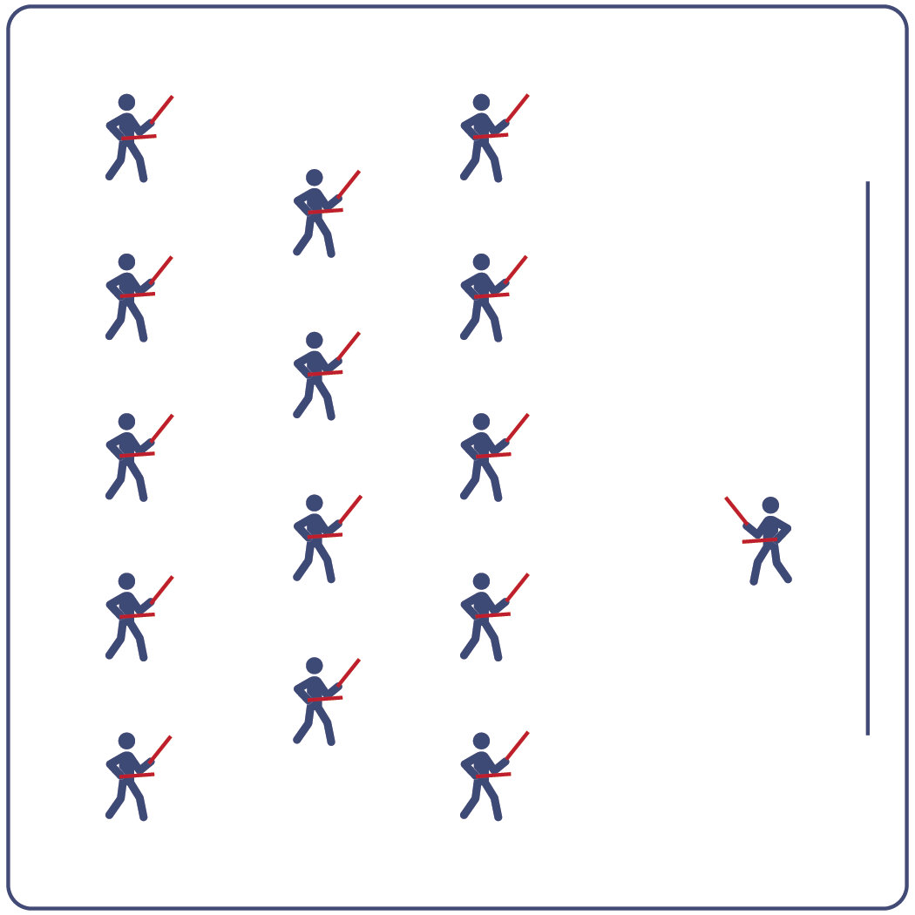
Equipment:
- Computer or tablet to play video
- Projector and screen (or wall to project on)
- Lummi sticks or pool noodles for each student
- Spot markers for each student
- Run It Back Routine Card
- Video: Run It Back Rhythm Fit Routine (YouTube)

Set-Up:
- Arrange spot markers in rows, with enough space for all students to move side to side.
- Have technology set up to project the video for students (with sound).

ACTIVITY PROCEDURES
- This activity is an intermediate Rhythm Fit routine called Run It Back.
- The object of this routine is to focus on sharing your enthusiasm while learning and performing the routine and valuing the powerful influence you all have on others.
- When the video begins, you will follow along working to perform movements with the beat and tempo of the music.
- Teachers: you can teach the movement sequences using the routine card prior to playing the video.

GRADE LEVEL PROGRESSION
- Grades K-2: Try this activity with students sitting on the floor using pool noodles (instead of Lummi sticks).
- Grades 3-5: Perform the activity as described above.
- Grades 6-8: Choose a few students to be in the front of the class to help demonstrate the routine and call out the sequences/counts from the routine card.

TEACHING CUES
- Cue 1: Listen and count with the beat of the music.
- Cue 2: Use equipment safely.
- Cue 3: If you get lost, jump back in on the next movement.

Run It Back (continued…)

UNIVERSAL DESIGN ADAPTATIONS
- UDL 1: Provide modified movements or equipment to make sure the activity is inclusive for all.
- UDL 2: Provide noise canceling headphones to reduce the volume of noise the equipment will make.
- UDL 3: Display the routine sequence card.

ACADEMIC LANGUAGE
Powerful, Share, Combination, Enjoyment

PRIORITY OUTCOMES
Social Interaction:
- Describes the social benefits gained from participating in physical activity.
Personal Enjoyment:
- Explains the relationship between self-expression and lifelong enjoyment of physical activity.
Personal Responsibility & Safety:
- Works independently and safely in physical education.

DEBRIEF QUESTIONS
Cognitive Question Set:
- DOK 1: Can you remember some of the movements and sequences from this routine?
- DOK 2: What did you notice about the sequence of choreography for this routine?
- DOK 3: If we changed the music used for this routine, would the movements need to be performed differently? If yes, how?

Social & Emotional Question Set:
- DOK 1: Describe a time in which you had a powerful impact on someone’s feelings.
- DOK 2: What did you do to make that impact?
- DOK 3: Why was that action so powerful?

