Hip Hop Feet
beginner

STUDENT TARGETS
- Skill: I will perform movements with the beat and tempo of the music.
- Cognitive: I will perform the order and sequence of the routine by memory.
- Fitness: I will increase and sustain my heart rate for the duration of the routine.
- Social/Emotional: I will demonstrate safe movement patterns and self-control in my actions.

EQUIPMENT & SET-UP | 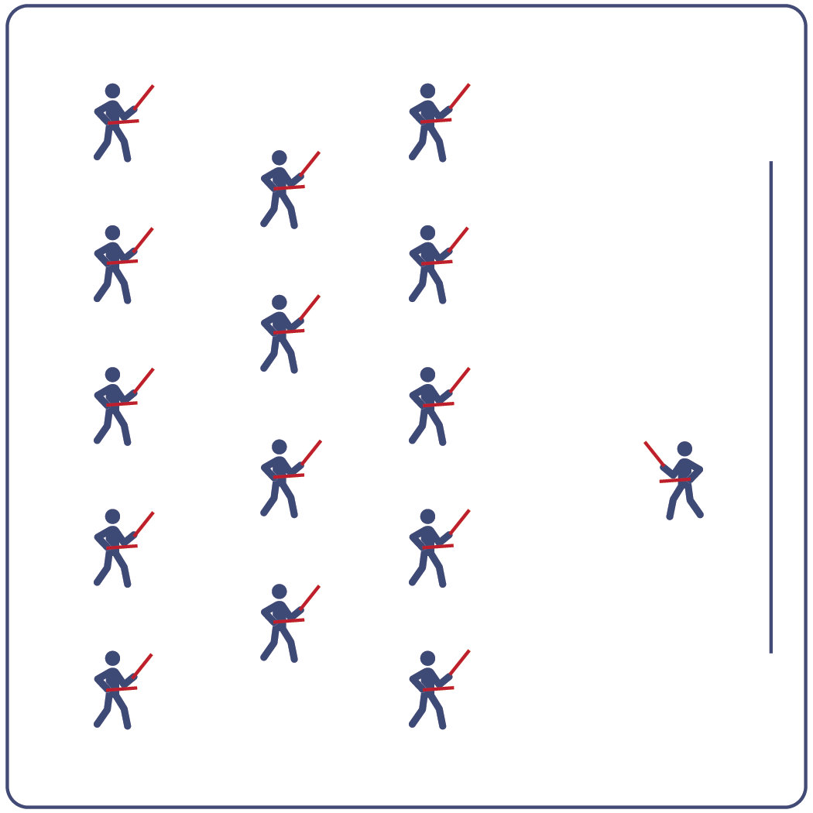
Equipment:
- Computer or tablet to play video
- Projector and screen (or wall to project on)
- Lummi Sticks or pool noodles for each student
- Spot markers for each student
- Hip Hop Feet Routine Card
- Video: Hip Hop Feet Rhythm Fit Routine (YouTube)

Set-Up:
- Arrange spot markers in rows, with enough space for all students to move side to side.
- Have technology set up to project the video for students (with sound).

ACTIVITY PROCEDURES
- This activity is a beginner Rhythm Fit routine called Hip Hop Feet.
- The object of this routine is to identify your motivation to try new things and discuss ways to increase your engagement in this activity.
- When the video begins, you will follow along working to perform movements with the beat and tempo of the music.
- Teachers: you can teach the movement sequences using the routine card prior to playing the video.

GRADE LEVEL PROGRESSION
- Grades K-2: Try this activity with students sitting on the floor and using pool noodles (instead of Lummi sticks).
- Grades 3-5: Perform the activity as described above.
- Grades 6-8: Choose a few students to be in the front of the class to help demonstrate the routine and call out the sequences/counts from the routine card.

TEACHING CUES
- Cue 1: Listen and count with the beat of the music.
- Cue 2: Use equipment safely.
- Cue 3: If you get lost, jump back in on the next movement.

Hip Hop Feet (continued…)

UNIVERSAL DESIGN ADAPTATIONS
- UDL 1: Provide modified movements or equipment to make sure the activity is inclusive for all.
- UDL 2: Provide noise canceling headphones to reduce the volume of noise the equipment will make.
- UDL 3: Display the routine sequence card.

ACADEMIC LANGUAGE
Rhythm, Click, Beat, Engagement, Motivation

PRIORITY OUTCOMES
Non-Locomotor Skills:
- Refines non-locomotor skills specific to improve performance in dance, fitness, and sport activities.
Personal Responsibility & Safety:
- Follows directions for safe participation and proper use of equipment without reminders.
Social Interaction:
- Describes the positive social interactions that come when engaged with others in physical activity.

DEBRIEF QUESTIONS
Cognitive Question Set:
- DOK 1: Can you remember some of the sequences and cues for this routine?
- DOK 2: What did you notice about the sequence of choreography for this routine?
- DOK 3: Since the movements follow the same order every time, how could you know when to do the next movement if the teacher did not call it out for you?

Social & Emotional Question Set:
- DOK 1: Name a person whose engagement improves your school community.
- DOK 2: What skills or qualities does that person contribute?
- DOK 3: What skills or qualities do you have to contribute to your school community?

Coastin’
beginner

STUDENT TARGETS
- Skill: I will perform the choreography of this routine to the correct beat and tempo.
- Cognitive: I will perform the correct movements and sequences on cue.
- Fitness: I will stay actively engaged in this activity in order to increase my heart rate.
- Social/Emotional: I will recognize and respond appropriately to challenges.

EQUIPMENT & SET-UP
Equipment:
- Computer or tablet to play video
- Projector and screen (or wall to project on)
- Lummi sticks or pool noodles for each student
- Spot Markers for each student
- Coastin’ Routine Card
- Video: Coastin’ Rhythm Fit Routine (YouTube)

Set-Up:
- Arrange spot markers in rows, with enough space for all students to move side to side.
- Have technology set up to project the video for students (with sound).

ACTIVITY PROCEDURES
- This activity is a beginner Rhythm Fit routine called Coastin’.
- The object of this routine is to focus on being responsible and setting a good example for your classmates. You can do that by demonstrating positive characteristics and respect towards them.
- When the video begins, you will follow along working to perform movements with the beat and tempo of the music.
- Teachers: you can teach the movement sequences using the routine card prior to playing the video.

GRADE LEVEL PROGRESSION
- Grades K-2: Try this activity with students sitting on the floor using pool noodles (instead of Lummi sticks).
- Grades 3-5: Perform the activity as described above.
- Grades 6-8: Choose a few students to be in the front of the class to help demonstrate the routine and call out the sequences/counts from the routine card.

TEACHING CUES
- Cue 1: Listen and count with the beat of the music.
- Cue 2: Use equipment safely.
- Cue 3: If you get lost, jump back in on the next movement.

Coastin’ (continued…)

UNIVERSAL DESIGN ADAPTATIONS
- UDL 1: Provide modified movements or equipment to make sure the activity is inclusive for all.
- UDL 2: Provide noise canceling headphones to reduce the volume of noise the equipment will make.
- UDL 3: Display the routine sequence card.

ACADEMIC LANGUAGE
Responsible, Example, Tempo, Choreography

PRIORITY OUTCOMES
Social Interaction:
- Describes the social benefits gained from participating in physical activity.
Personal Enjoyment:
- Describes how moving competently creates enjoyment and self-expression.
Personal Responsibility & Safety:
- Follows directions for safe participation and proper use of equipment without reminders.

DEBRIEF QUESTIONS
Cognitive Question Set:
- DOK 1: Can you describe the pattern of movements we used in this routine?
- DOK 2: What did you notice about the way the music fit together with the choreography for this routine?
- DOK 3: Do you think that the way the beats of the music fit together with the movements could help with learning other routines as well? How so?

Social & Emotional Question Set:
- DOK 1: Name 1 younger person that you know who you would like to set a good example for.
- DOK 2: Ten years into the future, what do you hope that person says when they are asked to describe you?

Jump-N-Kick
intermediate

STUDENT TARGETS
- Skill: I will demonstrate the movements with the correct rhythm and in the correct sequence.
- Cognitive: I will perform the order and sequence of the routine by memory.
- Fitness: I will actively engage for the duration of the routine.
- Social/Emotional: I will demonstrate patience with myself and others as we learn this routine.

EQUIPMENT & SET-UP
Equipment:
- Computer or tablet to play video
- Projector and screen (or wall to project on)
- Lummi sticks or pool noodles for each student
- Spot markers for each student
- Jump-N-Kick Routine Card
- Video: Jump-N-Kick Rhythm Fit Routine (YouTube)

Set-Up:
- Arrange spot markers in rows, with enough space for all students to move side to side.
- Have technology set up to project the video for students (with sound).

ACTIVITY PROCEDURES
- This activity is an intermediate Rhythm Fit routine called Jump-N-Kick.
- The object of this routine is to be a leader for your classmates if they are struggling with the routine and to try and reach your full potential.
- When the video begins, you will follow along working to perform movements with the beat and tempo of the music.
- Teachers: you can teach the movement sequences using the routine card prior to playing the video.

GRADE LEVEL PROGRESSION
- Grades K-2: Try this activity with students sitting on the floor using pool noodles (instead of Lummi sticks).
- Grades 3-5: Perform the activity as described above.
- Grades 6-8: Choose a few students to be in the front of the class to help demonstrate the routine and call out the sequences/counts from the routine card.

TEACHING CUES
- Cue 1: Listen and count with the beat of the music.
- Cue 2: Use equipment safely.
- Cue 3: If you get lost, jump back in on the next movement.

Jump-N-Kick (continued…)

UNIVERSAL DESIGN ADAPTATIONS
- UDL 1: Provide modified movements or equipment to make sure the activity is inclusive for all.
- UDL 2: Provide noise canceling headphones to reduce the volume of noise the equipment will make.
- UDL 3: Display the routine sequence card.

ACADEMIC LANGUAGE
Leader, Potential, Movement, Actively Engage

PRIORITY OUTCOMES
Etiquette:
- Identifies the rules and etiquette for physical activities/games and dance activities.
Personal Enjoyment:
- Describes positive feelings that result from physical activity participation.
Personal Responsibility & Safety:
- Engages in physical activity with responsible interpersonal behavior (e.g., peer to peer, student to teacher).

DEBRIEF QUESTIONS
Cognitive Question Set:
- DOK 1: Can you remember some of the movements used for this routine?
- DOK 2: How did the music affect how you moved during this routine?
- DOK 3: What did you notice about how the beat and tempo impacted the movement choices used in this routine?

Social & Emotional Question Set:
- DOK 1: Name a time that you used your talents and abilities to reach a goal.
- DOK 2: What does being a leader look like?
- DOK 3: Give an example of a time you thought someone was being a leader. Explain why you thought their actions showed leadership.

Run It Back
intermediate

STUDENT TARGETS
- Skill: I will perform movements with the beat and tempo of the music.
- Cognitive: I will perform the correct movements and sequences on cue.
- Fitness: I will increase and sustain my heart rate for the duration of the routine.
- Social/Emotional: I will demonstrate respect for the special and unique qualities of others.

EQUIPMENT & SET-UP
Equipment:
- Computer or tablet to play video
- Projector and screen (or wall to project on)
- Lummi sticks or pool noodles for each student
- Spot markers for each student
- Run It Back Routine Card
- Video: Run It Back Rhythm Fit Routine (YouTube)

Set-Up:
- Arrange spot markers in rows, with enough space for all students to move side to side.
- Have technology set up to project the video for students (with sound).

ACTIVITY PROCEDURES
- This activity is an intermediate Rhythm Fit routine called Run It Back.
- The object of this routine is to focus on sharing your enthusiasm while learning and performing the routine and valuing the powerful influence you all have on others.
- When the video begins, you will follow along working to perform movements with the beat and tempo of the music.
- Teachers: you can teach the movement sequences using the routine card prior to playing the video.

GRADE LEVEL PROGRESSION
- Grades K-2: Try this activity with students sitting on the floor using pool noodles (instead of Lummi sticks).
- Grades 3-5: Perform the activity as described above.
- Grades 6-8: Choose a few students to be in the front of the class to help demonstrate the routine and call out the sequences/counts from the routine card.

TEACHING CUES
- Cue 1: Listen and count with the beat of the music.
- Cue 2: Use equipment safely.
- Cue 3: If you get lost, jump back in on the next movement.

Run It Back (continued…)

UNIVERSAL DESIGN ADAPTATIONS
- UDL 1: Provide modified movements or equipment to make sure the activity is inclusive for all.
- UDL 2: Provide noise canceling headphones to reduce the volume of noise the equipment will make.
- UDL 3: Display the routine sequence card.

ACADEMIC LANGUAGE
Powerful, Share, Combination, Enjoyment

PRIORITY OUTCOMES
Social Interaction:
- Describes the social benefits gained from participating in physical activity.
Personal Enjoyment:
- Explains the relationship between self-expression and lifelong enjoyment of physical activity.
Personal Responsibility & Safety:
- Works independently and safely in physical education.

DEBRIEF QUESTIONS
Cognitive Question Set:
- DOK 1: Can you remember some of the movements and sequences from this routine?
- DOK 2: What did you notice about the sequence of choreography for this routine?
- DOK 3: If we changed the music used for this routine, would the movements need to be performed differently? If yes, how?

Social & Emotional Question Set:
- DOK 1: Describe a time in which you had a powerful impact on someone’s feelings.
- DOK 2: What did you do to make that impact?
- DOK 3: Why was that action so powerful?

Cross & Dip
advanced

STUDENT TARGETS
- Skill: I will demonstrate the movements with the correct rhythm and in the correct sequence.
- Cognitive: I will perform the order and sequence of the routine by memory.
- Fitness: I will stay actively engaged in this activity in order to increase my heart rate. Social/Emotional: I will demonstrate perseverance and have a growth mindset when learning this routine.

EQUIPMENT & SET-UP
Equipment:
- Computer or tablet to play video
- Projector and screen (or wall to project on)
- Lummi sticks or pool noodles for each student
- Spot markers for each student
- Cross & Dip Routine Card
- Video: Cross & Dip Rhythm Fit Routine
  - Performed Standing (YouTube)
  - Performed Sitting (YouTube)

Set-Up:
- Arrange spot markers in rows, with enough space for all students to move side to side.
- Have technology set up to project the video for students (with sound).

ACTIVITY PROCEDURES
- This activity is an advanced Rhythm Fit routine called Cross & Dip.
- The object of this routine is to focus on showing support to your classmates while practicing the sequences and ensuring emotional safety of all while learning and performing this routine.
- When the video begins, you will follow along working to perform movements with the beat and tempo of the music.
- Teachers: you can teach the movement sequences using the routine card prior to playing the video.

GRADE LEVEL PROGRESSION
- Grades K-2: Try this activity with students sitting on the floor using pool noodles (instead of Lummi sticks).
- Grades 3-5: Perform the activity as described above.
- Grades 6-8: Choose a few students to be in the front of the class to help demonstrate the routine and call out the sequences/counts from the routine card.

TEACHING CUES
- Cue 1: Listen and count with the beat of the music.
- Cue 2: Use equipment safely.
- Cue 3: If you get lost, jump back in on the next movement.

Cross & Dip (continued…)

UNIVERSAL DESIGN ADAPTATIONS
- UDL 1: Provide modified movements or equipment to make sure the activity is inclusive for all.
- UDL 2: Provide noise canceling headphones to reduce the volume of noise the equipment will make.
- UDL 3: Display the routine sequence card.

ACADEMIC LANGUAGE
Support, Safety, Pattern, Practice

PRIORITY OUTCOMES
Personal Challenge:
- Discusses the challenge that comes from learning new physical activities.
Personal Responsibility & Safety:
- Works independently and safely in physical activity settings.
Working with Others:
- Accepts responsibility for class protocols with personal and cooperative behavior as well as performance actions.

DEBRIEF QUESTIONS
Cognitive Question Set:
- DOK 1: Can you remember some of the movements used in this routine?
- DOK 2: Can you describe how the music made you feel when it started to play?
- DOK 3: How were the movements related to the beat and tempo of the music?

Social & Emotional Question Set:
- DOK 1: What is an example of something that can help you feel emotionally safe?
- DOK 2: What can you do for your classmates, friends, and family members to help them feel emotional safety?

