BALANCING ACT

STUDENT TARGETS
- Skill: I will use focused control to balance the beanbag on the paddle while I walk.
- Cognitive: I will demonstrate growth mindset by allowing myself to fail fast and try again.
- Fitness: I will be actively engaged in this Minute to Win challenge.
- Social/Emotional: I will use positive and encouraging communication with my teammates.

EQUIPMENT & SET-UP | 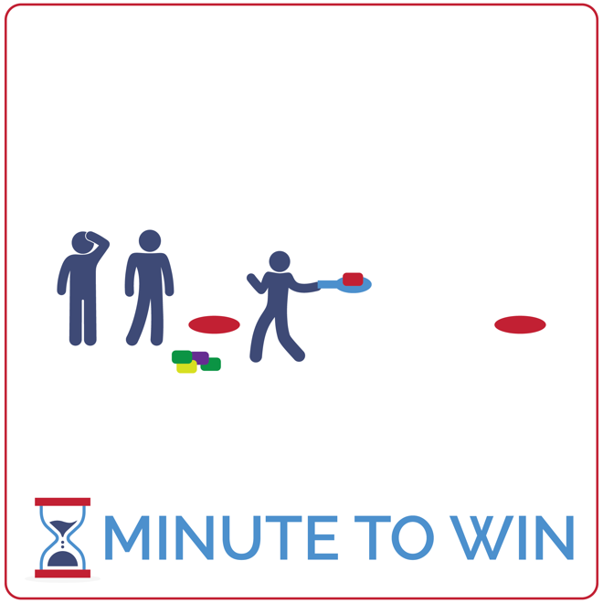
Equipment:
- 1 paddle per team of 3
- 5 beanbags per team
- 2 low profile cones per team
- 1-Minute Timer Music (Spotify, Apple)

Set-Up:
- Create teams of 3 players.
- Create 2 lines of low-profile cones with a cone on each side of the activity area.
- Each team lines up behind a cone with a paddle and a pile of 5 beanbags.
ACTIVITY PROCEDURES
- This activity is called Balancing Act! The object of the game is to see how many successful laps around your team’s cone you can complete in 1 minute.
- Get ready with 1 teammate at the front of the line with 1 beanbag balanced on a paddle. The other 2 teammates are in a file line behind the leader.
- On the start signal, walk in a file line around the opposite cone being careful not to drop the beanbag.
- As soon as you’re back at your starting cone, the leader passes the paddle to the next teammate in line while the teammate at the end of the line picks up another beanbag and stacks it on the paddle. Your team must now walk down around the opposite cone while the new leader balances 2 beanbags on the paddle. This continues for the full 1 minute. If your team stacks all 5 beanbags on the paddle, continue counting laps until you hear the stop signal.
- If a beanbag drops at any time, your team must return to the starting cone without counting that lap.

GRADE LEVEL PROGRESSION
- Grade 3: Play the game with only 1 beanbag per team. They must balance and pass the paddle, but not stack additional beanbags.
- Grades 4 & 5: Play the activity as described above.

TEACHING CUES
- Fail Fast: If a beanbag drops, don’t fuss. Quickly continue to the start and learn from the error.
- Focus on the Challenge: Actively focus on the challenge you’re facing. Avoid distractions.
- Be Positive: Help your teammates fail fast and focus by using encouraging words and statements.

BALANCING ACT (continued…)

UNIVERSAL DESIGN ADAPTATIONS
- UDL 1: Do not stack bean bags. Keep the challenge to walking with 1 bag on the paddle.
- UDL 2: Remove the time challenge and focus on successful movement.
- UDL 3: Provide clearly marked paths between cones using brightly colored spot markers.

ACADEMIC LANGUAGE
Growth Mindset, Failure, Challenge

PRIORITY OUTCOMES
Personal Challenge:
- (Grade 3) Discusses the challenge that comes from learning new physical activities.
- (Grade 4) Rates the enjoyment of participating in challenging and mastered physical activities.
- (Grade 5) Expresses the enjoyment and challenge of participating in a favorite physical activity.

DEBRIEF QUESTIONS
Growth Mindset Question Set:
- DOK 1: What is growth mindset?
- DOK 2: What does it mean to Fail Fast?
- DOK 3: How is failing related to learning? How is it related to growth mindset?

Teamwork Question Set:
- DOK 1: What is positive communication? What does it sound like?
- DOK 2: How does positive communication impact the way a team works together?
- DOK 3: What are specific examples of how you used positive communication with your teammates in today’s activity?

