CONE CATCHER

STUDENT TARGETS
- Skill: I will use correct form for an underhand toss.
- Cognitive: I will focus my attention on the challenge in an effort to improve my team’s score.
- Fitness: I will be actively engaged in this Minute to Win challenge.
- Social/Emotional: I will use positive and encouraging communication with my teammates.

EQUIPMENT & SET-UP | 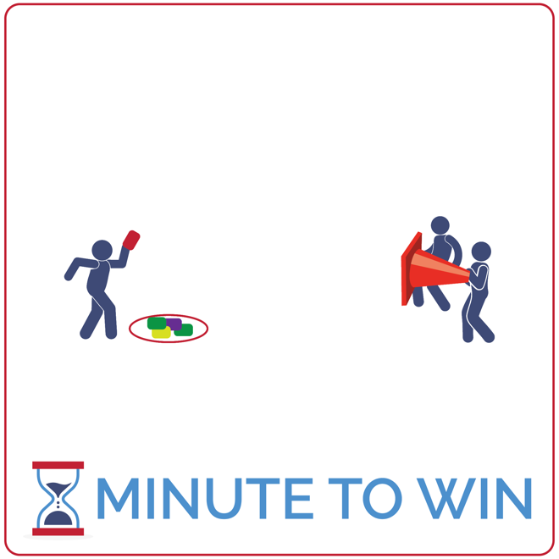
Equipment:
- 1 large game cone per team of 3
- 5 to 10 beanbags per team
- 1 hoop per team
- 1-Minute Timer Music (Spotify, Apple)

Set-Up:
- Create teams of 3 players.
- Each team has space with beanbags placed in a hoop and a cone 5 paces away from the hoop.
- One teammate is the tosser and stands behind the hoop and beanbags.
- The other two teammates are cone holders and stand 5 paces away with the cone opening facing the tosser.
ACTIVITY PROCEDURES
- This activity is called Cone Catcher! The object of the game is for your team to use the cone to catch as many beanbags as you can in 1 minute.
- Get ready with 2 players holding a cone, and 1 player 5 paces away, ready to toss the beanbag into the cone.
- On the start signal, the tosser makes the first toss and quickly picks up another beanbag for another toss. The cone holders count catches aloud to keep track of the score.
- Cone holders can move the cone to help the tosser and make the catch. If your team tosses all of your beanbags successfully in the cone before time expires, cone holders quickly dump the beanbags back into position and play continues. Beanbags that miss the cone and fall to the ground can be collected and tossed again.
- Repeat this challenge with students focused on improvement.

GRADE LEVEL PROGRESSION
- Grade 3: Play the activity as described above.
- Grades 4 & 5: With skilled players, increase the distance between the tosser and the cone.

TEACHING CUES
- Stay Focused: Tossers and cone holders must all stay focued on the goal of tossing and catching.
- Step with Opposite Foot: Step to target with opposite foot. Toss underhand with tick-tock motion.
- Cooperate: Communicate with positive language. Work together to continually improve.

CONE CATCHER (continued…)

UNIVERSAL DESIGN ADAPTATIONS
- UDL 1: Allow students to prop the cone either on the floor or using a desk.
- UDL 2: Remove the time challenge and focus on successful movement.
- UDL 3: Use a larger target – like a hula hoop.

ACADEMIC LANGUAGE
Growth Mindset, Failure, Challenge

PRIORITY OUTCOMES
Personal Challenge:
- (Grade 3) Discusses the challenge that comes from learning new physical activities.
- (Grade 4) Rates the enjoyment of participating in challenging and mastered physical activities.
- (Grade 5) Expresses the enjoyment and challenge of participating in a favorite physical activity.

DEBRIEF QUESTIONS
Growth Mindset Question Set:
- DOK 1: What are some words that you can think of that are related to growth mindset?
- DOK 2: How does growth mindset apply to practicing Minute To Win challenges?
- DOK 3: How can you apply growth mindset to other areas of your life?

Teamwork Question Set:
- DOK 1: What is teamwork? What does it look like? What does it sound like?
- DOK 2: How does teamwork affect how well your team performs in Minute to Win challenges?
- DOK 3: How does growth mindset affect how well you work with a team?

