HOOP IT UP

STUDENT TARGETS
- Skill: I will use correct form for an underhand toss. I will catch with 2 hands.
- Cognitive: I will focus my attention on the challenge in an effort to improve my team’s score.
- Fitness: I will be actively engaged in this Minute to Win challenge.
- Social/Emotional: I will use positive and encouraging communication with my teammates.

EQUIPMENT & SET-UP | 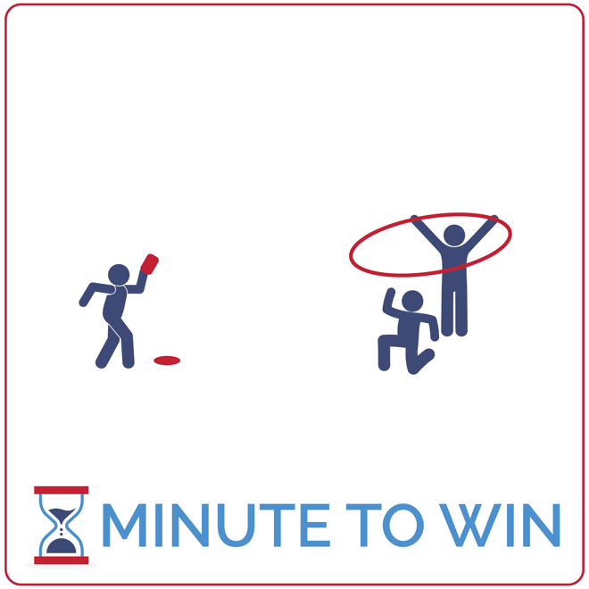
Equipment:
- 1 hoop per team of 3
- 1 beanbag (or foam ball) per team
- 1 low profile cone per team
- 1-Minute Timer Music (Spotify, Apple)

Set-Up:
- Create teams of 3 players.
- Each team has space with a beanbag placed next to a low profile cone – the cone and beanbag are 5 paces away from a hoop.
- One teammate is the tosser and stands behind the cone with the beanbag.
- One teammate is the hoop holder and the third teammate is the catcher – positioned under the hoop, ready to catch the toss.
ACTIVITY PROCEDURES
- This activity is called Hoop It Up. The object of this game is to toss the beanbag through the hoop as many times as you can in 1 minute. However, for a toss to count, the beanbag cannot hit the floor. It has to be caught by a teammate before hitting the ground.
- Get ready with one teammate holding the hoop, parallel to the ground. Another teammate is 5 paces away with a beanbag, ready to toss. A third teammate is positioned to catch the beanbag when it goes thought the hoop.
- On the start signal, the first toss is made. The teammate in position to catch the toss will grab the beanbag and quickly switch places with the tosser. This rotation continues with 2 teammates tossing and catching for the full minute.
- Count your score aloud each time a successful toss and catch is made. If a toss is not caught, or it doesn’t go through the hoop – continue with the rotation but do not count that toss in the score.
- Repeat this challenge with students focused on improvement.

GRADE LEVEL PROGRESSION
- Grades 3 & 4: Consider swapping beanbags with larger foam balls to increase success.
- Grade 5: Play the activity as described above.

TEACHING CUES
- Step with Opposite Foot: Step to target with opposite foot. Toss underhand with tick-tock motion.
- Transition Quickly: The tosser and catcher focus on quickly moving into position after a toss.
- Cooperate: Communicate with positive language. Work together to continually improve.

HOOP IT UP (continued…)

UNIVERSAL DESIGN ADAPTATIONS
- UDL 1: Allow the tossed object to fall to the floor before being picked up. Count all tosses as points.
- UDL 2: Change the distance between the tosser and the target.
- UDL 3: Remove the time challenge and focus on successful movement.

ACADEMIC LANGUAGE
Growth Mindset, Failure, Challenge

PRIORITY OUTCOMES
Personal Challenge:
- (Grade 3) Discusses the challenge that comes from learning new physical activities.
- (Grade 4) Rates the enjoyment of participating in challenging and mastered physical activities.
- (Grade 5) Expresses the enjoyment and challenge of participating in a favorite physical activity.

DEBRIEF QUESTIONS
Growth Mindset Question Set:
- DOK 1: What is a challenge? Can you give examples of a challenge that someone might face?
- DOK 2: How would you apply growth mindset to facing a challenge?
- DOK 3: Describe what someone might learn from facing a difficult challenge.

Teamwork Question Set:
- DOK 1: How did you demonstrate teamwork when you faced today’s challenge?
- DOK 2: How would you summarize your entire team’s performance today?
- DOK 3: How was teamwork related to that performance?

