SPINNER WINNER

STUDENT TARGETS
- Skill: I will spin my team’s hoop with attention to safety.
- Cognitive: I will remain focused the challenge and stay ready to rotate when it’s my turn to spin.
- Fitness: I will be actively engaged in this Minute to Win challenge.
- Social/Emotional: I will use positive and encouraging communication with my teammates.

EQUIPMENT & SET-UP | 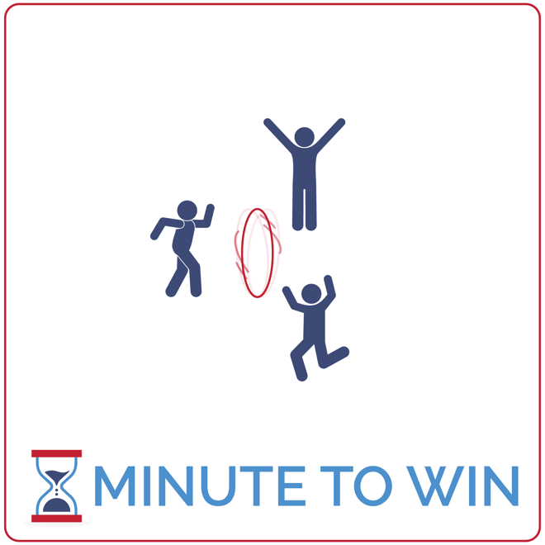
Equipment:
- 1 hoop per team of 3
- 1-Minute Timer Music (Spotify, Apple)

Set-Up:
- Create teams of 3 players.
- Each team has space with a hoop.
- Teammates determine who will spin first, second, and third.
- The first spinner stands with the hoop.
- The other teammates stand on the sides of the hoop ready to rotate.
ACTIVITY PROCEDURES
- This activity is called Spinner Winner. The object of the game is to spin your team’s hoop like a coin for as long as you can and end up with the fewest number of spins in 1 minute as possible.
- Get ready with one teammate ready to spin the hoop and the others on the sides of the hoop, ready to pick it up as soon as it stops spinning.
- On the start signal, one player spins the hoop. As soon as it drops and stops spinning, the next teammate will pick up the hoop and spin it again. When it stops again, the third teammate will pick it up and spin it.
- This rotation continues for the full minute. Count how many times you spin your hoop before the minute expires. Score 10 points with only 1 spin; 5 points with 2 spins; 3 points with 3 spins; and 1 point for 4 or more spins.
- Repeat this challenge with students focused on improvement.

GRADE LEVEL PROGRESSION
- Grades 3 & 4: Play the activity as described above.
- Grade 5: Increase the challenges by requiring all 3 players to work cooperatively to spin the hoop.

TEACHING CUES
- Spin from the Top: Keep the hoop upright and spin it by hand holding the top of the hoop.
- Transition Quickly: The players waiting to spin should be ready to move, pick up the hoop and spin.
- Cooperate: Communicate with positive language. Work together to continually improve.

SPINNER WINNER (continued…)

UNIVERSAL DESIGN ADAPTATIONS
- UDL 1: Play this activity with coins instead of hoops.
- UDL 2: Shorten the time from 1 minute to 30 seconds.
- UDL 3: Remove the time challenge and focus on successful movement.

ACADEMIC LANGUAGE
Feedback, Coachable, Support System

PRIORITY OUTCOMES
Personal Challenge:
- (Grade 3) Discusses the challenge that comes from learning new physical activities.
- (Grade 4) Rates the enjoyment of participating in challenging and mastered physical activities.
- (Grade 5) Expresses the enjoyment and challenge of participating in a favorite physical activity.

DEBRIEF QUESTIONS
Growth Mindset Question Set:
- DOK 1: What is feedback?
- DOK 2: What kind of feedback could you give to classmates who found spinning a hoop to be a challenge?
- DOK 3: How could you have improved your performance based on the feedback that you just heard?

Teamwork Question Set:
- DOK 1: Can you list positive and encouraging words that could be used to give someone feedback?
- DOK 2: Can you give an example of using positive communication to give feedback to a teammate?
- DOK 3: Can you predict how you’d react to a teammate who gave you feedback using positive communication versus someone who used negative language and communication?

