HOOP TOSS

STUDENT TARGETS
- Skill: I will toss the hoop with a focus on accuracy and safety.
- Cognitive: I will focus my attention on the challenge in an effort to improve my team’s score.
- Fitness: I will be actively engaged in this Minute to Win challenge.
- Social/Emotional: I will use positive and encouraging communication with my teammates.

EQUIPMENT & SET-UP | 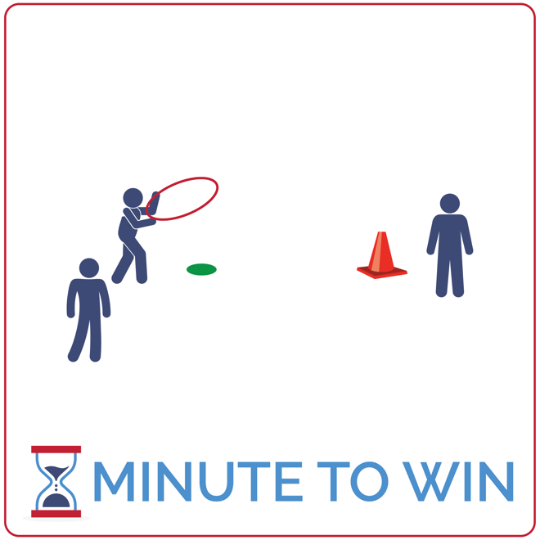
Equipment:
- 1 hoop per team of 3
- 1 large game cone per team
- 1 low-profile cone per team
- 1-Minute Timer Music (Spotify, Apple)

Set-Up:
- Create teams of 3 players.
- Each team has space with a hoop placed next to a low-profile cone – the cone and hoop are 5 paces away from a large game cone.
- One teammate is the tosser and stands behind the low-profile cone with the hoop.
- A second teammate is waiting to be the next tosser and the third is the retriever – standing next to the game cone.
ACTIVITY PROCEDURES
- This activity is called Hoop Toss. The object of the game is for your team to toss and land your hoop onto the cone as many times as you can in 1 minute.
- Get ready with one teammate holding the hoop 5 paces away from the cone. Another teammate will stand next to the first, and the third teammate will stand near the cone.
- On the start signal, the first player will toss the hoop. It must land on the hoop and be secure around it before it’s removed. Next, the player standing next to the cone will pick up the hoop and roll it back to the player who was waiting to become the next tosser. The tosser then rotates down to the cone and the next toss is thrown.
- Continue this rotation cycle until you hear the stop signal. Count each successful toss as a point.
- Repeat this challenge with students focused on improvement.

GRADE LEVEL PROGRESSION
- Grade 3: Remove the hoop roll and have students rotate quickly handing off the hoop from one player to the next.
- Grades 4 & 5: Play the activity as described above.

TEACHING CUES
- Up and Over: Use 2 hands to toss the hoop parallel to the ground, up and over the top of the cone.
- Rotate Quickly: All players stay ready to move and rotate quickly.
- Cooperate: Communicate with positive language. Work together to continually improve.

HOOP TOSS (continued…)

UNIVERSAL DESIGN ADAPTATIONS
- UDL 1: Use large hoops with smaller but stable cones.
- UDL 2: Decrease the distance between the tosser and the target.
- UDL 3: Remove the time challenge and focus on successful movement.

ACADEMIC LANGUAGE
Feedback, Coachable, Support System

PRIORITY OUTCOMES
Growth Mindset Challenge:
- (Grade 3) Discusses the challenge that comes from learning new physical activities.
- (Grade 4) Rates the enjoyment of participating in challenging and mastered physical activities.
- (Grade 5) Expresses the enjoyment and challenge of participating in a favorite physical activity.

DEBRIEF QUESTIONS
Cognitive Question Set:
- DOK 1: What does it mean to be coachable?
- DOK 2: Can you compare and contrast people who are coachable vs not coachable?
- DOK 3: How is being coachable related to growth mindset?

Teamwork Question Set:
- DOK 1: How can you recognize a coachable teammate?
- DOK 2: What is something that you can do to be more coachable?
- DOK 3: How is being coachable related to being a good teammate?

