CHOPSTICK NOODLES

STUDENT TARGETS
- Skill: I will carry the foam noodles with purpose and a focus on safety.
- Cognitive: I will focus my attention on the challenge in an effort to improve my team’s score.
- Fitness: I will be actively engaged in this Minute to Win challenge.
- Social/Emotional: I will use positive and encouraging communication with my teammates.

EQUIPMENT & SET-UP | 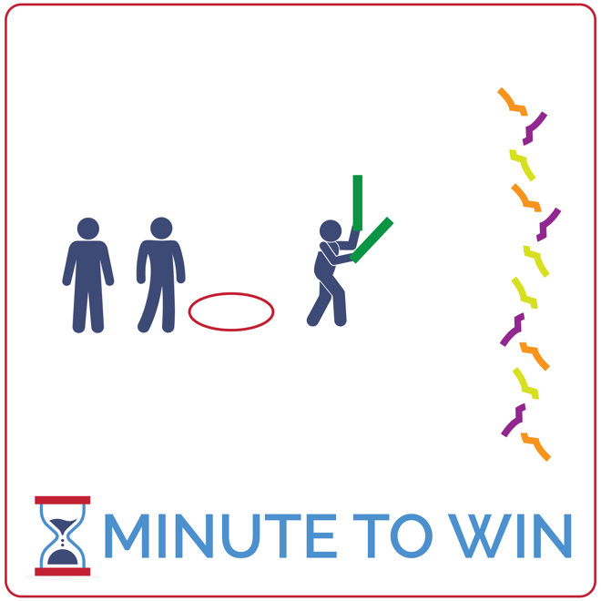
Equipment:
- 2 foam noodles per team of 3
- 1 hoop per team
- As many juggling scarves as possible. At least 6 per team.
- 1-Minute Timer Music (Spotify, Apple)

Set-Up:
- Create teams of 3 players.
- Line hoops along 1 side of the activity area with 2 noodles inside each hoop.
- Scatter juggling scarves along the opposite side of the activity area.
- Send each team of 3 to a hoop.
ACTIVITY PROCEDURES
- This activity is called Chopstick Noodles. The object of the game is for teams to collect as many scarves as they can using the foam noodles to pick up each scarf.
- Get ready with one teammate holding two foam noodles, ready to move to collect a scarf (1 at a time). The other two teammates are in relay race formation behind their team’s hoop.
- On the start signal, the player with the noodles will run to the opposite end of the activity area, use the noodles to pinch and pick up 1 scarf, and then return and place it in the hoop.
- If a player drops a scarf on the way to a hoop, just pick it back up and continue.
- Rotate using relay race formation with players taking turns collecting scarves. Each scarf is worth 1 point. Repeat this challenge with students focused on improvement.

GRADE LEVEL PROGRESSION
- Grade 3: Begin with player running and collecting scarves by hand and add the noodles when they’ve learned the activity procedures.
- Grades 4 & 5: Play the activity as described above.

TEACHING CUES
- Hold Halfway: Get a firm grip in the center of each noodle to help add solid leverage for pinching.
- Be Ready to Run: All players stay ready to quickly pass the noodles and take a turn.
- Cooperate: Communicate with positive language. Work together to continually improve.

CHOPSTICK NOODLES (continued…)

UNIVERSAL DESIGN ADAPTATIONS
- UDL 1: Replace noodles with an object that is easier to manipulate.
- UDL 2: Decrease the distance that students must travel holding the scarves.
- UDL 3: Remove the time challenge and focus on successful movement.

ACADEMIC LANGUAGE
Feedback, Coachable, Support System

PRIORITY OUTCOMES
Personal Challenge:
- (Grade 3) Discusses the challenge that comes from learning new physical activities.
- (Grade 4) Rates the enjoyment of participating in challenging and mastered physical activities.
- (Grade 5) Expresses the enjoyment and challenge of participating in a favorite physical activity.

DEBRIEF QUESTIONS
Growth Mindset Question Set:
- DOK 1: How would you describe a support network?
- DOK 2: How does having a support network affect your ability to overcome a challenge?
- DOK 3: What are the steps to building a support network?

Teamwork Question Set:
- DOK 1: What would it look like for you to be a part of the support network for your teammates?
- DOK 2: How can you apply what you’ve learned about growth mindset to being an active part of a support network for your teammates?
- DOK 3: How would your willingness to accept feedback impact your ability to receive help from a support network?

