EGG TOSS

STUDENT TARGETS
- Skill: I will focus on my bounce technique and repeat form and movements to find a consistent toss.
- Cognitive: I will focus my attention on the challenge in an effort to improve my team’s score.
- Fitness: I will be actively engaged in this Minute to Win challenge.
- Social/Emotional: I will use positive and encouraging communication with my teammates.

EQUIPMENT & SET-UP | 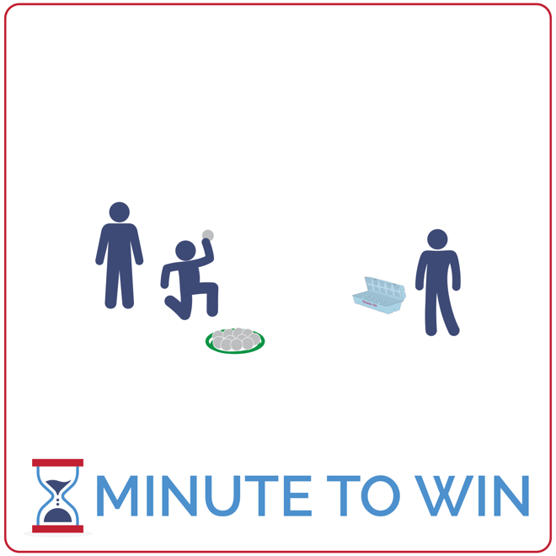
Equipment:
- 1 egg carton per team of 3
- 12 ping pong balls per team
- 1 flying disc per team
- 1-Minute Timer Music (Spotify, Apple)

Set-Up:
- Create teams of 3 players.
- Place egg cartons approximately 2 feet from each flying disc.
- Place 12 ping pong balls inside each disc.
- Send each team to a set of equipment.
ACTIVITY PROCEDURES
- This activity is called Egg Toss. The object of the game is to toss and bounce as many ping pong balls into your team’s egg carton as you can in 1 minute. Each teammate will take a turn for a full minute (3 rounds total). You’ll add the score from each round to get a final score.
- Get ready by sitting on the floor with an egg carton 2 feet in front of you (open). Ping pong balls are next to you sitting in an upside-down flying disc.
- On the start signal, toss and bounce the ball so that it lands inside of the egg carton. If you miss, your teammates can retrieve the ball and place it in the flying disc.
- Continue until you hear the stop signal. Then, prepare for the next teammate to have a turn.

GRADE LEVEL PROGRESSION
- Grade 3: Allow students to increase or decrease the distance from the egg carton.
- Grades 4 & 5: Play the activity as described above.

TEACHING CUES
- Practice Makes Perfect: Use practice tosses to find the perfect toss and bounce.
- Quickly Collect & Return: Teammates quickly retrieve balls that miss the target and return them to the team’s disc.
- Cooperate: Communicate with positive language. Work together to continually improve.

EGG TOSS (continued…)

UNIVERSAL DESIGN ADAPTATIONS
- UDL 1: Use a large bowl or box rather than an egg carton.
- UDL 2: Allow students with fine motor challenges to pick up and place the balls inside of the carton.
- UDL 3: Increase or remove the time challenge and focus on successful movement.

ACADEMIC LANGUAGE
Motivation, Inspiration, Celebrate

PRIORITY OUTCOMES
Personal Challenge:
- (Grade 3) Discusses the challenge that comes from learning new physical activities.
- (Grade 4) Rates the enjoyment of participating in challenging and mastered physical activities.
- (Grade 5) Expresses the enjoyment and challenge of participating in a favorite physical activity.

DEBRIEF QUESTIONS
Growth Mindset Question Set:
- DOK 1: What is motivation? What does it mean to be motivated?
- DOK 2: What people or things motivate you?
- DOK 3: How is a person’s motivation related to their performance?

Teamwork Question Set:
- DOK 1: What does a motivated team look like? What do they sound like?
- DOK 2: What’s the difference between a motivated team and a team who lacks motivation?
- DOK 3: If two teams have the same skills and abilities, but one team is very motivated and the other is not motivated, what do you think the outcome of a competition between the two would be? Support your answer with details.

