BALANCING SPOONS

STUDENT TARGETS
- Skill: I will use my peripheral vision to help balance the ping pong ball and walk safely to the disc.
- Cognitive: I will focus my attention on the challenge in an effort to improve my team’s score.
- Fitness: I will be actively engaged in this Minute to Win challenge.
- Social/Emotional: I will use positive and encouraging communication with my teammates.

EQUIPMENT & SET-UP | 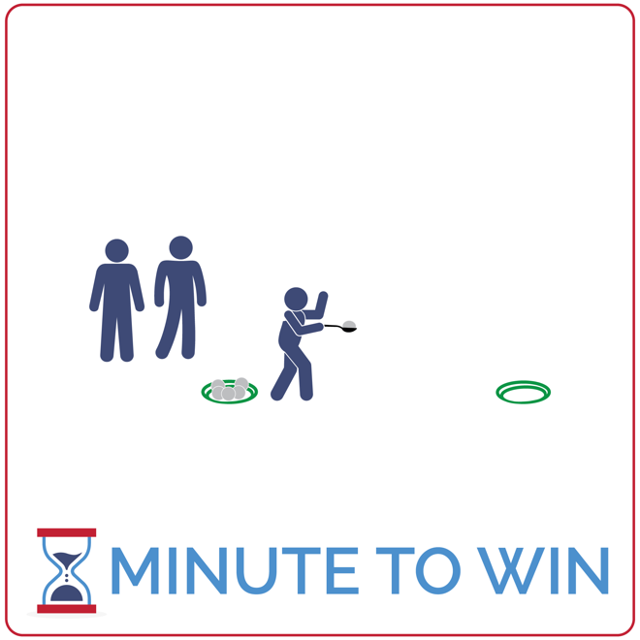
Equipment:
- 6 ping pong balls per team of 3
- 2 flying discs per team
- 1 spoon per team
- 1-Minute Timer Music (Spotify, Apple)

Set-Up:
- Create teams of 3 players.
- Create 2 lines of flying discs – each line on opposite ends of the activity area.
- Place 6 ping pong balls and 1 spoon in each starting disc.
- Teams line up relay race style behind the starting discs.
ACTIVITY PROCEDURES
- This activity is called Balancing Spoons. The object is to move as many ping pong balls as possible from one flying disc to another in 1 minute. You must use a spoon to transport each ball.
- This is a relay race challenge. Get ready with the first player in line standing behind the team cone, holding a ping pong ball in the spoon. Other teammates are behind the first player.
- On the start signal, player 1 will travel down to the team’s flying disc and carefully place the ball inside the disc before returning and passing the spoon to the next player. If a ball is dropped, pick it up and continue.
- The next player gets a ball from the disc and begins down to the opposite disc. This repeats until time runs out. If your team places all 6 balls into the opposite disc with time remaining, move to collect one at a time and return it back to the starting disc.
- Each ball moved is worth 1 point. Repeat this challenge with students focused on improvement.
GRADE LEVEL PROGRESSION
- Grade 3: Increase the size of the spoons used. Decrease the distance between flying discs.
- Grades 4 & 5: Play the activity as described above.
TEACHING CUES
- Use Your Vision: Look at the spoon when moving but also use your peripheral vision to stay straight and safe.
- Be Ready to Move: All players stay ready to quickly pass the spoon and take a turn.
- Cooperate: Communicate with positive language. Work together to continually improve.

BALANCING SPOONS (continued…)

UNIVERSAL DESIGN ADAPTATIONS
- UDL 1: Use double sided tape to help secure the ball to the spoons.
- UDL 2: Use large wooden spoons with deep indentations to increase success.
- UDL 3: Increase or remove the time challenge and focus on successful movement.

ACADEMIC LANGUAGE
Motivation, Inspiration, Celebrate

PRIORITY OUTCOMES
Personal Challenge:
- (Grade 3) Discusses the challenge that comes from learning new physical activities.
- (Grade 4) Rates the enjoyment of participating in challenging and mastered physical activities.
- (Grade 5) Expresses the enjoyment and challenge of participating in a favorite physical activity.

DEBRIEF QUESTIONS
Growth Mindset Question Set:
- DOK 1: How would you describe a celebration?
- DOK 2: Can you describe a time or moment when it’s appropriate to celebrate?
- DOK 3: How can a celebration help you improve and grow as a person?

Teamwork Question Set:
- DOK 1: How can you recognize a team who is celebrating together?
- DOK 2: How can a celebration affect motivation?
- DOK 3: Based on what you’ve learned about growth mindset – why might celebrating with others be beneficial to your personal growth?

