BALANCING ACT

STUDENT TARGETS
- Skill: I will use focused control to balance the beanbag on the paddle while I walk.
- Cognitive: I will demonstrate growth mindset by allowing myself to fail fast and try again.
- Fitness: I will be actively engaged in this Minute to Win challenge.
- Social/Emotional: I will use positive and encouraging communication with my teammates.

EQUIPMENT & SET-UP | 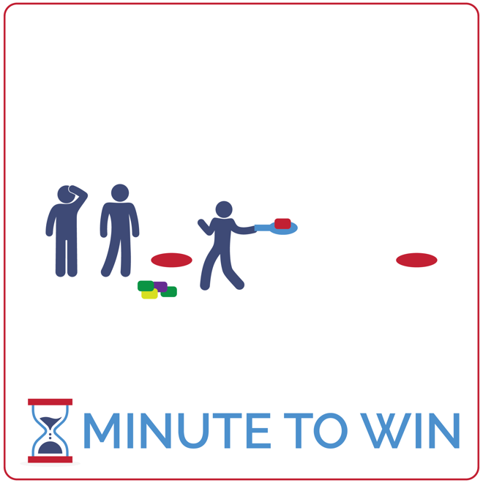
Equipment:
- 1 paddle per team of 3
- 5 beanbags per team
- 2 low profile cones per team
- 1-Minute Timer Music (Spotify, Apple)

Set-Up:
- Create teams of 3 players.
- Create 2 lines of low-profile cones with a cone on each side of the activity area.
- Each team lines up behind a cone with a paddle and a pile of 5 beanbags.
ACTIVITY PROCEDURES
- This activity is called Balancing Act! The object of the game is to see how many successful laps around your team’s cone you can complete in 1 minute.
- Get ready with 1 teammate at the front of the line with 1 beanbag balanced on a paddle. The other 2 teammates are in a file line behind the leader.
- On the start signal, walk in a file line around the opposite cone being careful not to drop the beanbag.
- As soon as you’re back at your starting cone, the leader passes the paddle to the next teammate in line while the teammate at the end of the line picks up another beanbag and stacks it on the paddle. Your team must now walk down around the opposite cone while the new leader balances 2 beanbags on the paddle. This continues for the full 1 minute. If your team stacks all 5 beanbags on the paddle, continue counting laps until you hear the stop signal.
- If a beanbag drops at any time, your team must return to the starting cone without counting that lap.

GRADE LEVEL PROGRESSION
- Grade 3: Play the game with only 1 beanbag per team. They must balance and pass the paddle, but not stack additional beanbags.
- Grades 4 & 5: Play the activity as described above.

TEACHING CUES
- Fail Fast: If a beanbag drops, don’t fuss. Quickly continue to the start and learn from the error.
- Focus on the Challenge: Actively focus on the challenge you’re facing. Avoid distractions.
- Be Positive: Help your teammates fail fast and focus by using encouraging words and statements.

BALANCING ACT (continued…)

UNIVERSAL DESIGN ADAPTATIONS
- UDL 1: Do not stack bean bags. Keep the challenge to walking with 1 bag on the paddle.
- UDL 2: Remove the time challenge and focus on successful movement.
- UDL 3: Provide clearly marked paths between cones using brightly colored spot markers.

ACADEMIC LANGUAGE
Growth Mindset, Failure, Challenge

PRIORITY OUTCOMES
Personal Challenge:
- (Grade 3) Discusses the challenge that comes from learning new physical activities.
- (Grade 4) Rates the enjoyment of participating in challenging and mastered physical activities.
- (Grade 5) Expresses the enjoyment and challenge of participating in a favorite physical activity.

DEBRIEF QUESTIONS
Growth Mindset Question Set:
- DOK 1: What is growth mindset?
- DOK 2: What does it mean to Fail Fast?
- DOK 3: How is failing related to learning? How is it related to growth mindset?

Teamwork Question Set:
- DOK 1: What is positive communication? What does it sound like?
- DOK 2: How does positive communication impact the way a team works together?
- DOK 3: What are specific examples of how you used positive communication with your teammates in today’s activity?

CONE CATCHER

STUDENT TARGETS
- Skill: I will use correct form for an underhand toss.
- Cognitive: I will focus my attention on the challenge in an effort to improve my team’s score.
- Fitness: I will be actively engaged in this Minute to Win challenge.
- Social/Emotional: I will use positive and encouraging communication with my teammates.

EQUIPMENT & SET-UP | 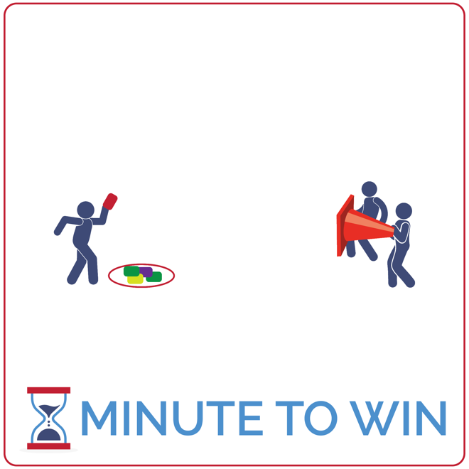
Equipment:
- 1 large game cone per team of 3
- 5 to 10 beanbags per team
- 1 hoop per team
- 1-Minute Timer Music (Spotify, Apple)

Set-Up:
- Create teams of 3 players.
- Each team has space with beanbags placed in a hoop and a cone 5 paces away from the hoop.
- One teammate is the tosser and stands behind the hoop and beanbags.
- The other two teammates are cone holders and stand 5 paces away with the cone opening facing the tosser.
ACTIVITY PROCEDURES
- This activity is called Cone Catcher! The object of the game is for your team to use the cone to catch as many beanbags as you can in 1 minute.
- Get ready with 2 players holding a cone, and 1 player 5 paces away, ready to toss the beanbag into the cone.
- On the start signal, the tosser makes the first toss and quickly picks up another beanbag for another toss. The cone holders count catches aloud to keep track of the score.
- Cone holders can move the cone to help the tosser and make the catch. If your team tosses all of your beanbags successfully in the cone before time expires, cone holders quickly dump the beanbags back into position and play continues. Beanbags that miss the cone and fall to the ground can be collected and tossed again.
- Repeat this challenge with students focused on improvement.

GRADE LEVEL PROGRESSION
- Grade 3: Play the activity as described above.
- Grades 4 & 5: With skilled players, increase the distance between the tosser and the cone.

TEACHING CUES
- Stay Focused: Tossers and cone holders must all stay focued on the goal of tossing and catching.
- Step with Opposite Foot: Step to target with opposite foot. Toss underhand with tick-tock motion.
- Cooperate: Communicate with positive language. Work together to continually improve.

CONE CATCHER (continued…)

UNIVERSAL DESIGN ADAPTATIONS
- UDL 1: Allow students to prop the cone either on the floor or using a desk.
- UDL 2: Remove the time challenge and focus on successful movement.
- UDL 3: Use a larger target – like a hula hoop.

ACADEMIC LANGUAGE
Growth Mindset, Failure, Challenge

PRIORITY OUTCOMES
Personal Challenge:
- (Grade 3) Discusses the challenge that comes from learning new physical activities.
- (Grade 4) Rates the enjoyment of participating in challenging and mastered physical activities.
- (Grade 5) Expresses the enjoyment and challenge of participating in a favorite physical activity.

DEBRIEF QUESTIONS
Growth Mindset Question Set:
- DOK 1: What are some words that you can think of that are related to growth mindset?
- DOK 2: How does growth mindset apply to practicing Minute To Win challenges?
- DOK 3: How can you apply growth mindset to other areas of your life?

Teamwork Question Set:
- DOK 1: What is teamwork? What does it look like? What does it sound like?
- DOK 2: How does teamwork affect how well your team performs in Minute to Win challenges?
- DOK 3: How does growth mindset affect how well you work with a team?

HOOP IT UP

STUDENT TARGETS
- Skill: I will use correct form for an underhand toss. I will catch with 2 hands.
- Cognitive: I will focus my attention on the challenge in an effort to improve my team’s score.
- Fitness: I will be actively engaged in this Minute to Win challenge.
- Social/Emotional: I will use positive and encouraging communication with my teammates.

EQUIPMENT & SET-UP | 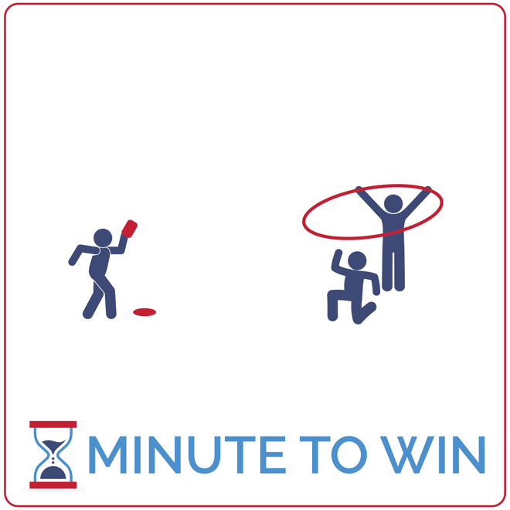
Equipment:
- 1 hoop per team of 3
- 1 beanbag (or foam ball) per team
- 1 low profile cone per team
- 1-Minute Timer Music (Spotify, Apple)

Set-Up:
- Create teams of 3 players.
- Each team has space with a beanbag placed next to a low profile cone – the cone and beanbag are 5 paces away from a hoop.
- One teammate is the tosser and stands behind the cone with the beanbag.
- One teammate is the hoop holder and the third teammate is the catcher – positioned under the hoop, ready to catch the toss.
ACTIVITY PROCEDURES
- This activity is called Hoop It Up. The object of this game is to toss the beanbag through the hoop as many times as you can in 1 minute. However, for a toss to count, the beanbag cannot hit the floor. It has to be caught by a teammate before hitting the ground.
- Get ready with one teammate holding the hoop, parallel to the ground. Another teammate is 5 paces away with a beanbag, ready to toss. A third teammate is positioned to catch the beanbag when it goes thought the hoop.
- On the start signal, the first toss is made. The teammate in position to catch the toss will grab the beanbag and quickly switch places with the tosser. This rotation continues with 2 teammates tossing and catching for the full minute.
- Count your score aloud each time a successful toss and catch is made. If a toss is not caught, or it doesn’t go through the hoop – continue with the rotation but do not count that toss in the score.
- Repeat this challenge with students focused on improvement.

GRADE LEVEL PROGRESSION
- Grades 3 & 4: Consider swapping beanbags with larger foam balls to increase success.
- Grade 5: Play the activity as described above.

TEACHING CUES
- Step with Opposite Foot: Step to target with opposite foot. Toss underhand with tick-tock motion.
- Transition Quickly: The tosser and catcher focus on quickly moving into position after a toss.
- Cooperate: Communicate with positive language. Work together to continually improve.

HOOP IT UP (continued…)

UNIVERSAL DESIGN ADAPTATIONS
- UDL 1: Allow the tossed object to fall to the floor before being picked up. Count all tosses as points.
- UDL 2: Change the distance between the tosser and the target.
- UDL 3: Remove the time challenge and focus on successful movement.

ACADEMIC LANGUAGE
Growth Mindset, Failure, Challenge

PRIORITY OUTCOMES
Personal Challenge:
- (Grade 3) Discusses the challenge that comes from learning new physical activities.
- (Grade 4) Rates the enjoyment of participating in challenging and mastered physical activities.
- (Grade 5) Expresses the enjoyment and challenge of participating in a favorite physical activity.

DEBRIEF QUESTIONS
Growth Mindset Question Set:
- DOK 1: What is a challenge? Can you give examples of a challenge that someone might face?
- DOK 2: How would you apply growth mindset to facing a challenge?
- DOK 3: Describe what someone might learn from facing a difficult challenge.

Teamwork Question Set:
- DOK 1: How did you demonstrate teamwork when you faced today’s challenge?
- DOK 2: How would you summarize your entire team’s performance today?
- DOK 3: How was teamwork related to that performance?

SPINNER WINNER

STUDENT TARGETS
- Skill: I will spin my team’s hoop with attention to safety.
- Cognitive: I will remain focused the challenge and stay ready to rotate when it’s my turn to spin.
- Fitness: I will be actively engaged in this Minute to Win challenge.
- Social/Emotional: I will use positive and encouraging communication with my teammates.

EQUIPMENT & SET-UP | 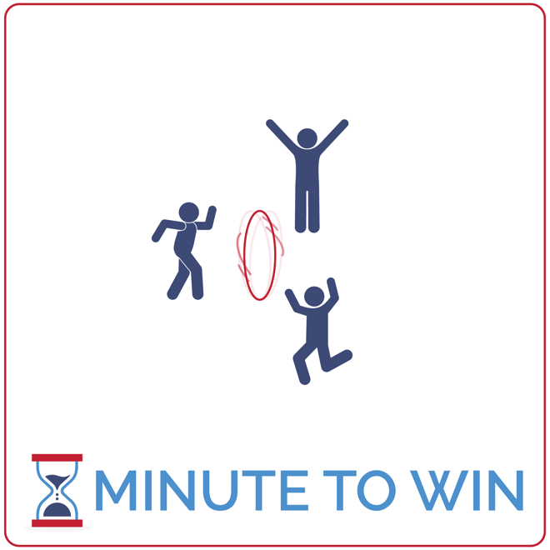
Equipment:
- 1 hoop per team of 3
- 1-Minute Timer Music (Spotify, Apple)

Set-Up:
- Create teams of 3 players.
- Each team has space with a hoop.
- Teammates determine who will spin first, second, and third.
- The first spinner stands with the hoop.
- The other teammates stand on the sides of the hoop ready to rotate.
ACTIVITY PROCEDURES
- This activity is called Spinner Winner. The object of the game is to spin your team’s hoop like a coin for as long as you can and end up with the fewest number of spins in 1 minute as possible.
- Get ready with one teammate ready to spin the hoop and the others on the sides of the hoop, ready to pick it up as soon as it stops spinning.
- On the start signal, one player spins the hoop. As soon as it drops and stops spinning, the next teammate will pick up the hoop and spin it again. When it stops again, the third teammate will pick it up and spin it.
- This rotation continues for the full minute. Count how many times you spin your hoop before the minute expires. Score 10 points with only 1 spin; 5 points with 2 spins; 3 points with 3 spins; and 1 point for 4 or more spins.
- Repeat this challenge with students focused on improvement.

GRADE LEVEL PROGRESSION
- Grades 3 & 4: Play the activity as described above.
- Grade 5: Increase the challenges by requiring all 3 players to work cooperatively to spin the hoop.

TEACHING CUES
- Spin from the Top: Keep the hoop upright and spin it by hand holding the top of the hoop.
- Transition Quickly: The players waiting to spin should be ready to move, pick up the hoop and spin.
- Cooperate: Communicate with positive language. Work together to continually improve.

SPINNER WINNER (continued…)

UNIVERSAL DESIGN ADAPTATIONS
- UDL 1: Play this activity with coins instead of hoops.
- UDL 2: Shorten the time from 1 minute to 30 seconds.
- UDL 3: Remove the time challenge and focus on successful movement.

ACADEMIC LANGUAGE
Feedback, Coachable, Support System

PRIORITY OUTCOMES
Personal Challenge:
- (Grade 3) Discusses the challenge that comes from learning new physical activities.
- (Grade 4) Rates the enjoyment of participating in challenging and mastered physical activities.
- (Grade 5) Expresses the enjoyment and challenge of participating in a favorite physical activity.

DEBRIEF QUESTIONS
Growth Mindset Question Set:
- DOK 1: What is feedback?
- DOK 2: What kind of feedback could you give to classmates who found spinning a hoop to be a challenge?
- DOK 3: How could you have improved your performance based on the feedback that you just heard?

Teamwork Question Set:
- DOK 1: Can you list positive and encouraging words that could be used to give someone feedback?
- DOK 2: Can you give an example of using positive communication to give feedback to a teammate?
- DOK 3: Can you predict how you’d react to a teammate who gave you feedback using positive communication versus someone who used negative language and communication?

HOOP TOSS

STUDENT TARGETS
- Skill: I will toss the hoop with a focus on accuracy and safety.
- Cognitive: I will focus my attention on the challenge in an effort to improve my team’s score.
- Fitness: I will be actively engaged in this Minute to Win challenge.
- Social/Emotional: I will use positive and encouraging communication with my teammates.

EQUIPMENT & SET-UP | 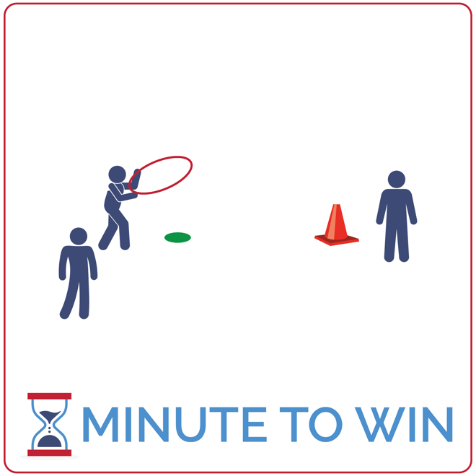
Equipment:
- 1 hoop per team of 3
- 1 large game cone per team
- 1 low-profile cone per team
- 1-Minute Timer Music (Spotify, Apple)

Set-Up:
- Create teams of 3 players.
- Each team has space with a hoop placed next to a low-profile cone – the cone and hoop are 5 paces away from a large game cone.
- One teammate is the tosser and stands behind the low-profile cone with the hoop.
- A second teammate is waiting to be the next tosser and the third is the retriever – standing next to the game cone.
ACTIVITY PROCEDURES
- This activity is called Hoop Toss. The object of the game is for your team to toss and land your hoop onto the cone as many times as you can in 1 minute.
- Get ready with one teammate holding the hoop 5 paces away from the cone. Another teammate will stand next to the first, and the third teammate will stand near the cone.
- On the start signal, the first player will toss the hoop. It must land on the hoop and be secure around it before it’s removed. Next, the player standing next to the cone will pick up the hoop and roll it back to the player who was waiting to become the next tosser. The tosser then rotates down to the cone and the next toss is thrown.
- Continue this rotation cycle until you hear the stop signal. Count each successful toss as a point.
- Repeat this challenge with students focused on improvement.

GRADE LEVEL PROGRESSION
- Grade 3: Remove the hoop roll and have students rotate quickly handing off the hoop from one player to the next.
- Grades 4 & 5: Play the activity as described above.

TEACHING CUES
- Up and Over: Use 2 hands to toss the hoop parallel to the ground, up and over the top of the cone.
- Rotate Quickly: All players stay ready to move and rotate quickly.
- Cooperate: Communicate with positive language. Work together to continually improve.

HOOP TOSS (continued…)

UNIVERSAL DESIGN ADAPTATIONS
- UDL 1: Use large hoops with smaller but stable cones.
- UDL 2: Decrease the distance between the tosser and the target.
- UDL 3: Remove the time challenge and focus on successful movement.

ACADEMIC LANGUAGE
Feedback, Coachable, Support System

PRIORITY OUTCOMES
Growth Mindset Challenge:
- (Grade 3) Discusses the challenge that comes from learning new physical activities.
- (Grade 4) Rates the enjoyment of participating in challenging and mastered physical activities.
- (Grade 5) Expresses the enjoyment and challenge of participating in a favorite physical activity.

DEBRIEF QUESTIONS
Cognitive Question Set:
- DOK 1: What does it mean to be coachable?
- DOK 2: Can you compare and contrast people who are coachable vs not coachable?
- DOK 3: How is being coachable related to growth mindset?

Teamwork Question Set:
- DOK 1: How can you recognize a coachable teammate?
- DOK 2: What is something that you can do to be more coachable?
- DOK 3: How is being coachable related to being a good teammate?

CHOPSTICK NOODLES

STUDENT TARGETS
- Skill: I will carry the foam noodles with purpose and a focus on safety.
- Cognitive: I will focus my attention on the challenge in an effort to improve my team’s score.
- Fitness: I will be actively engaged in this Minute to Win challenge.
- Social/Emotional: I will use positive and encouraging communication with my teammates.

EQUIPMENT & SET-UP | 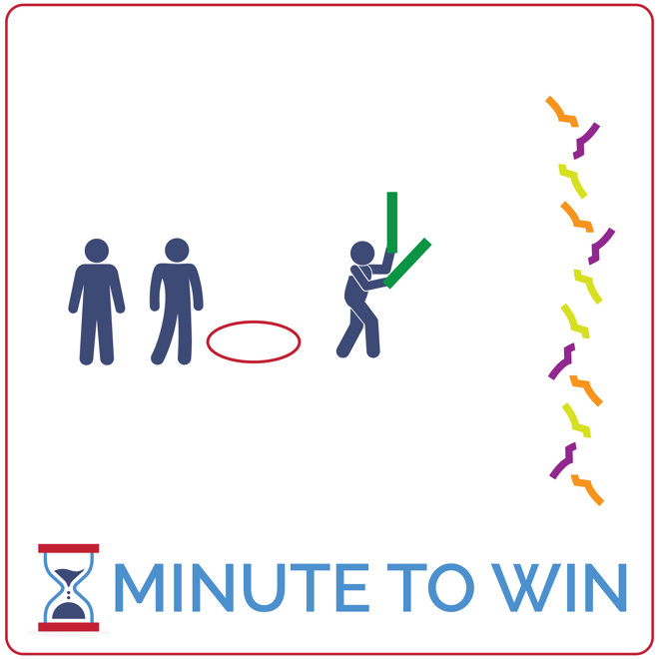
Equipment:
- 2 foam noodles per team of 3
- 1 hoop per team
- As many juggling scarves as possible. At least 6 per team.
- 1-Minute Timer Music (Spotify, Apple)

Set-Up:
- Create teams of 3 players.
- Line hoops along 1 side of the activity area with 2 noodles inside each hoop.
- Scatter juggling scarves along the opposite side of the activity area.
- Send each team of 3 to a hoop.
ACTIVITY PROCEDURES
- This activity is called Chopstick Noodles. The object of the game is for teams to collect as many scarves as they can using the foam noodles to pick up each scarf.
- Get ready with one teammate holding two foam noodles, ready to move to collect a scarf (1 at a time). The other two teammates are in relay race formation behind their team’s hoop.
- On the start signal, the player with the noodles will run to the opposite end of the activity area, use the noodles to pinch and pick up 1 scarf, and then return and place it in the hoop.
- If a player drops a scarf on the way to a hoop, just pick it back up and continue.
- Rotate using relay race formation with players taking turns collecting scarves. Each scarf is worth 1 point. Repeat this challenge with students focused on improvement.

GRADE LEVEL PROGRESSION
- Grade 3: Begin with player running and collecting scarves by hand and add the noodles when they’ve learned the activity procedures.
- Grades 4 & 5: Play the activity as described above.

TEACHING CUES
- Hold Halfway: Get a firm grip in the center of each noodle to help add solid leverage for pinching.
- Be Ready to Run: All players stay ready to quickly pass the noodles and take a turn.
- Cooperate: Communicate with positive language. Work together to continually improve.

CHOPSTICK NOODLES (continued…)

UNIVERSAL DESIGN ADAPTATIONS
- UDL 1: Replace noodles with an object that is easier to manipulate.
- UDL 2: Decrease the distance that students must travel holding the scarves.
- UDL 3: Remove the time challenge and focus on successful movement.

ACADEMIC LANGUAGE
Feedback, Coachable, Support System

PRIORITY OUTCOMES
Personal Challenge:
- (Grade 3) Discusses the challenge that comes from learning new physical activities.
- (Grade 4) Rates the enjoyment of participating in challenging and mastered physical activities.
- (Grade 5) Expresses the enjoyment and challenge of participating in a favorite physical activity.

DEBRIEF QUESTIONS
Growth Mindset Question Set:
- DOK 1: How would you describe a support network?
- DOK 2: How does having a support network affect your ability to overcome a challenge?
- DOK 3: What are the steps to building a support network?

Teamwork Question Set:
- DOK 1: What would it look like for you to be a part of the support network for your teammates?
- DOK 2: How can you apply what you’ve learned about growth mindset to being an active part of a support network for your teammates?
- DOK 3: How would your willingness to accept feedback impact your ability to receive help from a support network?

EGG TOSS

STUDENT TARGETS
- Skill: I will focus on my bounce technique and repeat form and movements to find a consistent toss.
- Cognitive: I will focus my attention on the challenge in an effort to improve my team’s score.
- Fitness: I will be actively engaged in this Minute to Win challenge.
- Social/Emotional: I will use positive and encouraging communication with my teammates.

EQUIPMENT & SET-UP | 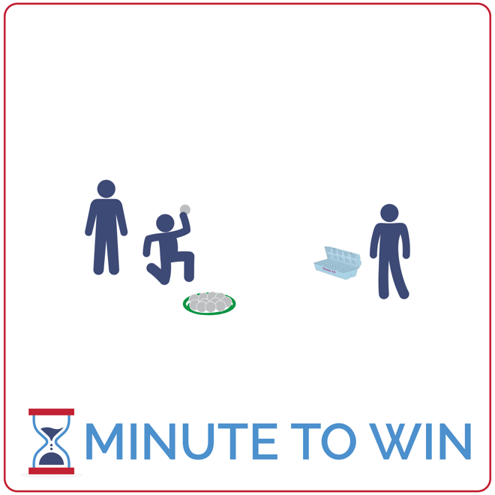
Equipment:
- 1 egg carton per team of 3
- 12 ping pong balls per team
- 1 flying disc per team
- 1-Minute Timer Music (Spotify, Apple)

Set-Up:
- Create teams of 3 players.
- Place egg cartons approximately 2 feet from each flying disc.
- Place 12 ping pong balls inside each disc.
- Send each team to a set of equipment.
ACTIVITY PROCEDURES
- This activity is called Egg Toss. The object of the game is to toss and bounce as many ping pong balls into your team’s egg carton as you can in 1 minute. Each teammate will take a turn for a full minute (3 rounds total). You’ll add the score from each round to get a final score.
- Get ready by sitting on the floor with an egg carton 2 feet in front of you (open). Ping pong balls are next to you sitting in an upside-down flying disc.
- On the start signal, toss and bounce the ball so that it lands inside of the egg carton. If you miss, your teammates can retrieve the ball and place it in the flying disc.
- Continue until you hear the stop signal. Then, prepare for the next teammate to have a turn.

GRADE LEVEL PROGRESSION
- Grade 3: Allow students to increase or decrease the distance from the egg carton.
- Grades 4 & 5: Play the activity as described above.

TEACHING CUES
- Practice Makes Perfect: Use practice tosses to find the perfect toss and bounce.
- Quickly Collect & Return: Teammates quickly retrieve balls that miss the target and return them to the team’s disc.
- Cooperate: Communicate with positive language. Work together to continually improve.

EGG TOSS (continued…)

UNIVERSAL DESIGN ADAPTATIONS
- UDL 1: Use a large bowl or box rather than an egg carton.
- UDL 2: Allow students with fine motor challenges to pick up and place the balls inside of the carton.
- UDL 3: Increase or remove the time challenge and focus on successful movement.

ACADEMIC LANGUAGE
Motivation, Inspiration, Celebrate

PRIORITY OUTCOMES
Personal Challenge:
- (Grade 3) Discusses the challenge that comes from learning new physical activities.
- (Grade 4) Rates the enjoyment of participating in challenging and mastered physical activities.
- (Grade 5) Expresses the enjoyment and challenge of participating in a favorite physical activity.

DEBRIEF QUESTIONS
Growth Mindset Question Set:
- DOK 1: What is motivation? What does it mean to be motivated?
- DOK 2: What people or things motivate you?
- DOK 3: How is a person’s motivation related to their performance?

Teamwork Question Set:
- DOK 1: What does a motivated team look like? What do they sound like?
- DOK 2: What’s the difference between a motivated team and a team who lacks motivation?
- DOK 3: If two teams have the same skills and abilities, but one team is very motivated and the other is not motivated, what do you think the outcome of a competition between the two would be? Support your answer with details.

BALL DROP

STUDENT TARGETS
- Skill: I will focus on my drop technique and repeat form and movements to find a consistent drop.
- Cognitive: I will focus my attention on the challenge in an effort to improve my team’s score.
- Fitness: I will be actively engaged in this Minute to Win challenge.
- Social/Emotional: I will use positive and encouraging communication with my teammates.

EQUIPMENT & SET-UP | 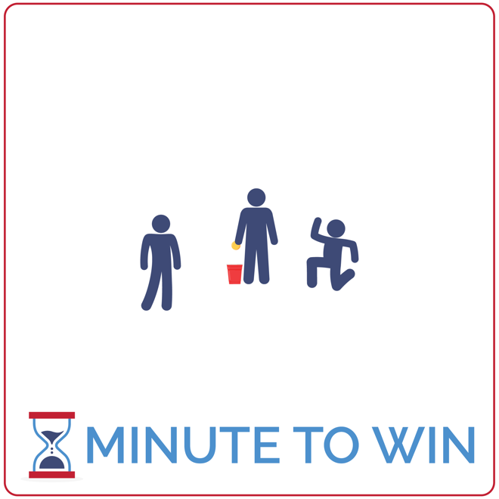
Equipment:
- 1 ping pong ball per team of 3
- 1 plastic cup per team (at least 16 oz)
- 1-Minute Timer Music (Spotify, Apple)

Set-Up:
- Create teams of 3 players.
- Place a cup and ping pong ball in space for each team to participate.
- Send each team to a ball and cup.
ACTIVITY PROCEDURES
- This activity is called Egg Drop. The object of the game is to score as many points as possible by dropping a ping pong ball into a cup from waist height. Each teammate will take a turn for a full minute (3 rounds total). You’ll add the score from each round to get a final score.
- Get ready by standing with a ping pong ball in one hand and a cup directly underneath the ball. Teammates who are not taking a turn will act as ball retrievers. One will retrieve balls that miss the cup, the other will retrieve balls that make it into the cup.
- On the start signal, drop the ball. If it lands in the cup it’s 1 point. Retrievers, quickly get the ball and hand it back to your teammate. If you need to move the cup, make sure you put it back in place.
- Continue until you hear the stop signal. Then, prepare for the next teammate to have a turn.

GRADE LEVEL PROGRESSION
- Grade 3: Increase the size of the cup to make the challenge easier. Place a paper towel or cotton ball in the bottom of the cup to make it less bouncy.
- Grades 4 & 5: Play the activity as described above.

TEACHING CUES
- Quick but Consistent: Find a consistent drop touch that works. Then repeat that over and over.
- Quickly Collect & Return: Teammates quickly retrieve balls and return them to their teammate.
- Cooperate: Communicate with positive language. Work together to continually improve.

BALL DROP (continued…)

UNIVERSAL DESIGN ADAPTATIONS
- UDL 1: Use a large box with a towel in the bottom to decrease the amount of bounce.
- UDL 2: Use different types of balls that will increase success.
- UDL 3: Increase or remove the time challenge and focus on successful movement.

ACADEMIC LANGUAGE
Motivation, Inspiration, Celebrate

PRIORITY OUTCOMES
Personal Challenge:
- (Grade 3) Discusses the challenge that comes from learning new physical activities.
- (Grade 4) Rates the enjoyment of participating in challenging and mastered physical activities.
- (Grade 5) Expresses the enjoyment and challenge of participating in a favorite physical activity.

DEBRIEF QUESTIONS
Growth Mindset Question Set:
- DOK 1: What does inspiration mean?
- DOK 2: What do you know about feeling inspired?
- DOK 3: Have you ever seen anyone do something that was inspirational? If so, what was it? How did it make you feel? Why was it inspirational?

Teamwork Question Set:
- DOK 1: Can you make a list of inspiring movies or music?
- DOK 2: Can you summarize what makes those things inspirational?
- DOK 3: How might you be able to inspire your teammates to try their best during challenges or competitions?

BALANCING SPOONS

STUDENT TARGETS
- Skill: I will use my peripheral vision to help balance the ping pong ball and walk safely to the disc.
- Cognitive: I will focus my attention on the challenge in an effort to improve my team’s score.
- Fitness: I will be actively engaged in this Minute to Win challenge.
- Social/Emotional: I will use positive and encouraging communication with my teammates.

EQUIPMENT & SET-UP | 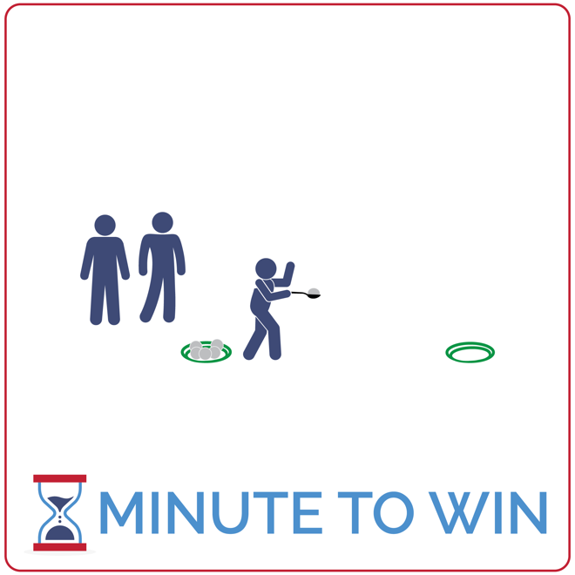
Equipment:
- 6 ping pong balls per team of 3
- 2 flying discs per team
- 1 spoon per team
- 1-Minute Timer Music (Spotify, Apple)

Set-Up:
- Create teams of 3 players.
- Create 2 lines of flying discs – each line on opposite ends of the activity area.
- Place 6 ping pong balls and 1 spoon in each starting disc.
- Teams line up relay race style behind the starting discs.
ACTIVITY PROCEDURES
- This activity is called Balancing Spoons. The object is to move as many ping pong balls as possible from one flying disc to another in 1 minute. You must use a spoon to transport each ball.
- This is a relay race challenge. Get ready with the first player in line standing behind the team cone, holding a ping pong ball in the spoon. Other teammates are behind the first player.
- On the start signal, player 1 will travel down to the team’s flying disc and carefully place the ball inside the disc before returning and passing the spoon to the next player. If a ball is dropped, pick it up and continue.
- The next player gets a ball from the disc and begins down to the opposite disc. This repeats until time runs out. If your team places all 6 balls into the opposite disc with time remaining, move to collect one at a time and return it back to the starting disc.
- Each ball moved is worth 1 point. Repeat this challenge with students focused on improvement.
GRADE LEVEL PROGRESSION
- Grade 3: Increase the size of the spoons used. Decrease the distance between flying discs.
- Grades 4 & 5: Play the activity as described above.
TEACHING CUES
- Use Your Vision: Look at the spoon when moving but also use your peripheral vision to stay straight and safe.
- Be Ready to Move: All players stay ready to quickly pass the spoon and take a turn.
- Cooperate: Communicate with positive language. Work together to continually improve.

BALANCING SPOONS (continued…)

UNIVERSAL DESIGN ADAPTATIONS
- UDL 1: Use double sided tape to help secure the ball to the spoons.
- UDL 2: Use large wooden spoons with deep indentations to increase success.
- UDL 3: Increase or remove the time challenge and focus on successful movement.

ACADEMIC LANGUAGE
Motivation, Inspiration, Celebrate

PRIORITY OUTCOMES
Personal Challenge:
- (Grade 3) Discusses the challenge that comes from learning new physical activities.
- (Grade 4) Rates the enjoyment of participating in challenging and mastered physical activities.
- (Grade 5) Expresses the enjoyment and challenge of participating in a favorite physical activity.

DEBRIEF QUESTIONS
Growth Mindset Question Set:
- DOK 1: How would you describe a celebration?
- DOK 2: Can you describe a time or moment when it’s appropriate to celebrate?
- DOK 3: How can a celebration help you improve and grow as a person?

Teamwork Question Set:
- DOK 1: How can you recognize a team who is celebrating together?
- DOK 2: How can a celebration affect motivation?
- DOK 3: Based on what you’ve learned about growth mindset – why might celebrating with others be beneficial to your personal growth?

