GOLF BUCKET CHALLENGE

STUDENT TARGETS
- Skill: I will use proper grip and stance when chipping.
- Cognitive: I will demonstrate growth mindset by allowing myself to fail fast and try again.
- Fitness: I will be actively engaged in this Minute to Win challenge.
- Social/Emotional: I will use positive and encouraging communication with my teammates.

EQUIPMENT & SET-UP | 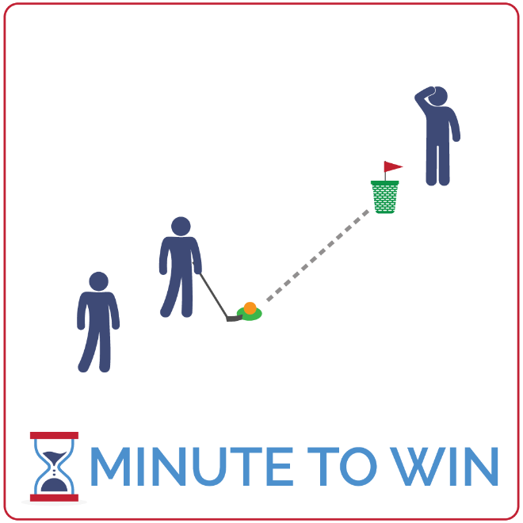
Equipment:
- 1 bucket golf club per team of 3
- 1 bucket golf ball per team
- 1 bucket golf “bucket” per team
- 1 spot marker or hitting mat per team
- 1-Minute Timer Music (Spotify, Apple)

Set-Up:
- Create teams of 3 players.
- Each team has a bucket 10 to 15 feet from a spot marker or hitting mat.
- One teammate is the chipper and stands by the spot marker/hitting mat with the club and ball.
- The second teammate is waiting by the bucket to retrieve the ball, and the third teammate is waiting behind the chipper.

ACTIVITY PROCEDURES
- This activity is called the Golf Bucket Challenge! The object of the game is to see how many times your team can chip a golf ball into the bucket in 1 minute.
- Get ready with 1 teammate by the spot marker/hitting mat with the golf club and a ball. The second teammate will stand by the bucket ready to retrieve the ball and the third teammate will wait in line behind the leader.
- On the start signal, the first teammate will chip the golf ball and try to “sink” it in the bucket. The second teammate will retrieve the ball and bring it back to the spot marker/hitting mat.
- As soon as you’re back at your starting spot, rotate positions and try again. The chipper becomes the retriever, the retriever will now wait in line, and the teammate who was waiting in line is now the chipper. This continues for the full 1 minute. Your goal is to “sink” the golf ball in the bucket as many times as possible before time expires.
- Teacher Note: repeat this challenge with students focused on improvement.

GRADE LEVEL PROGRESSION
- Grade 3: Play the game with putting vs. chipping. Students will putt towards the bucket, and if the ball hits it, they would score a point.
- Grades 4 & 5: Play the activity as described above.

TEACHING CUES
- Fail Fast: If a chip misses, don’t fuss. Quickly continue and learn from the error.
- Focus on the Challenge: Actively focus on the challenge you’re facing. Avoid distractions.
- Be Positive: Help your teammates fail fast and focus by using encouraging words and statements.

GOLF BUCKET CHALLEGE (continued…)

UNIVERSAL DESIGN ADAPTATIONS
- UDL 1: Allow for an underhand toss instead of using a golf club.
- UDL 2: Remove the time challenge and focus on safe and successful movement.
- UDL 3: Provide clearly marked buckets and brightly colored spot markers.

ACADEMIC LANGUAGE
Growth Mindset, Failure, Challenge, Communication

PRIORITY OUTCOMES
Personal Challenge:
- (Grade 3) Discusses the challenge that comes from learning new physical activities.
- (Grade 4) Rates the enjoyment of participating in challenging and mastered physical activities.
- (Grade 5) Expresses the enjoyment and challenge of participating in a favorite physical activity.

DEBRIEF QUESTIONS
Growth Mindset Question Set:
- DOK 1: What is growth mindset?
- DOK 2: What does it mean to Fail Fast?
- DOK 3: How is failing related to learning? How is it related to growth mindset?

Teamwork Question Set:
- DOK 1: What is positive communication? What does it sound like?
- DOK 2: How does positive communication impact the way a team works together?
- DOK 3: What are specific examples of how you used positive communication with your teammates in today’s activity?

