The Pumpkin Patch

STUDENT TARGETS
- Skill: I will use the appropriate amount of force to roll my ball into a hula hoop.
- Cognitive: I will be able to state the cues for underhand rolling.
- Fitness: I will work to stay actively engaged during all activities.
- Social/Emotional: I will use positive and encouraging communication with my teammates.

EQUIPMENT & SET-UP | 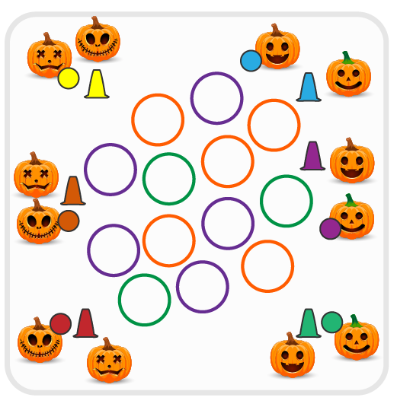
Equipment:
- As many hula hoops as possible
- 1 Cone per team
- 1 Foam ball per team

Set-Up:
- Create teams of 2 players.
- Scatter hula hoops in center of activity area with cones around the perimeter. Place a ball either on top of or near each cone.
- Each team will line up at a cone and wait for start signal.
ACTIVITY PROCEDURES
- This activity is called The Pumpkin Patch! The object of the game is to collect as many pumpkin patches (hula hoops) as you can for your team. You do that by rolling your pumpkin (ball) into the pumpkin patch (hoop).
- Get ready with one teammate holding the ball, and the other teammate standing by the cone.
- On the start signal, the teammate with the ball will roll the pumpkin into the activity area where the hula hoops are spread out. If a roll successfully lands in a hoop, then the player will collect the hoop to bring back and put around their cone. If the roll is not successful, then the player will collect their pumpkin (ball) and bring it back to their cone so their teammate can have a try.
- Each team will continue taking turns rolling the pumpkin into the pumpkin patch until all hoops are collected or you hear the stop signal. The team with the most pumpkin patches wins!
- The ball must go into (and stay inside of) a hoop in order for the team to collect the pumpkin patch and bring it back to their cone.

DEBRIEF QUESTIONS
- DOK 1: What are the cues for underhand rolling?
- DOK 2: How does using the cues affect how well you roll the ball?
- DOK 3: If your ball rolled in but kept going past the hoop and didn’t stay in, what could you do differently on the next attempt?

PRIORITY OUTCOMES
Manipulative Skills:
- Grades K-2: Demonstrates control while combining locomotor and manipulative skills in self-space and general space.
- Grades 3-5: Demonstrates manipulative skills using mature patterns for accuracy and control.

Ghost Tossers

STUDENT TARGETS
- Skill: I will use the cues for tossing in order to hit a target with the ghost ball.
- Cognitive: I will be able to repeat the cues for tossing towards a target.
- Fitness: I will work to stay actively engaged during all activities.
- Social/Emotional: I will use positive and encouraging communication with my teammates.

EQUIPMENT & SET-UP | 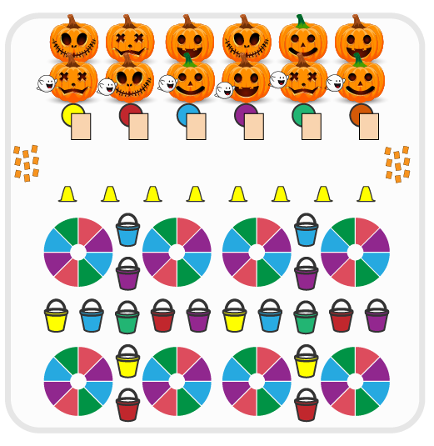
Equipment:
- Cones for boundaries
- Balls wrapped in scarves (ghost balls)
- Buckets for targets
- Small parachutes for targets
- Ghost Tossers Vocabulary Handout
- Alphabet Letter Cut Outs

Set-Up:
- Create teams of 2-3 players.
- Have a spot marker for each team at one end of activity area with a Ghost Tossers Vocabulary Handout. At the other end, set a line of cones as the “throwing line” with buckets and parachutes in front of the line as targets. Create an area with alphabet letters are spread face down.
- Each team begins at a spot marker.

ACTIVITY PROCEDURES
- This activity is called Ghost Tossers! The object of the game is to throw the ghost balls to the target(s) in order to collect letters to create vocabulary words. You do that by collecting one letter if a ghost ball goes in a bucket and collecting two letters if your ghost ball lands on the small parachute.
- Get ready with your team by a spot marker. This is where you will bring all of your letters and where you will bring your ghost ball to switch roles with your partner after each toss attempt.
- On the start signal, one player takes the ghost ball to the throwing line and tosses it either towards a bucket or a small parachute. If successful, get your ghost ball and go to the letter area to collect one letter if you made it in a bucket or two letters if your ghost ball landed on the small parachute. Bring your ghost ball and your letters back to your spot marker and a new teammate takes a turn.
- Continue with the toss attempts until you hear the stop signal.
- If your toss is not successful, you will collect your ghost ball and bring it back to your spot marker so a new teammate can have a turn.

DEBRIEF QUESTIONS
- DOK 1: What does positive and encouraging communication sound like?
- DOK 2: How does positive and encouraging communication impact the way a team works together?

PRIORITY OUTCOMES
Etiquette:
- Grades K-2: Exhibits the established protocols for class activities without reminders.
- Grades 3-5: Exhibits etiquette and adherence to rules in a variety of physical activities.

Monster Madness

STUDENT TARGETS
- Skill: I will apply chasing, fleeing, and dodging strategies during the activity.
- Cognitive: I will identify the muscles being strengthened during the activity.
- Fitness: I will continue moving during the tag game in an effort to increase my heart rate.
- Social/Emotional: I will demonstrate good sportsmanship if tagged.

EQUIPMENT & SET-UP | 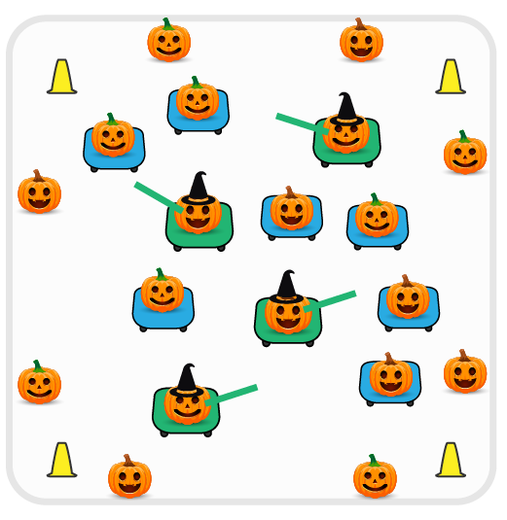
Equipment:
- 4 foam noodles for taggers
- 4 scooters for taggers, and 1 scooter per team of 2 students
- Cones for boundaries

Set-Up:
- Create teams of 2 players.
- Place cones around perimeter of activity area, scooters spread out inside of boundary cones.
- Identify 2 teams (4 students) to begin as taggers and have them sit on scooters just outside of the boundary cones, holding foam noodles. Each remaining team will have one person begin on the scooter, and remaining teammate stands outside of the boundary cones.
ACTIVITY PROCEDURES
- This activity is called Monster Madness! The object of the game is to use chasing, fleeing and dodging skills to tag as many people as possible or avoid being tagged. You do that by moving in various pathways and directions while on a scooter.
- Get ready by having one teammate on a scooter in the middle, and the other teammate will stand just outside of the boundary cones.
- On the start signal, the 4 monsters (taggers) will begin to try and tag players on a scooter with the foam noodles. If a player is tagged, they have been turned into a monster! The tagged player must stand up and carry their scooter outside of the activity area in order to trade places with their teammate. The teammate who has just gotten tagged must complete 15 jumping jacks outside the cones to no longer be a monster. Their teammate will join in the game by sitting down on the scooter and trying to avoid being tagged by the monsters.
- Teams will continue to trade places each time a teammate is turned into a monster until you hear the stop signal. We will switch out the taggers every few minutes and start a new game.

DEBRIEF QUESTIONS
- DOK 1: Which muscles did you feel were working the hardest while you were on a scooter?
- DOK 2: Which component(s) of health-related fitness were we working to enhance today?

PRIORITY OUTCOMES
Fitness Knowledge:
- Grades K-2: Identifies physical activities that contribute to fitness.
- Grades 3-5: Identifies activities that require and/or improve the components of fitness.

Zombie Tag

STUDENT TARGETS
- Skill: I will travel at a controlled and moderate pace in order to maintain a safe environment.
- Cognitive: I will identify fleeing and dodging strategies that help me avoid the taggers.
- Fitness: I will work to stay actively engaged during all activities.
- Social/Emotional: I will follow rules and procedures in order to create a positive and safe environment.

EQUIPMENT & SET-UP | 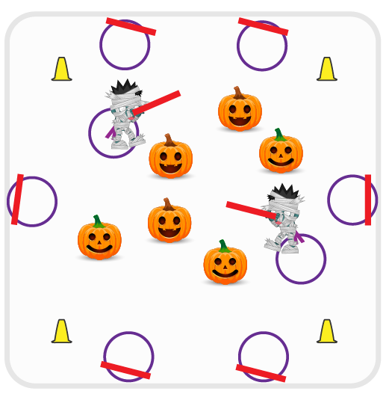
Equipment:
- 1 foam noodle per student
- 1 hula hoop per student
- Cones for boundaries

Set-Up:
- Students spread out on the outside of the boundary cones with one hoop and one noodle each.
- Teacher selects 3-4 students to begin as taggers. Taggers (zombies) bring their hoop and noodle and come by the teacher.
- All remaining students (non-taggers) leave their hoop and noodle outside the cones and spread out in the middle of the activity area.
ACTIVITY PROCEDURES
- This activity is called Zombie Tag! The object of the game is to avoid being turned into a zombie by avoiding the taggers. You do that by using your chasing, fleeing, and dodging skills to avoid being caught.
- Zombies (taggers) stand just outside of the cones by the teacher while all of the humans (other students) spread out in the activity area.
- On the start signal, Zombies (taggers) will use their foam noodle to tag as many humans as they can while dragging their hula hoop behind them with one foot. If a human gets tagged, they have been turned into a zombie! They will go outside of the cones to get their hula hoop and foam noodle, and will join the taggers to turn the remaining humans into zombies as well.
- Zombies will continue to tag the humans until you hear the stop signal or until there are no humans left.
- We will switch out the taggers every few minutes and start a new game.
DEBRIEF QUESTIONS
- DOK 1: What is a rule? What is a procedure?
- DOK 2: How does following rules and procedures affect class games and activities?

PRIORITY OUTCOMES
Personal Responsibility and Safety:
- Grades K-2: Follows directions for safe participation and proper use of equipment without reminders.
- Grades 3-5: Engages in physical activity with responsible interpersonal behavior (e.g., peer to peer, student to teacher).

Partner Pumpkin Rolling

STUDENT TARGETS
- Skill: I will safely move in general space during the activity.
- Cognitive: I will discuss the importance of aerobic capacity.
- Fitness: I will pace my activity so that I try to work within my target heart rate zone.
- Social/Emotional: I will cooperate with and encourage my teammates during the activity.

EQUIPMENT & SET-UP | 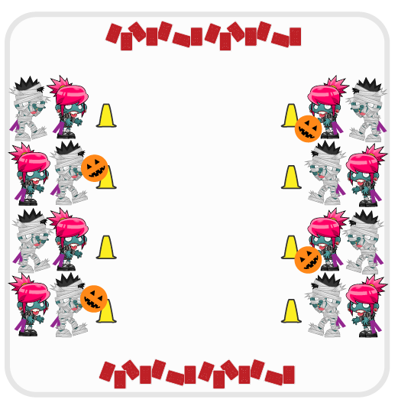
Equipment:
- 1 playground ball or basketball per team
- 2 cones per team
- Decks of playing cards

Set-Up:
- Create teams of 4 players.
- Create two parallel lines of cones on opposite sides of activity area. Each team of 4 will have 2 students start on each side of the activity area at a cone directly across from each other.
- One side of the activity area will have a ball by each cone.
- Scatter playing cards on each end of the parallel lines of cones face down.
ACTIVITY PROCEDURES
- This activity is called Partner Pumpkin Rolling! The object of the game is to move the pumpkin across the activity area as many times as possible so you can collect playing cards. You do that by working together with your teammates relay-race style to take turns rolling the pumpkin.
- Your team of 4 is split into two smaller groups that are directly across from each other.
- On the start signal, one player from each team rolls the pumpkin (ball) across the activity area to their teammates.
- Once the pumpkin is rolled all the way across, the roller will then go to the card area and choose one playing card and bring it back to their cone.
- Teams continue to roll the pumpkin back and forth and collect playing cards until you hear the stop signal.
- Each team will then add up all of the points from the playing cards you collected. A 3 of hearts equals 3 points, etc. and all face cards are worth 10 points! The team with the most points wins that round.

DEBRIEF QUESTIONS
- DOK 1: What is aerobic capacity?
- DOK 2: How is aerobic capacity related to your ability to do the things you like to do?

PRIORITY OUTCOMES
Fitness Knowledge:
- Grades K-2: Identifies physical activities that contribute to fitness.
- Grades 3-5: Describes the concept of fitness and provides examples of physical activity to enhance fitness.

Spooky Stations

STUDENT TARGETS
- Skill: I will demonstrate proper form and attention to safety during each station.
- Cognitive: I will follow the instructions on each station card in order to stay actively engaged.
- Fitness: I will work to keep moving and increase my heart rate during each station.
- Social/Emotional: I will exhibit personal responsibility during each station.

EQUIPMENT & SET-UP | 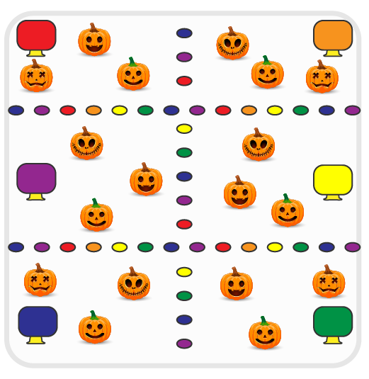
Equipment:
- Low profile cones for station boundaries
- Cones and task tents for each station
- Station music and music player
- Spooky Station Cards (see each card for specific equipment needs)

Set-Up:
- Use low profile cones to create 6 station grids.
- Place station cards in a task tent at each station.
- Set up equipment at each station according to its station card.
- Create groups of 4-5 students, each group at a different station.
ACTIVITY PROCEDURES
- This activity is called Spooky Stations! The object is to utilize self-control and personal responsibility while you participate in a variety of different spooky station activities.
- Teacher: Talk through and demonstrate each station.
- When the music starts, begin working at your station. There is a task tent with a station card at each one to help you remember the expectations and directions.
- When the music stops, you will have 30 seconds to clean up the station equipment and rotate to the next station. Wait until the music begins again to start the new station activity.

DEBRIEF QUESTIONS
- DOK 1: Why is it important for you to work together with your classmates to share equipment and space?
- DOK 2: What are some of the ways you exhibited personal responsibility and/or self-control during the station activities?

PRIORITY OUTCOMES
Working with Others:
- Grades K-2: Accepts responsibility for class protocols with personal and cooperative behavior as well as performance actions.
- Grades 3-5: Accepts, recognizes, and actively involves others with both higher and lower skill abilities into physical activities and group projects.

Ghostbusters Tag

STUDENT TARGETS
- Skill: I will demonstrate safe behaviors and pacing during the tag game.
- Cognitive: I will discuss the enjoyment of being active with family and friends.
- Fitness: I will increase my heart rate during this activity.
- Social/Emotional: I will describe the social benefits gained from participating in physical activity.

EQUIPMENT & SET-UP | 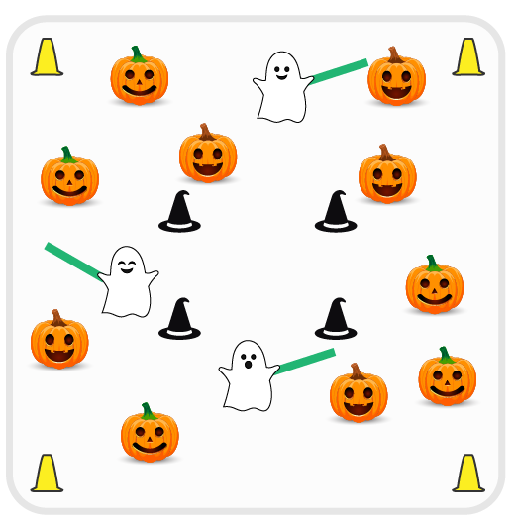
Equipment:
- Cones for boundaries and haunted castle
- 3-4 foam noodles
- Music player and Ghostbusters theme song

Set-Up:
- Select 3-4 students as ghosts (taggers) and give them a foam noodle.
- Create a large activity area with cones. In the center of the area, create another space (haunted castle) with cones that is large enough for several students to safely perform jumping jacks.
- Remaining students scatter throughout activity area.
ACTIVITY PROCEDURES
- This activity is called Ghostbusters Tag! The object of the game is to avoid being tagged by the ghosts.
- Teachers: Play the first game at a speed walking pace. Increase the pace when students demonstrate safe behaviors.
- When the music starts, the tag game begins. If tagged by a ghost with a foam noodle, you must report to the haunted castle and perform jumping jacks until you hear the word “ghostbusters” in the song. You can then return to the game.
- You must be inside the haunted castle by the time you hear “ghostbusters” after you have been tagged. If you are outside the haunted castle when “ghostbusters” is said, you must enter the castle and perform jumping jacks until the next time you hear it.
- We will continue to play until you hear the music stop. I may pause the music sometimes so we can switch out the ghosts (taggers).

DEBRIEF QUESTIONS
- DOK 1: What is responsibility? How did you show responsibility during the game?
- DOK 2: Why is it important for a leader to demonstrate responsibility?

PRIORITY OUTCOMES
Social Interaction:
- Grades K-2: Discusses the enjoyment of playing with family and friends.
- Grades 3-5: Describes the social benefits gained from participating in physical activity.

Zombie Invasion

STUDENT TARGETS
- Skill: I will demonstrate safe behaviors and pacing during the activity.
- Cognitive: I will discuss responsibility and leadership during physical education class.
- Fitness: I will increase my heart rate during this activity.
- Social/Emotional: I will demonstrate responsibility by moving safely and with consideration for others.

EQUIPMENT & SET-UP | 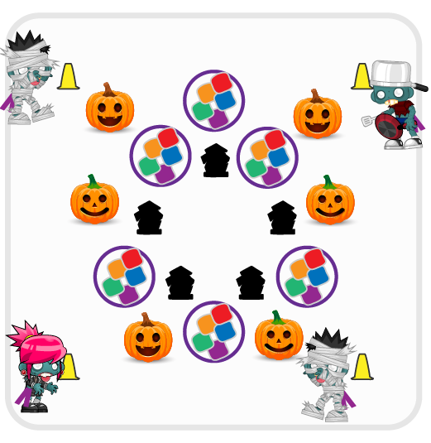
Equipment:
- Cones for boundaries
- 10 hula hoops with 5 items inside each hoop (foam balls, bean bags, etc.)
- 1 flag belt per 2 students
Set-Up:
- Create 2 teams, with one team wearing flag belts. The team with belts is the Zombie team and they begin outside of the activity area.
- The team without flag belts are inside the activity area and are defending the “candy” inside each hoop.
- Use cones to create a large activity area. Create a smaller circular area inside of the activity area to be the “graveyard” zone. Scatter hoops with 5 items inside around the activity area.
ACTIVITY PROCEDURES
- This activity is called Zombie Invasion! The object of the game is for the Zombies to capture all of the candy inside each of the hoops.
- The Zombie team (with flag belts) will begin in the safe zone outside of the cones. The candy defenders (without flag belts) need to be scattered inside the activity area and ready to fend off the Zombies by pulling their flags.
- On the start signal, the Zombies can invade the activity area. They can only collect 1 piece of candy at a time and must make it back outside of the activity area without getting their flag pulled. If a Zombie’s flag is pulled, candy must be returned to the hoop and the Zombie must report to the graveyard.
- Zombies in the graveyard can be set free if a fellow Zombie can make it into the graveyard without having a flag pulled. All freed Zombies get a free pass back outside of the activity area.
- We will continue to play until you hear the stop signal.

DEBRIEF QUESTIONS
- DOK 1: What is a leader? How can you demonstrate leadership in physical education class?
- DOK 2: What does “leading by example” mean?

PRIORITY OUTCOMES
Movement Concepts:
- Grades K-2: Safely moves in both personal and general space using different pathways and speeds.
- Grades 3-5: Recognizes open and closed spaces in a variety of movement contexts.

Pickles in the Pumpkin Patch

STUDENT TARGETS
- Skill: I will toss foam balls using skill cues.
- Cognitive: I will discuss self-control during the activity.
- Fitness: I will increase my heart rate during this activity.
- Social/Emotional: I will demonstrate self-control while competing and having fun.

EQUIPMENT & SET-UP | 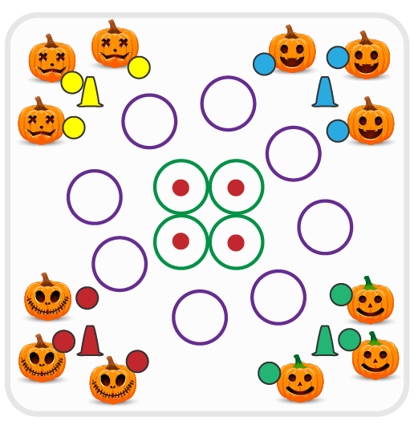
Equipment:
- 4 spot markers
- 24 hula hoops
- 1 foam ball or yarn ball per student
- 1 cone per team to create a team patch

Set-Up:
- Create equal teams of 3-6 players.
- Divide foam/yarn balls evenly. Give 1 team only the green balls (they are the pickles).
- Create a large activity area with cones. Scatter hoops evenly in the activity area.
- Place 4 hoops in the center of the area with spot markers inside each hoop.
ACTIVITY PROCEDURES
- This activity is called Pickles in the Pumpkin Patch! The object of the game is to collect as many hoops (pumpkins) as you can. You do that by tossing a ball so that it lands and stays in the hoop. Center hoops can only be taken if the ball stays on the spot marker.
- The green team (the pickles) will use their green balls to try and knock other balls out of hoops before they’re collected. The pickles are trying to see how long they can keep the pumpkins safe and in the patch.
- On the start signal, all teams start tossing balls into the hoops (pumpkins). If a ball lands (and stays) inside a hoop, move to collect the hoop and bring it back to your team’s area. If you miss with a toss, move to collect your ball and try again. If 2 balls land in a hoop at the same time, use Rock, Paper, Scissors to determine who captures the pumpkin.
- Teams will continue to play until you hear the stop signal.

DEBRIEF QUESTIONS
- DOK 1: What is self-control?
- DOK 2: How did you demonstrate self-control during this game?

PRIORITY OUTCOMES
Personal Responsibility and Safety:
- Grades K-2: Works independently and safely in physical education.
- Grades 3-5: Exhibits responsible behavior in independent group situations.

Monster Mash

STUDENT TARGETS
- Skill: I will throw foam balls using skill cues.
- Cognitive: I will discuss self-regulation during the activity discussions.
- Fitness: I will increase my heart rate during this activity.
- Social/Emotional: I will demonstrate self-control while competing and having fun.

EQUIPMENT & SET-UP | 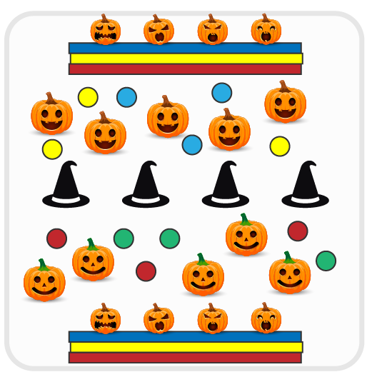
Equipment:
- 2 rows of folded mats
- Plastic pumpkins and/or Halloween themed stuffed animals
- Cones (covered with witches hats)
- 1 foam ball per student

Set-Up:
- Create 2 teams, with each team being assigned one side of the activity area.
- Use cones to divide the activity area in half. Set up a row of folded mats in the back of each activity area. Place objects on top of the mats (pumpkins, stuffed animals, etc.)
- Each team is spread out on their side of the activity area.

ACTIVITY PROCEDURES
- This activity is called Monster Mash! The object of the game is to throw foam balls to knock the monsters (e.g., pumpkins/stuffed animals) off of the other team’s row of mats.
- On the start signal, begin throwing at the monsters. You can defend your team’s monsters by using a ball to block an incoming throw. Once a monster is knocked down, you cannot pick it back up.
- We will keep playing until one team knocks off all of the monsters, or until you hear the stop signal.
- We will then reset the game and play again.

DEBRIEF QUESTIONS
- DOK 1: What is self-regulation? What does self-regulation look like in physical education class?
- DOK 2: What strategies can help us with emotional self-regulation?

PRIORITY OUTCOMES
Etiquette:
- Grades K-2: Exhibits the established protocols for class activities without reminders.
- Grades 3-5: Recognizes the role of rules and etiquette in physical activity with peers.

Haunted House

STUDENT TARGETS
- Skill: I will demonstrate safe behaviors and pacing during the activity.
- Cognitive: I will discuss integrity and fair play.
- Fitness: I will increase my heart rate during this activity.
- Social/Emotional: I will demonstrate integrity by following all rules of the game.

EQUIPMENT & SET-UP | 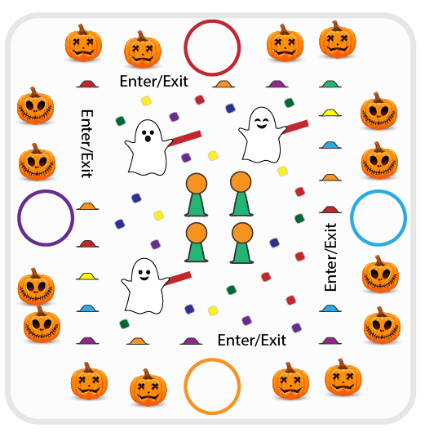
Equipment:
- 60+ bean bags and foam noodle slices
- 4 basketballs & 4 cones
- 40 low profile cones
- 4 foam noodles
- 1 hoop per team
- Scooters (optional)
Set-Up:
- Place 1 hoop per team around the perimeter of the Haunted House. Create even teams (1 scooter per team is optional).
- Designate 2-4 students as “ghosts” with noodles.
- Use low-profile cones to build a haunted house with 4+ entries/exits. Create the “kitchen” in the center with basketballs (pumpkins) on 12” cones. Scatter bean bags and noodle slices (candy) throughout the Haunted House.
ACTIVITY PROCEDURES
- This activity is called Haunted House! The object of the game is for each team to collect as many pieces of candy and pumpkins as possible while avoiding ghosts. Candy equals 1 point and pumpkins equal 5 points.
- When the music starts, 1 player per team will enter the haunted house (either on foot or on scooters). The game is played in relay format. Students in the haunted house can collect 1 piece of candy or 1 pumpkin at a time and return it to their team’s hula hoop. If tagged, students must return to their team empty handed.
- When the music stops, we will count our candy and pumpkins to see which team has the most.

DEBRIEF QUESTIONS
- DOK 1: What is integrity? How is it related to fair play during our games and activities?
- DOK 2: How does integrity help you be a better teammate?

PRIORITY OUTCOMES
Personal Responsibility and Safety:
- Grades K-2: Works independently and safely in physical education.
- Grades 3-5: Engages in physical activity with responsible interpersonal behavior (e.g., peer to peer and student to teacher).

Pumpkin Ball

STUDENT TARGETS
- Skill: I will demonstrate safe behaviors and shoot my basketball only from spot markers.
- Cognitive: I will discuss grit and determination during class discussions.
- Fitness: I will increase my heart rate during this activity.
- Social/Emotional: I will demonstrate determination by working hard and using shooting skill cues.

EQUIPMENT & SET-UP | 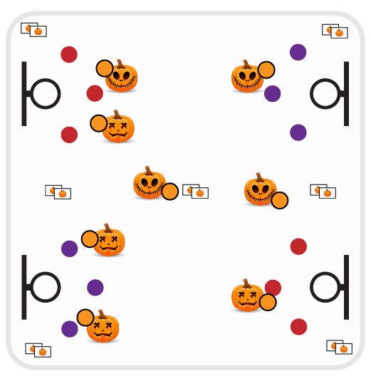
Equipment:
- 1 basketball per student or pair
- Basketball hoops
- Spot markers
- Pumpkin Ball Math Flashcards

Set-Up:
- Scatter students in the activity area (either each student with a basketball or with 1 ball per pair of students).
- Play on a basketball court with multiple hoops. Place a pile of flashcards in the corners of the court as well as on the half court line.
- Scatter spot markers around hoops in shooting range – based on student skill level.
ACTIVITY PROCEDURES
- This activity is called Pumpkin Ball! The object of the game is to earn shots by correctly answering math flashcards.
- When the music starts, dribble to a pile of math flashcards and pick one up. If you’re playing in pairs, bring the card back to your partner and answer the question. Place the flashcard back in the pile when finished.
- If math flashcard is answered correctly, you earn 1 shot. Dribble to a spot marker next to a hoop and take 1 shot. Rebound your ball and dribble to a different pile of flashcards and try again.
- If you’re playing in pairs, take turns shooting and dribbling.
- Continue to play until you hear the music stop.

DEBRIEF QUESTIONS
- DOK 1: What is grit? How is grit related to determination?
- DOK 2: Why are grit and determination important for you as you try to reach personal goals?

PRIORITY OUTCOMES
Manipulative Skills:
- Grades K-2: Demonstrates control while combining locomotor and manipulative skills in self-space and general space.
- Grades 3-5: Demonstrates manipulative skills using mature patterns for accuracy and control.

Ghost Hunt

STUDENT TARGETS
- Skill: I will demonstrate safe behaviors while hunting for ghosts.
- Cognitive: I will discuss grit and determination with my classmates.
- Fitness: I will increase my heart rate during this activity.
- Social/Emotional: I will demonstrate determination by working with my team to complete exercises and hunt for ghosts.

EQUIPMENT & SET-UP | 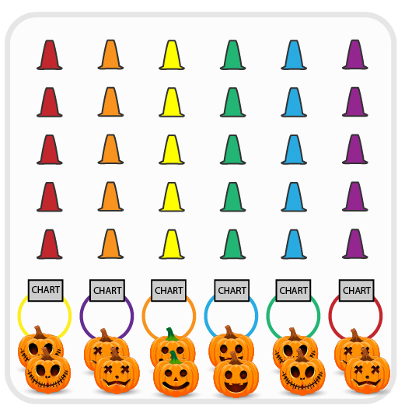
Equipment:
- 50-100 cones
- 40-90 colored yarn balls or bean bags
- 10 white yarn balls or paper “Ghosts”
- 6 hula hoops
- Exercise Charts

Set-Up:
- Create 6 even teams. Each team begins at a hoop with an exercise chart.
- Create a grid of cones with colored and white yarn balls/bean bags hidden under the cones. Place hula hoops in a row at one end of the activity area.
ACTIVITY PROCEDURES
- This activity is called Ghost Hunt! The object of the game is for your team to collect as many ghosts (white yarn balls) as you can.
- This is a speed walking game (or you could use scooters).
- On the start signal, teams will send 1 student (relay race format) out into the graveyard to hunt for ghosts. Student chooses one cone to look under. If that cone is hiding a white yarn ball (ghost) bring it back and put it into your team’s hula hoop (ghost trap). If the cone you looked under has a colored object, leave it there and move back to your team. Look on the exercise chart and lead your team in the exercise listed under the color that matches the object you just uncovered. When done, the next player moves out to hunt for a ghost.
- Continue rotating ghost hunters from your team until you hear the stop signal.

DEBRIEF QUESTIONS
- DOK 1: In your own words, what does determination mean?
- DOK 2: How are grit and determination related to your personal health?

PRIORITY OUTCOMES
Personal Enjoyment:
- Grades K-2: Describes positive feelings that result from physical activity participation.
- Grades 3-5: Reflects on the reasons for enjoying selected physical activities.

The Great Pumpkin Run

STUDENT TARGETS
- Skill: I will practice my running pace in preparation for race day.
- Cognitive: I will discuss social and emotional concepts with my classmates.
- Fitness: I will walk/jog/run at a steady pace in preparation for race day.
- Social/Emotional: I will demonstrate grit, leadership, fair play, and self-regulation.

EQUIPMENT & SET-UP | 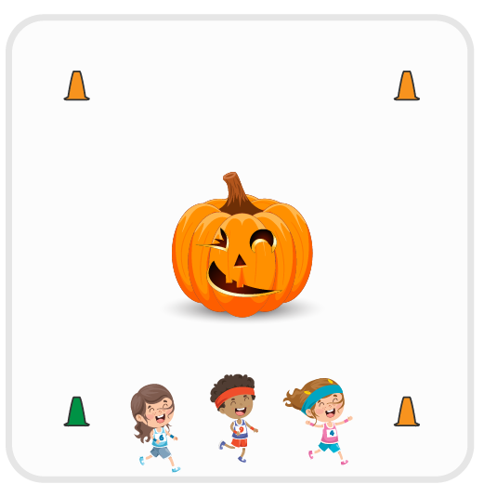
Equipment:
- Cones, signs, and/or sidewalk chalk to mark run course
- Great Pumpkin Run race bibs
- Participation awards
- Clementine prizes for top 3 runners

Set-Up:
- Create a running course that is age appropriate for your students. Grades K-1 = ¼ mile; Grades 2-5 = ½ mile
- Students will begin at a starting line and end at a finish line.
ACTIVITY PROCEDURES
- This activity is called The Great Pumpkin Run! The object is to complete the Great Pumpkin Run as fast as you can.
- Throughout the Pumpkin Patch Games in the month of October, allow students to walk/jog/run the course to practice (e.g., train for the big race). Set a race date and celebrate with decorations, music, race bibs, and healthy prizes. Use music as your start signal.
- When the music starts, runners can begin and the clock starts. Give participation awards to all students. Award Clementine Jack-O-Lanterns to the top 3 finishers. Consider having a running and walking category for prizes, especially if you have students who are reluctant runners.
- Take pictures and have fun!

DEBRIEF QUESTIONS
- What is grit and how does it relate to training for a race?
- How can you demonstrate leadership in an event like The Great Pumpkin Run?
- What does fair play look like during a race event like The Great Pumpkin Run?
- Why is self-regulation important on race day? What emotions might need to be regulated?

PRIORITY OUTCOMES
Personal Challenge:
- Grades K-2: Participates in physical activities that bring confidence and challenge.
- Grades 3-5: Expresses the enjoyment and challenge of participating in a favorite physical activity.

Silly Spooky Storytime

STUDENT TARGETS
- Skill: I will actively engage in the development of my silly, spooky story.
- Cognitive: I will recognize the role that etiquette plays when telling my story.
- Fitness: I will safely participate in order to increase my heart rate and warm up my body.
- Social/Emotional: I will cooperate with my partner in order to tell a silly, spooky story.

EQUIPMENT & SET-UP | 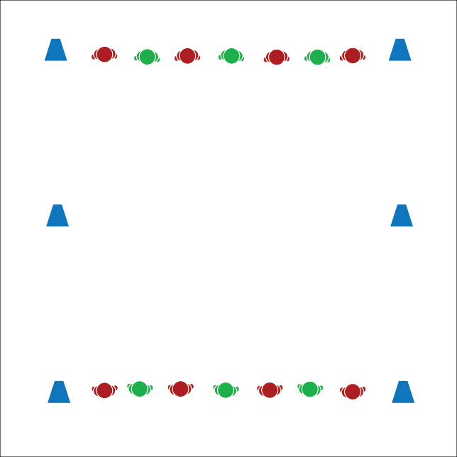
Equipment:
- 6 cones or spot markers to mark lines

Set-Up:
- Create 3 parallel lines that are 8–10 yards apart. There will be 2 home lines on the ends and a center line in the middle.
- Pair students in groups of 2, with partners facing each other on opposite ends of the activity area on the home lines.
- Designate 1 line of students as the “story starters.”
ACTIVITY PROCEDURES
- This activity is called Silly Spooky Storytime. The object is for you and your partner to take turns creating and telling a silly, spooky story while staying active.
- On the start signal, meet your partner at the center line and begin jogging in place. The story starter will begin the story using the story starter that I give to the class. Continue telling the story until you hear the stop signal.
- On the stop signal, return to the home line and wait until you hear the start signal again. On the start signal, return to the center line. The other partner is now the story starter, and this time, you will both do jumping jacks while you tell the story.
- Continue taking turns in this way until I tell you that our Storytime is complete.
Sample Story Starters:
- “Once upon a time, in the great pumpkin patch…”
- “There once was a friendly ghost who loved to trick or treat…”

DEBRIEF QUESTIONS
- DOK 1: What does etiquette mean?
- DOK 2: What can you share about the etiquette of Silly Spooky Storytime?
- DOK 3: How is following activity etiquette related to being a good classmate?

PRIORITY OUTCOMES
Social Interaction:
- Grades K-2: Discusses the enjoyment of playing with family and friends.
- Grades 3-5: Describes the positive social interactions that come when engaged with others in physical activity.

Sleepy Hollow Race

STUDENT TARGETS
- Skill: I will maintain balance and control during the race.
- Cognitive: I will discuss ways to demonstrate safe behaviors with my classmates.
- Fitness: I will work to increase my heart rate during this activity.
- Social/Emotional: I will follow all safety rules during the race.

EQUIPMENT & SET-UP | 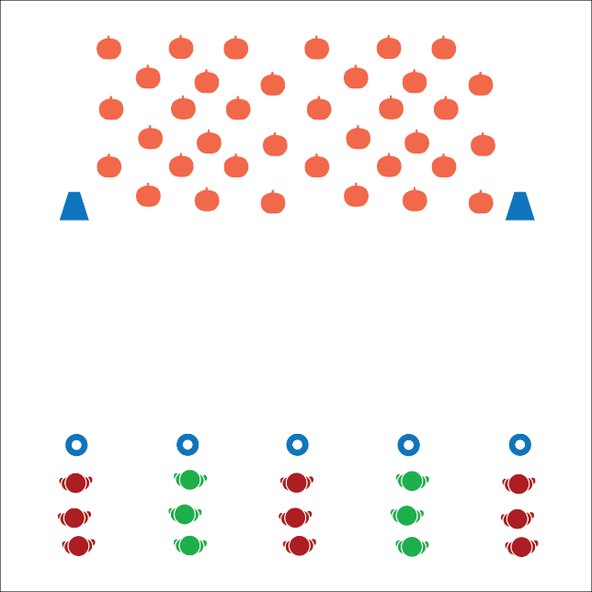
Equipment:
- As many foam or playground balls as you have available, but least 2 per student (can substitute bean bags if necessary)
- 1 cone per group of 3-4 students
- 2 large cones
- 1 scooter per group of students (optional)

Set-Up:
- Create a line of starting cones along 1 side of the activity area.
- On the other side of the activity area, use 2 large cones to create a pumpkin patch zone.
- Create groups of 3-4 students, 1 group at each starting cone.
ACTIVITY PROCEDURES
- This activity is called the Sleepy Hollow Race. You are all headless horse-people. The object is for your team to collect as many heads (playground balls) as possible from the pumpkin patch.
- On the start signal, the first player will gallop (or ride the scooter) directly to the pumpkin patch, collect 1 pumpkin, then return to your team. Take turns in relay-race formation until all heads are collected.
- Players waiting can play catch with 1 of the pumpkins your team collected while you wait for your turn.

DEBRIEF QUESTIONS
- DOK 1: How can you recognize safe behaviors in physical education?
- DOK 2: How do safe behaviors affect the amount of fun we can have in class?
- DOK 3: How would you describe scooter safety to a new member of our class?

PRIORITY OUTCOMES
Personal Responsibility and Safety:
- Grades K-2: Follows directions for safe participation and proper use of equipment without reminders.
- Grades 3-5: Exhibits responsible behavior in independent group situations.

Trick or Treat Fitness

STUDENT TARGETS
- Skill: I will perform fitness exercises with a focus on form and safety.
- Cognitive: I will discuss aerobic capacity and the benefits of being active with family and friends.
- Fitness: I will work to actively engage in order to increase my heart rate.
- Social/Emotional: I will share space and equipment with my classmates.

EQUIPMENT & SET-UP | 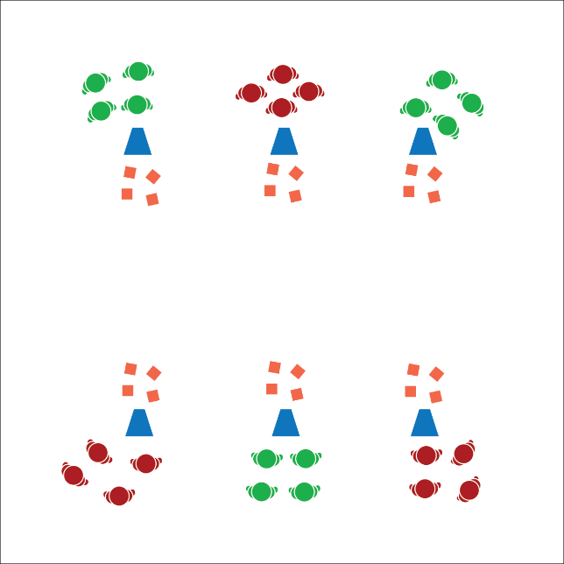
Equipment:
- 24 - 48 bean bags
- 6 large cones
- 6 task tents
- Trick or Treat Fitness Station Cards

Set-Up:
- Create a station circuit using 6 cones, task tents, and station cards.
- Place 4 - 8 bean bags at each station.
- Divide students into equal groups and send each group to a station.
ACTIVITY PROCEDURES
- This activity is called Trick or Treat Fitness! The object is to collect a treat at each station. You’ll do that by completing the exercise on the station card.
- When the music starts, it’s time to trick or treat. Once you’ve collected a treat at your current station, jog clockwise to the next station and place your treat next to the cone. Collect a new treat by completing the exercise on the new station card.
- Note: Students should only be carrying 1 treat at a time from cone to cone. If you have enough “treats” (bean bags) you could modify the activity to allow students to collect as many as possible.

DEBRIEF QUESTIONS
- DOK 1: How can you recognize an activity that helps improve aerobic capacity?
- DOK 2: What are all of the things that you know about aerobic capacity?
- DOK 3: How could you change the way you trick or treat during this activity that could help you improve aerobic capacity?

PRIORITY OUTCOMES
Fitness Knowledge:
- Grades K-2: Identifies the heart as a muscle that grows stronger with exercise/play and physical activity.
- Grades 3-5: Identifies activities that require and/or improve the components of fitness.

Pumpkin Patch Fitness

STUDENT TARGETS
- Skill: I will perform fitness exercises with a focus on form and safety.
- Cognitive: I will identify if exercises are health-related or skill-related.
- Fitness: I will actively engage in order to increase my heart rate during the activity.
- Social/Emotional: I will cooperate with my partner by taking turns in the pumpkin patch.

EQUIPMENT & SET-UP | 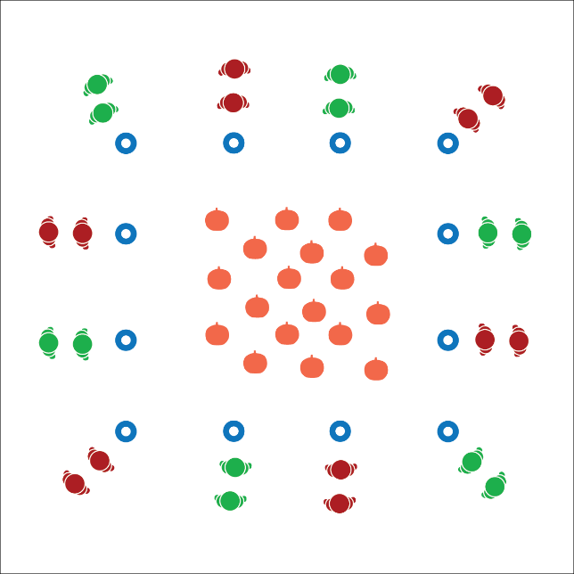
Equipment:
- Pumpkin Patch Exercise Cards
- 1 large cone or low-profile cone per group
- Halloween music and music player

Set-Up:
- Place cones around the perimeter of the activity area.
- Scatter Pumpkin Patch Exercise Cards in the middle of the activity area inside the cones.
- Create groups of 2-3 students. Send each group to a cone.
ACTIVITY PROCEDURES
- This activity is called Pumpkin Patch Fitness! When the music starts, one partner will gallop into the center to pick a pumpkin (exercise card) and return it to your cone. The other partner will jog in place.
- When the partner returns with the pumpkin, begin completing the exercise that is identified on the card.
- As soon as you’ve completed the exercise, the other partner will gallop into the center to return the pumpkin and pick a different exercise card to repeat the process.
- Continue taking turns until the music stops.

DEBRIEF QUESTIONS
- DOK 1: Can you name an exercise that helps you improve your fitness?
- DOK 2: Does that exercise primarily help improve health-related or skill-related fitness?

PRIORITY OUTCOMES
Fitness Knowledge:
- Grades K-2: Identifies physical activities that contribute to fitness.
- Grades 3-5: Identifies the component of health-related and skill-related fitness.

