The Pumpkin Patch

STUDENT TARGETS
- Skill: I will use the appropriate amount of force to roll my ball into a hula hoop.
- Cognitive: I will be able to state the cues for underhand rolling.
- Fitness: I will work to stay actively engaged during all activities.
- Social/Emotional: I will use positive and encouraging communication with my teammates.

EQUIPMENT & SET-UP | 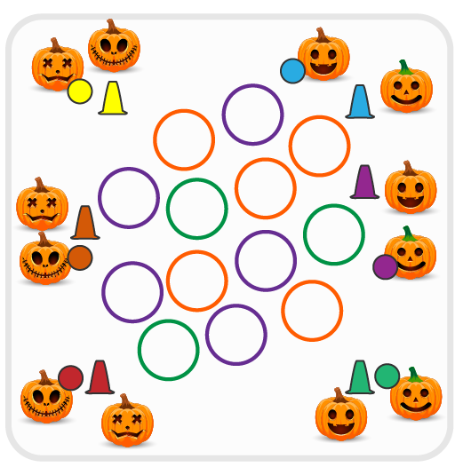
Equipment:
- As many hula hoops as possible
- 1 Cone per team
- 1 Foam ball per team

Set-Up:
- Create teams of 2 players.
- Scatter hula hoops in center of activity area with cones around the perimeter. Place a ball either on top of or near each cone.
- Each team will line up at a cone and wait for start signal.
ACTIVITY PROCEDURES
- This activity is called The Pumpkin Patch! The object of the game is to collect as many pumpkin patches (hula hoops) as you can for your team. You do that by rolling your pumpkin (ball) into the pumpkin patch (hoop).
- Get ready with one teammate holding the ball, and the other teammate standing by the cone.
- On the start signal, the teammate with the ball will roll the pumpkin into the activity area where the hula hoops are spread out. If a roll successfully lands in a hoop, then the player will collect the hoop to bring back and put around their cone. If the roll is not successful, then the player will collect their pumpkin (ball) and bring it back to their cone so their teammate can have a try.
- Each team will continue taking turns rolling the pumpkin into the pumpkin patch until all hoops are collected or you hear the stop signal. The team with the most pumpkin patches wins!
- The ball must go into (and stay inside of) a hoop in order for the team to collect the pumpkin patch and bring it back to their cone.

DEBRIEF QUESTIONS
- DOK 1: What are the cues for underhand rolling?
- DOK 2: How does using the cues affect how well you roll the ball?
- DOK 3: If your ball rolled in but kept going past the hoop and didn’t stay in, what could you do differently on the next attempt?

PRIORITY OUTCOMES
Manipulative Skills:
- Grades K-2: Demonstrates control while combining locomotor and manipulative skills in self-space and general space.
- Grades 3-5: Demonstrates manipulative skills using mature patterns for accuracy and control.

