Ghost Tossers

STUDENT TARGETS
- Skill: I will use the cues for tossing in order to hit a target with the ghost ball.
- Cognitive: I will be able to repeat the cues for tossing towards a target.
- Fitness: I will work to stay actively engaged during all activities.
- Social/Emotional: I will use positive and encouraging communication with my teammates.

EQUIPMENT & SET-UP | 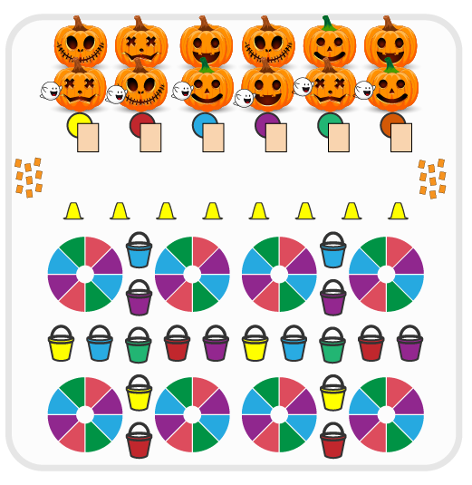
Equipment:
- Cones for boundaries
- Balls wrapped in scarves (ghost balls)
- Buckets for targets
- Small parachutes for targets
- Ghost Tossers Vocabulary Handout
- Alphabet Letter Cut Outs

Set-Up:
- Create teams of 2-3 players.
- Have a spot marker for each team at one end of activity area with a Ghost Tossers Vocabulary Handout. At the other end, set a line of cones as the “throwing line” with buckets and parachutes in front of the line as targets. Create an area with alphabet letters are spread face down.
- Each team begins at a spot marker.

ACTIVITY PROCEDURES
- This activity is called Ghost Tossers! The object of the game is to throw the ghost balls to the target(s) in order to collect letters to create vocabulary words. You do that by collecting one letter if a ghost ball goes in a bucket and collecting two letters if your ghost ball lands on the small parachute.
- Get ready with your team by a spot marker. This is where you will bring all of your letters and where you will bring your ghost ball to switch roles with your partner after each toss attempt.
- On the start signal, one player takes the ghost ball to the throwing line and tosses it either towards a bucket or a small parachute. If successful, get your ghost ball and go to the letter area to collect one letter if you made it in a bucket or two letters if your ghost ball landed on the small parachute. Bring your ghost ball and your letters back to your spot marker and a new teammate takes a turn.
- Continue with the toss attempts until you hear the stop signal.
- If your toss is not successful, you will collect your ghost ball and bring it back to your spot marker so a new teammate can have a turn.

DEBRIEF QUESTIONS
- DOK 1: What does positive and encouraging communication sound like?
- DOK 2: How does positive and encouraging communication impact the way a team works together?

PRIORITY OUTCOMES
Etiquette:
- Grades K-2: Exhibits the established protocols for class activities without reminders.
- Grades 3-5: Exhibits etiquette and adherence to rules in a variety of physical activities.

