Zombie Tag

STUDENT TARGETS
- Skill: I will travel at a controlled and moderate pace in order to maintain a safe environment.
- Cognitive: I will identify fleeing and dodging strategies that help me avoid the taggers.
- Fitness: I will work to stay actively engaged during all activities.
- Social/Emotional: I will follow rules and procedures in order to create a positive and safe environment.

EQUIPMENT & SET-UP | 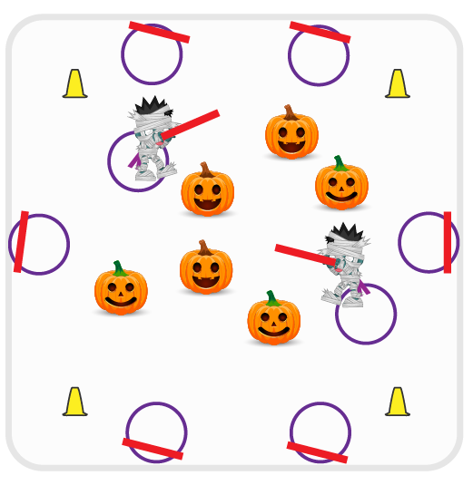
Equipment:
- 1 foam noodle per student
- 1 hula hoop per student
- Cones for boundaries

Set-Up:
- Students spread out on the outside of the boundary cones with one hoop and one noodle each.
- Teacher selects 3-4 students to begin as taggers. Taggers (zombies) bring their hoop and noodle and come by the teacher.
- All remaining students (non-taggers) leave their hoop and noodle outside the cones and spread out in the middle of the activity area.
ACTIVITY PROCEDURES
- This activity is called Zombie Tag! The object of the game is to avoid being turned into a zombie by avoiding the taggers. You do that by using your chasing, fleeing, and dodging skills to avoid being caught.
- Zombies (taggers) stand just outside of the cones by the teacher while all of the humans (other students) spread out in the activity area.
- On the start signal, Zombies (taggers) will use their foam noodle to tag as many humans as they can while dragging their hula hoop behind them with one foot. If a human gets tagged, they have been turned into a zombie! They will go outside of the cones to get their hula hoop and foam noodle, and will join the taggers to turn the remaining humans into zombies as well.
- Zombies will continue to tag the humans until you hear the stop signal or until there are no humans left.
- We will switch out the taggers every few minutes and start a new game.
DEBRIEF QUESTIONS
- DOK 1: What is a rule? What is a procedure?
- DOK 2: How does following rules and procedures affect class games and activities?

PRIORITY OUTCOMES
Personal Responsibility and Safety:
- Grades K-2: Follows directions for safe participation and proper use of equipment without reminders.
- Grades 3-5: Engages in physical activity with responsible interpersonal behavior (e.g., peer to peer, student to teacher).

