Spooky Stations

STUDENT TARGETS
- Skill: I will demonstrate proper form and attention to safety during each station.
- Cognitive: I will follow the instructions on each station card in order to stay actively engaged.
- Fitness: I will work to keep moving and increase my heart rate during each station.
- Social/Emotional: I will exhibit personal responsibility during each station.

EQUIPMENT & SET-UP | 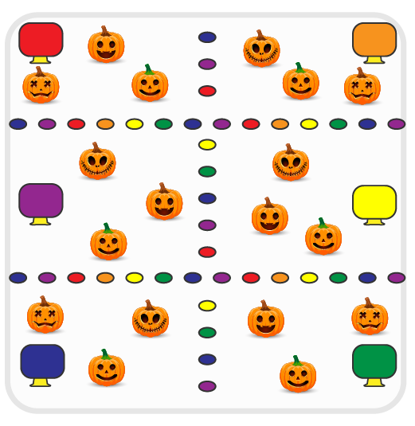
Equipment:
- Low profile cones for station boundaries
- Cones and task tents for each station
- Station music and music player
- Spooky Station Cards (see each card for specific equipment needs)

Set-Up:
- Use low profile cones to create 6 station grids.
- Place station cards in a task tent at each station.
- Set up equipment at each station according to its station card.
- Create groups of 4-5 students, each group at a different station.
ACTIVITY PROCEDURES
- This activity is called Spooky Stations! The object is to utilize self-control and personal responsibility while you participate in a variety of different spooky station activities.
- Teacher: Talk through and demonstrate each station.
- When the music starts, begin working at your station. There is a task tent with a station card at each one to help you remember the expectations and directions.
- When the music stops, you will have 30 seconds to clean up the station equipment and rotate to the next station. Wait until the music begins again to start the new station activity.

DEBRIEF QUESTIONS
- DOK 1: Why is it important for you to work together with your classmates to share equipment and space?
- DOK 2: What are some of the ways you exhibited personal responsibility and/or self-control during the station activities?

PRIORITY OUTCOMES
Working with Others:
- Grades K-2: Accepts responsibility for class protocols with personal and cooperative behavior as well as performance actions.
- Grades 3-5: Accepts, recognizes, and actively involves others with both higher and lower skill abilities into physical activities and group projects.

