Ghostbusters Tag

STUDENT TARGETS
- Skill: I will demonstrate safe behaviors and pacing during the tag game.
- Cognitive: I will discuss the enjoyment of being active with family and friends.
- Fitness: I will increase my heart rate during this activity.
- Social/Emotional: I will describe the social benefits gained from participating in physical activity.

EQUIPMENT & SET-UP | 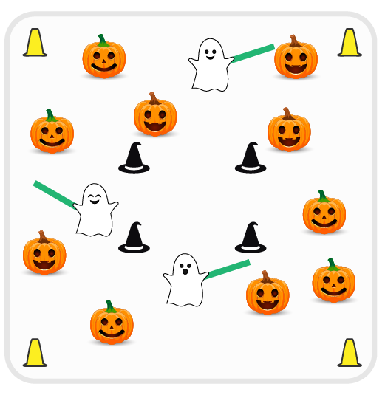
Equipment:
- Cones for boundaries and haunted castle
- 3-4 foam noodles
- Music player and Ghostbusters theme song

Set-Up:
- Select 3-4 students as ghosts (taggers) and give them a foam noodle.
- Create a large activity area with cones. In the center of the area, create another space (haunted castle) with cones that is large enough for several students to safely perform jumping jacks.
- Remaining students scatter throughout activity area.
ACTIVITY PROCEDURES
- This activity is called Ghostbusters Tag! The object of the game is to avoid being tagged by the ghosts.
- Teachers: Play the first game at a speed walking pace. Increase the pace when students demonstrate safe behaviors.
- When the music starts, the tag game begins. If tagged by a ghost with a foam noodle, you must report to the haunted castle and perform jumping jacks until you hear the word “ghostbusters” in the song. You can then return to the game.
- You must be inside the haunted castle by the time you hear “ghostbusters” after you have been tagged. If you are outside the haunted castle when “ghostbusters” is said, you must enter the castle and perform jumping jacks until the next time you hear it.
- We will continue to play until you hear the music stop. I may pause the music sometimes so we can switch out the ghosts (taggers).

DEBRIEF QUESTIONS
- DOK 1: What is responsibility? How did you show responsibility during the game?
- DOK 2: Why is it important for a leader to demonstrate responsibility?

PRIORITY OUTCOMES
Social Interaction:
- Grades K-2: Discusses the enjoyment of playing with family and friends.
- Grades 3-5: Describes the social benefits gained from participating in physical activity.

