Zombie Invasion

STUDENT TARGETS
- Skill: I will demonstrate safe behaviors and pacing during the activity.
- Cognitive: I will discuss responsibility and leadership during physical education class.
- Fitness: I will increase my heart rate during this activity.
- Social/Emotional: I will demonstrate responsibility by moving safely and with consideration for others.

EQUIPMENT & SET-UP | 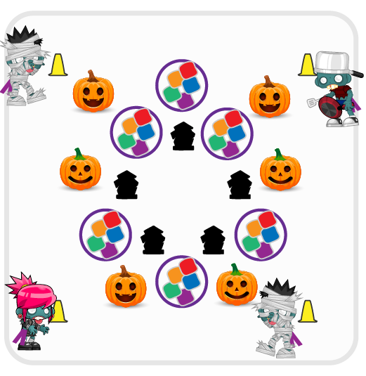
Equipment:
- Cones for boundaries
- 10 hula hoops with 5 items inside each hoop (foam balls, bean bags, etc.)
- 1 flag belt per 2 students
Set-Up:
- Create 2 teams, with one team wearing flag belts. The team with belts is the Zombie team and they begin outside of the activity area.
- The team without flag belts are inside the activity area and are defending the “candy” inside each hoop.
- Use cones to create a large activity area. Create a smaller circular area inside of the activity area to be the “graveyard” zone. Scatter hoops with 5 items inside around the activity area.
ACTIVITY PROCEDURES
- This activity is called Zombie Invasion! The object of the game is for the Zombies to capture all of the candy inside each of the hoops.
- The Zombie team (with flag belts) will begin in the safe zone outside of the cones. The candy defenders (without flag belts) need to be scattered inside the activity area and ready to fend off the Zombies by pulling their flags.
- On the start signal, the Zombies can invade the activity area. They can only collect 1 piece of candy at a time and must make it back outside of the activity area without getting their flag pulled. If a Zombie’s flag is pulled, candy must be returned to the hoop and the Zombie must report to the graveyard.
- Zombies in the graveyard can be set free if a fellow Zombie can make it into the graveyard without having a flag pulled. All freed Zombies get a free pass back outside of the activity area.
- We will continue to play until you hear the stop signal.

DEBRIEF QUESTIONS
- DOK 1: What is a leader? How can you demonstrate leadership in physical education class?
- DOK 2: What does “leading by example” mean?

PRIORITY OUTCOMES
Movement Concepts:
- Grades K-2: Safely moves in both personal and general space using different pathways and speeds.
- Grades 3-5: Recognizes open and closed spaces in a variety of movement contexts.

