Pickles in the Pumpkin Patch

STUDENT TARGETS
- Skill: I will toss foam balls using skill cues.
- Cognitive: I will discuss self-control during the activity.
- Fitness: I will increase my heart rate during this activity.
- Social/Emotional: I will demonstrate self-control while competing and having fun.

EQUIPMENT & SET-UP | 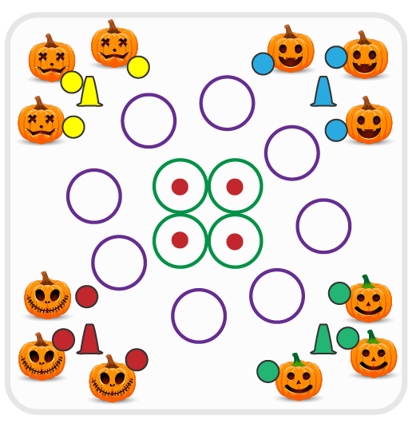
Equipment:
- 4 spot markers
- 24 hula hoops
- 1 foam ball or yarn ball per student
- 1 cone per team to create a team patch

Set-Up:
- Create equal teams of 3-6 players.
- Divide foam/yarn balls evenly. Give 1 team only the green balls (they are the pickles).
- Create a large activity area with cones. Scatter hoops evenly in the activity area.
- Place 4 hoops in the center of the area with spot markers inside each hoop.
ACTIVITY PROCEDURES
- This activity is called Pickles in the Pumpkin Patch! The object of the game is to collect as many hoops (pumpkins) as you can. You do that by tossing a ball so that it lands and stays in the hoop. Center hoops can only be taken if the ball stays on the spot marker.
- The green team (the pickles) will use their green balls to try and knock other balls out of hoops before they’re collected. The pickles are trying to see how long they can keep the pumpkins safe and in the patch.
- On the start signal, all teams start tossing balls into the hoops (pumpkins). If a ball lands (and stays) inside a hoop, move to collect the hoop and bring it back to your team’s area. If you miss with a toss, move to collect your ball and try again. If 2 balls land in a hoop at the same time, use Rock, Paper, Scissors to determine who captures the pumpkin.
- Teams will continue to play until you hear the stop signal.

DEBRIEF QUESTIONS
- DOK 1: What is self-control?
- DOK 2: How did you demonstrate self-control during this game?

PRIORITY OUTCOMES
Personal Responsibility and Safety:
- Grades K-2: Works independently and safely in physical education.
- Grades 3-5: Exhibits responsible behavior in independent group situations.

