Monster Mash

STUDENT TARGETS
- Skill: I will throw foam balls using skill cues.
- Cognitive: I will discuss self-regulation during the activity discussions.
- Fitness: I will increase my heart rate during this activity.
- Social/Emotional: I will demonstrate self-control while competing and having fun.

EQUIPMENT & SET-UP | 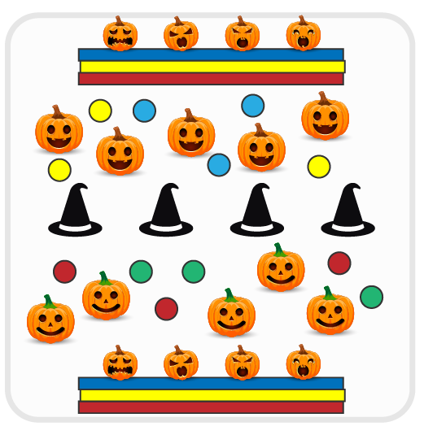
Equipment:
- 2 rows of folded mats
- Plastic pumpkins and/or Halloween themed stuffed animals
- Cones (covered with witches hats)
- 1 foam ball per student

Set-Up:
- Create 2 teams, with each team being assigned one side of the activity area.
- Use cones to divide the activity area in half. Set up a row of folded mats in the back of each activity area. Place objects on top of the mats (pumpkins, stuffed animals, etc.)
- Each team is spread out on their side of the activity area.

ACTIVITY PROCEDURES
- This activity is called Monster Mash! The object of the game is to throw foam balls to knock the monsters (e.g., pumpkins/stuffed animals) off of the other team’s row of mats.
- On the start signal, begin throwing at the monsters. You can defend your team’s monsters by using a ball to block an incoming throw. Once a monster is knocked down, you cannot pick it back up.
- We will keep playing until one team knocks off all of the monsters, or until you hear the stop signal.
- We will then reset the game and play again.

DEBRIEF QUESTIONS
- DOK 1: What is self-regulation? What does self-regulation look like in physical education class?
- DOK 2: What strategies can help us with emotional self-regulation?

PRIORITY OUTCOMES
Etiquette:
- Grades K-2: Exhibits the established protocols for class activities without reminders.
- Grades 3-5: Recognizes the role of rules and etiquette in physical activity with peers.

