Haunted House

STUDENT TARGETS
- Skill: I will demonstrate safe behaviors and pacing during the activity.
- Cognitive: I will discuss integrity and fair play.
- Fitness: I will increase my heart rate during this activity.
- Social/Emotional: I will demonstrate integrity by following all rules of the game.

EQUIPMENT & SET-UP | 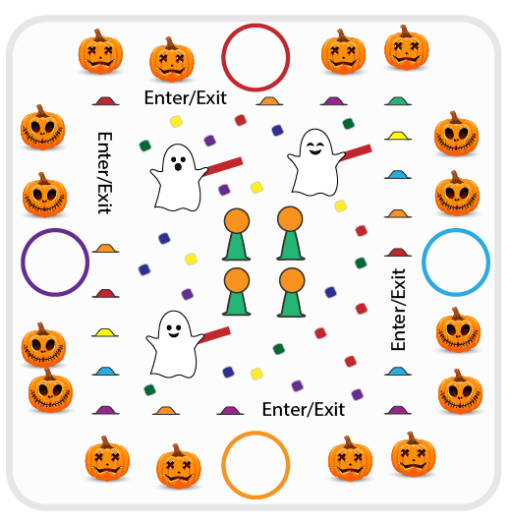
Equipment:
- 60+ bean bags and foam noodle slices
- 4 basketballs & 4 cones
- 40 low profile cones
- 4 foam noodles
- 1 hoop per team
- Scooters (optional)
Set-Up:
- Place 1 hoop per team around the perimeter of the Haunted House. Create even teams (1 scooter per team is optional).
- Designate 2-4 students as “ghosts” with noodles.
- Use low-profile cones to build a haunted house with 4+ entries/exits. Create the “kitchen” in the center with basketballs (pumpkins) on 12” cones. Scatter bean bags and noodle slices (candy) throughout the Haunted House.
ACTIVITY PROCEDURES
- This activity is called Haunted House! The object of the game is for each team to collect as many pieces of candy and pumpkins as possible while avoiding ghosts. Candy equals 1 point and pumpkins equal 5 points.
- When the music starts, 1 player per team will enter the haunted house (either on foot or on scooters). The game is played in relay format. Students in the haunted house can collect 1 piece of candy or 1 pumpkin at a time and return it to their team’s hula hoop. If tagged, students must return to their team empty handed.
- When the music stops, we will count our candy and pumpkins to see which team has the most.

DEBRIEF QUESTIONS
- DOK 1: What is integrity? How is it related to fair play during our games and activities?
- DOK 2: How does integrity help you be a better teammate?

PRIORITY OUTCOMES
Personal Responsibility and Safety:
- Grades K-2: Works independently and safely in physical education.
- Grades 3-5: Engages in physical activity with responsible interpersonal behavior (e.g., peer to peer and student to teacher).

