Pumpkin Ball

STUDENT TARGETS
- Skill: I will demonstrate safe behaviors and shoot my basketball only from spot markers.
- Cognitive: I will discuss grit and determination during class discussions.
- Fitness: I will increase my heart rate during this activity.
- Social/Emotional: I will demonstrate determination by working hard and using shooting skill cues.

EQUIPMENT & SET-UP | 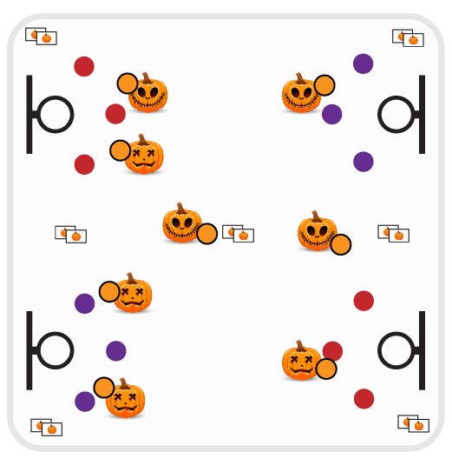
Equipment:
- 1 basketball per student or pair
- Basketball hoops
- Spot markers
- Pumpkin Ball Math Flashcards

Set-Up:
- Scatter students in the activity area (either each student with a basketball or with 1 ball per pair of students).
- Play on a basketball court with multiple hoops. Place a pile of flashcards in the corners of the court as well as on the half court line.
- Scatter spot markers around hoops in shooting range – based on student skill level.
ACTIVITY PROCEDURES
- This activity is called Pumpkin Ball! The object of the game is to earn shots by correctly answering math flashcards.
- When the music starts, dribble to a pile of math flashcards and pick one up. If you’re playing in pairs, bring the card back to your partner and answer the question. Place the flashcard back in the pile when finished.
- If math flashcard is answered correctly, you earn 1 shot. Dribble to a spot marker next to a hoop and take 1 shot. Rebound your ball and dribble to a different pile of flashcards and try again.
- If you’re playing in pairs, take turns shooting and dribbling.
- Continue to play until you hear the music stop.

DEBRIEF QUESTIONS
- DOK 1: What is grit? How is grit related to determination?
- DOK 2: Why are grit and determination important for you as you try to reach personal goals?

PRIORITY OUTCOMES
Manipulative Skills:
- Grades K-2: Demonstrates control while combining locomotor and manipulative skills in self-space and general space.
- Grades 3-5: Demonstrates manipulative skills using mature patterns for accuracy and control.

