Ghost Hunt

STUDENT TARGETS
- Skill: I will demonstrate safe behaviors while hunting for ghosts.
- Cognitive: I will discuss grit and determination with my classmates.
- Fitness: I will increase my heart rate during this activity.
- Social/Emotional: I will demonstrate determination by working with my team to complete exercises and hunt for ghosts.

EQUIPMENT & SET-UP | 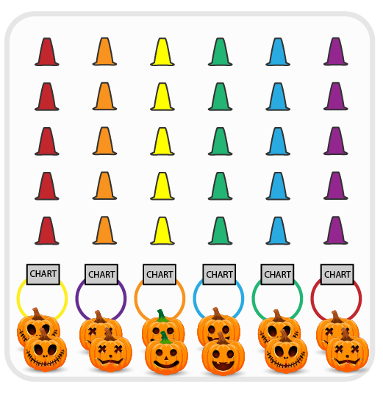
Equipment:
- 50-100 cones
- 40-90 colored yarn balls or bean bags
- 10 white yarn balls or paper “Ghosts”
- 6 hula hoops
- Exercise Charts

Set-Up:
- Create 6 even teams. Each team begins at a hoop with an exercise chart.
- Create a grid of cones with colored and white yarn balls/bean bags hidden under the cones. Place hula hoops in a row at one end of the activity area.
ACTIVITY PROCEDURES
- This activity is called Ghost Hunt! The object of the game is for your team to collect as many ghosts (white yarn balls) as you can.
- This is a speed walking game (or you could use scooters).
- On the start signal, teams will send 1 student (relay race format) out into the graveyard to hunt for ghosts. Student chooses one cone to look under. If that cone is hiding a white yarn ball (ghost) bring it back and put it into your team’s hula hoop (ghost trap). If the cone you looked under has a colored object, leave it there and move back to your team. Look on the exercise chart and lead your team in the exercise listed under the color that matches the object you just uncovered. When done, the next player moves out to hunt for a ghost.
- Continue rotating ghost hunters from your team until you hear the stop signal.

DEBRIEF QUESTIONS
- DOK 1: In your own words, what does determination mean?
- DOK 2: How are grit and determination related to your personal health?

PRIORITY OUTCOMES
Personal Enjoyment:
- Grades K-2: Describes positive feelings that result from physical activity participation.
- Grades 3-5: Reflects on the reasons for enjoying selected physical activities.

