The Great Pumpkin Run

STUDENT TARGETS
- Skill: I will practice my running pace in preparation for race day.
- Cognitive: I will discuss social and emotional concepts with my classmates.
- Fitness: I will walk/jog/run at a steady pace in preparation for race day.
- Social/Emotional: I will demonstrate grit, leadership, fair play, and self-regulation.

EQUIPMENT & SET-UP | 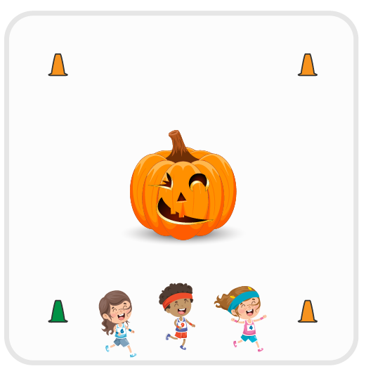
Equipment:
- Cones, signs, and/or sidewalk chalk to mark run course
- Great Pumpkin Run race bibs
- Participation awards
- Clementine prizes for top 3 runners

Set-Up:
- Create a running course that is age appropriate for your students. Grades K-1 = ¼ mile; Grades 2-5 = ½ mile
- Students will begin at a starting line and end at a finish line.
ACTIVITY PROCEDURES
- This activity is called The Great Pumpkin Run! The object is to complete the Great Pumpkin Run as fast as you can.
- Throughout the Pumpkin Patch Games in the month of October, allow students to walk/jog/run the course to practice (e.g., train for the big race). Set a race date and celebrate with decorations, music, race bibs, and healthy prizes. Use music as your start signal.
- When the music starts, runners can begin and the clock starts. Give participation awards to all students. Award Clementine Jack-O-Lanterns to the top 3 finishers. Consider having a running and walking category for prizes, especially if you have students who are reluctant runners.
- Take pictures and have fun!

DEBRIEF QUESTIONS
- What is grit and how does it relate to training for a race?
- How can you demonstrate leadership in an event like The Great Pumpkin Run?
- What does fair play look like during a race event like The Great Pumpkin Run?
- Why is self-regulation important on race day? What emotions might need to be regulated?

PRIORITY OUTCOMES
Personal Challenge:
- Grades K-2: Participates in physical activities that bring confidence and challenge.
- Grades 3-5: Expresses the enjoyment and challenge of participating in a favorite physical activity.

