Silly Spooky Storytime

STUDENT TARGETS
- Skill: I will actively engage in the development of my silly, spooky story.
- Cognitive: I will recognize the role that etiquette plays when telling my story.
- Fitness: I will safely participate in order to increase my heart rate and warm up my body.
- Social/Emotional: I will cooperate with my partner in order to tell a silly, spooky story.

EQUIPMENT & SET-UP | 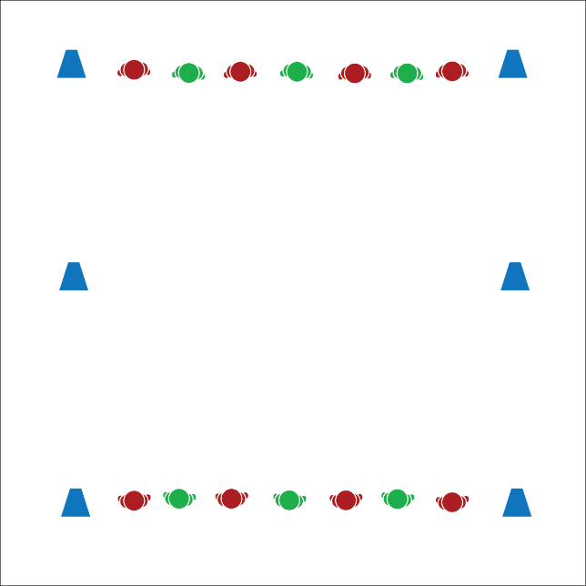
Equipment:
- 6 cones or spot markers to mark lines

Set-Up:
- Create 3 parallel lines that are 8–10 yards apart. There will be 2 home lines on the ends and a center line in the middle.
- Pair students in groups of 2, with partners facing each other on opposite ends of the activity area on the home lines.
- Designate 1 line of students as the “story starters.”
ACTIVITY PROCEDURES
- This activity is called Silly Spooky Storytime. The object is for you and your partner to take turns creating and telling a silly, spooky story while staying active.
- On the start signal, meet your partner at the center line and begin jogging in place. The story starter will begin the story using the story starter that I give to the class. Continue telling the story until you hear the stop signal.
- On the stop signal, return to the home line and wait until you hear the start signal again. On the start signal, return to the center line. The other partner is now the story starter, and this time, you will both do jumping jacks while you tell the story.
- Continue taking turns in this way until I tell you that our Storytime is complete.
Sample Story Starters:
- “Once upon a time, in the great pumpkin patch…”
- “There once was a friendly ghost who loved to trick or treat…”

DEBRIEF QUESTIONS
- DOK 1: What does etiquette mean?
- DOK 2: What can you share about the etiquette of Silly Spooky Storytime?
- DOK 3: How is following activity etiquette related to being a good classmate?

PRIORITY OUTCOMES
Social Interaction:
- Grades K-2: Discusses the enjoyment of playing with family and friends.
- Grades 3-5: Describes the positive social interactions that come when engaged with others in physical activity.

