Sleepy Hollow Race

STUDENT TARGETS
- Skill: I will maintain balance and control during the race.
- Cognitive: I will discuss ways to demonstrate safe behaviors with my classmates.
- Fitness: I will work to increase my heart rate during this activity.
- Social/Emotional: I will follow all safety rules during the race.

EQUIPMENT & SET-UP | 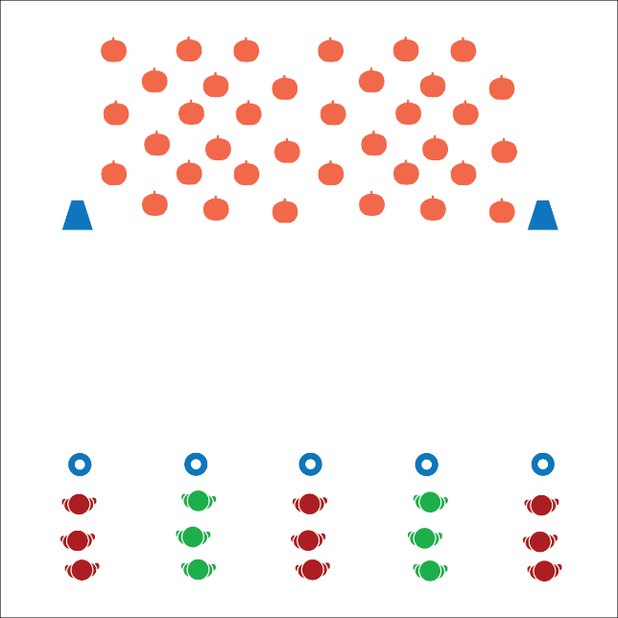
Equipment:
- As many foam or playground balls as you have available, but least 2 per student (can substitute bean bags if necessary)
- 1 cone per group of 3-4 students
- 2 large cones
- 1 scooter per group of students (optional)

Set-Up:
- Create a line of starting cones along 1 side of the activity area.
- On the other side of the activity area, use 2 large cones to create a pumpkin patch zone.
- Create groups of 3-4 students, 1 group at each starting cone.
ACTIVITY PROCEDURES
- This activity is called the Sleepy Hollow Race. You are all headless horse-people. The object is for your team to collect as many heads (playground balls) as possible from the pumpkin patch.
- On the start signal, the first player will gallop (or ride the scooter) directly to the pumpkin patch, collect 1 pumpkin, then return to your team. Take turns in relay-race formation until all heads are collected.
- Players waiting can play catch with 1 of the pumpkins your team collected while you wait for your turn.

DEBRIEF QUESTIONS
- DOK 1: How can you recognize safe behaviors in physical education?
- DOK 2: How do safe behaviors affect the amount of fun we can have in class?
- DOK 3: How would you describe scooter safety to a new member of our class?

PRIORITY OUTCOMES
Personal Responsibility and Safety:
- Grades K-2: Follows directions for safe participation and proper use of equipment without reminders.
- Grades 3-5: Exhibits responsible behavior in independent group situations.

