Trick or Treat Fitness

STUDENT TARGETS
- Skill: I will perform fitness exercises with a focus on form and safety.
- Cognitive: I will discuss aerobic capacity and the benefits of being active with family and friends.
- Fitness: I will work to actively engage in order to increase my heart rate.
- Social/Emotional: I will share space and equipment with my classmates.

EQUIPMENT & SET-UP | 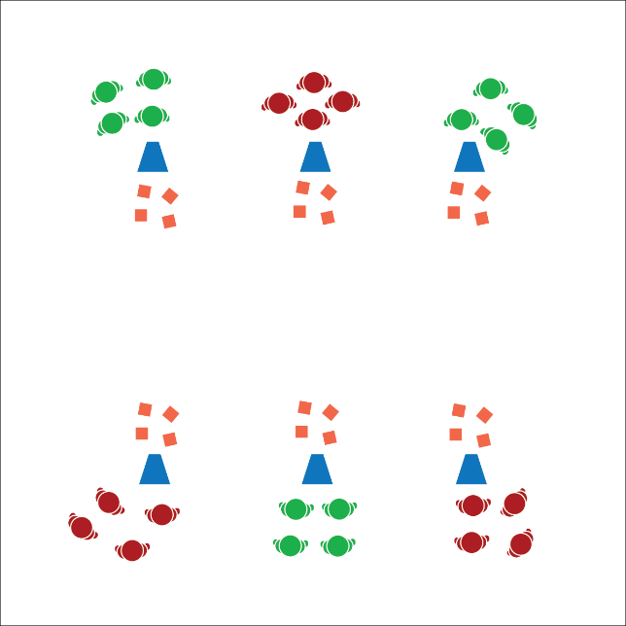
Equipment:
- 24 - 48 bean bags
- 6 large cones
- 6 task tents
- Trick or Treat Fitness Station Cards

Set-Up:
- Create a station circuit using 6 cones, task tents, and station cards.
- Place 4 - 8 bean bags at each station.
- Divide students into equal groups and send each group to a station.
ACTIVITY PROCEDURES
- This activity is called Trick or Treat Fitness! The object is to collect a treat at each station. You’ll do that by completing the exercise on the station card.
- When the music starts, it’s time to trick or treat. Once you’ve collected a treat at your current station, jog clockwise to the next station and place your treat next to the cone. Collect a new treat by completing the exercise on the new station card.
- Note: Students should only be carrying 1 treat at a time from cone to cone. If you have enough “treats” (bean bags) you could modify the activity to allow students to collect as many as possible.

DEBRIEF QUESTIONS
- DOK 1: How can you recognize an activity that helps improve aerobic capacity?
- DOK 2: What are all of the things that you know about aerobic capacity?
- DOK 3: How could you change the way you trick or treat during this activity that could help you improve aerobic capacity?

PRIORITY OUTCOMES
Fitness Knowledge:
- Grades K-2: Identifies the heart as a muscle that grows stronger with exercise/play and physical activity.
- Grades 3-5: Identifies activities that require and/or improve the components of fitness.

