Pumpkin Patch Fitness

STUDENT TARGETS
- Skill: I will perform fitness exercises with a focus on form and safety.
- Cognitive: I will identify if exercises are health-related or skill-related.
- Fitness: I will actively engage in order to increase my heart rate during the activity.
- Social/Emotional: I will cooperate with my partner by taking turns in the pumpkin patch.

EQUIPMENT & SET-UP | 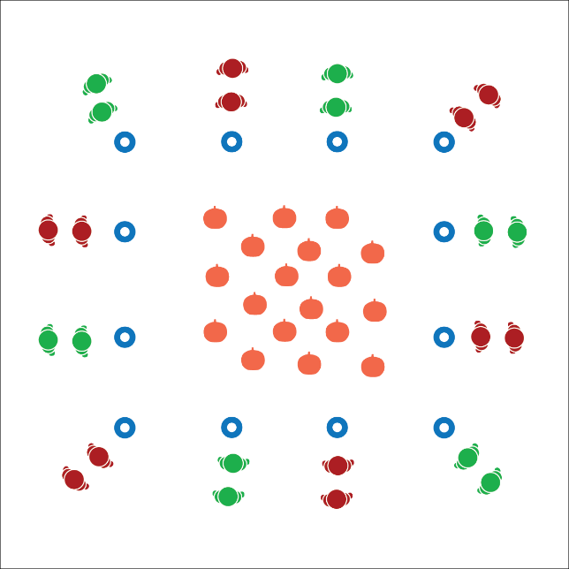
Equipment:
- Pumpkin Patch Exercise Cards
- 1 large cone or low-profile cone per group
- Halloween music and music player

Set-Up:
- Place cones around the perimeter of the activity area.
- Scatter Pumpkin Patch Exercise Cards in the middle of the activity area inside the cones.
- Create groups of 2-3 students. Send each group to a cone.
ACTIVITY PROCEDURES
- This activity is called Pumpkin Patch Fitness! When the music starts, one partner will gallop into the center to pick a pumpkin (exercise card) and return it to your cone. The other partner will jog in place.
- When the partner returns with the pumpkin, begin completing the exercise that is identified on the card.
- As soon as you’ve completed the exercise, the other partner will gallop into the center to return the pumpkin and pick a different exercise card to repeat the process.
- Continue taking turns until the music stops.

DEBRIEF QUESTIONS
- DOK 1: Can you name an exercise that helps you improve your fitness?
- DOK 2: Does that exercise primarily help improve health-related or skill-related fitness?

PRIORITY OUTCOMES
Fitness Knowledge:
- Grades K-2: Identifies physical activities that contribute to fitness.
- Grades 3-5: Identifies the component of health-related and skill-related fitness.

